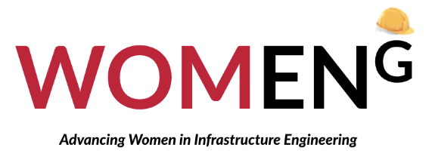

The Youth Program: Work Experience
RMIT is pleased to announce its invitation to your school for its participation to collaborate with our STEM College to bring forth the WOMENG Youth Program.

WOMENG is a multi-collaborative and multi-sponsored government initiative that has developed the Youth Program to spur future engagement for female students to develop and progress their interest in a career in infrastructure engineering. Through a proven method for STEM engagement, the WOMENG Youth Program has multiple touchpoints for ongoing engagement. Our program selects 15 students from year levels 9 to 10 (above the age of 15) from Victoria-based secondary schools to ensure the goals and priorities of the students. This program runs will run as work experience for the students, compliant

Program Components and Outline
- “Let’s get our hands dirty”: Excursion Visits (March 27th – March 29th)
RMIT has collaborated with Australia’s leading associations for road and pavement infrastructure design, construction, and maintenance: Austroads and AfPA, to bring forth site visits to Melbourne’s newest and largest constructions. These excursions will be at the Rail Academy Newport, the RPV Metro Tunnel HQ, and the Downer Group Somerton Plant.

These 3 site visits will allow students to elevate their knowledge on the lesser-known aspects of the infrastructure engineering industry and rail construction industry. The site visits are expected to expose students to all the possible roles within the industry, from the integral work of the construction worker to the importance of project management.

- “Just Another Day in the Office” Initiative: A Shadowing Experience (March 30th – March 31st)
After participating in the three excursions to grasp the scope of the field from a tactical perspective, the students will be given the opportunity to extend their knowledge by applying it to the 9-5 workday. Students will be provided with an experienced industry mentor for a day to shadow on a 3-on-1 basis. This experience will follow the three excursions, to further enhance the understanding of skills and attributes sought by the employer, and is a time for students and mentors to follow up on any questions regarding day-to-day tasks and gaining knowledge on how to map out their future career plans.

- Final 1-Day Workshop (April 21st 2023)
The candidates will be presented with a certificate of completion at the final 1-Day Workshop. This workshop invites industry speakers to present on the possible career pathways available to women in their company and discuss their personal experiences in the industry, while allowing a facilitated discussion to share personal experiences and interests that motivate the participants to plan for their future education pathways and careers.

Requirements from the school
Part 1 – Application and Interaction: Teachers are encouraged to motivate students with an interest in engineering as well as those without to apply for the program. Teachers are additionally welcome to participate and coordinate details of the excursions with students, parents, and carers.
Part 2 – Encouragement and Motivation: Teacher support will be required to deliver meaningful coordination between students and the program by connecting them with WOMENG, should any content require further communication or explanation upon delivery. Teachers are encouraged to attend and participate in the workshop session to take home any knowledge and information that may prove beneficial to the students.

Funding and Associated Costs
The program is fully funded to include resources, lunch, and transport from the RMIT City Campus to the excursion sites, the shadowing program, and the final workshop. As this falls under WOMENG’s Youth Program: Work Experience, CRT is not required, and the point of care and contact will be with the WOMENG Team for the three excursions, and will belong to the individual student for the Shadowing Program, with the written consent from the student, the principal of the student, and the parent/guardian of the student. The program comes at no cost to the students.

Contact
Should you have any questions, please do not hesitate to contact WOMENG project coordinator, Cody Jackson at: cody.jackson@rmit.edu.au

