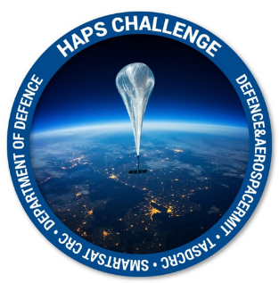

HAPS Challenge
Application Form Part A

Instructions

Please refer to the Guidelines on the Sir Lawrence Wackett Defence & Aerospace Centre website https://www.rmit.edu.au/defence-aerospace/haps-challenge before completing this application. Applications that do not meet the eligibility criteria set out in the Guidelines will not be considered.
You must complete all sections of the application. Your application should consist of the following documents, all available at the website above:
- Application Form (Part A - this form)
- Application Form (Part B)
- Quad Chart (Part C)
The body of your application, the PROPOSAL section, must be no longer than 3 pages and be typed in Ariel 12-point font with single spacing using the supplied template. Text in square brackets is to be erased prior to submission.
Use clear, concise language. Avoid jargon and uncommon acronyms.
Applications are to be submitted in both PDF and Word format
Application must be executed by an authorised Company representative.
Do not include this instructions page in your submission.
Applications are to be submitted in both PDF and Word format
Application must be executed by an authorised Company representative.
Submit the administrative document and proposal details to: HAPS.Challenge@tasdcrc.com.au by 24th May 2021.

Assessment Timeline – Phase 1

Release of Call for Submissions | 29th March 2021
Submission Due Date | 24th May 2021
Assessment of Applications | 27th May – 25th June 2021

Assessment Process

A panel of assessors will review the proposals against the criteria set out in the Guidelines.
Date
Application is for (choose one only) | Stream 1  Automated or Autonomous HAPS Platform Station-keeping and Constellation Maintenance | Stream 2  Automated or Autonomous Attitude Determination and Correction of payload platform
Project Title
Project Lead (point of contact)
Other Project Team members
Project Lead organisation
ABN/ACN
Project sub-contractors or consortium
Contact email
Contact mobile
Website
LinkedIn/Twitter
Proposal summary (1 paragraph)

Project Schedule
Activity | Details | Date
Project timelines
Project deliverables
Project milestones

Project Budget
Item | Description | $ Amount

By signing below, the signatory confirms that he/she is authorised to make this application and accepts the Terms & Conditions of entry.
Signature: |  | Position:
Name (print): |  | Date:
Name of Applicant:

