Collection Guidelines
RMIT University Archives
August 2021

Purpose
The purpose of these Guidelines is to define the material which RMIT University Archives (known hereon as ‘RMIT Archives’ or ‘Archives’) seeks to acquire for its collection and to inform staff, alumni and other donors of the approval process, terms and conditions for transferring or donating collection material to the Archives permanent collection.

Overview
RMIT Archives collects, preserves, and makes available a record of RMIT's history in accordance with the Public Records Act 1973 (VIC) and relevant University policies, and with a deep commitment to RMIT’s Bundjil Statement.
The collection consists of records and artefacts that help to tell the story of how the institution has evolved from the Working Men's College in 1887 to the global university of today. The archives are held onsite in a purpose-built facility at Bundoora, and in the University’s digital repository system Rosetta. (Note: there are also records related to RMIT’s history at the Public Records Office Victoria.)

Glossary
Donation in this document refers to records in any format which have been donated by a person or organisation external to RMIT.
Transfer in this document refers to records in any format sent by RMIT staff or work areas to Archives for inclusion in the collection.
Provenance refers to the person, family, group, or organisation which created, maintained or used the records prior to their transfer or donation to the Archives.
Disposal refers to “the range of processes associated with implementing records retention, deletion, destruction or transfer decisions which are documented in disposition authorities or other instruments”.

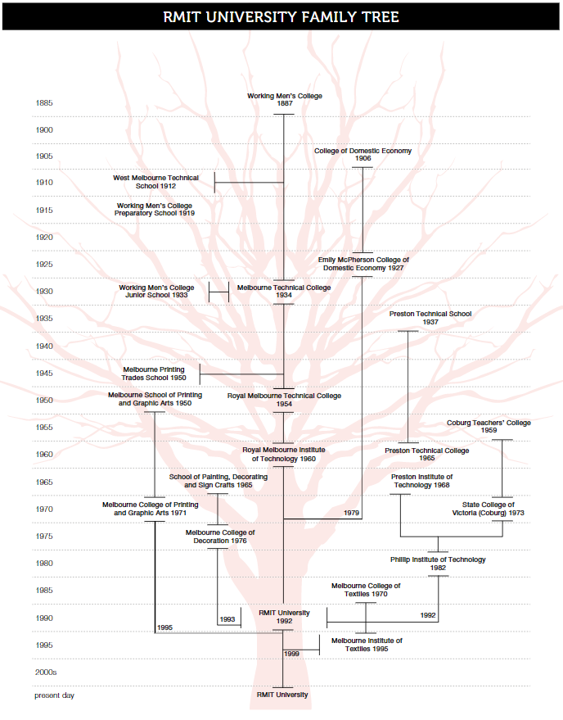

Collection Scope
RMIT Archives collects:
- Photographs and drawings that illustrate the significant contribution to education and training by RMIT University, the development of technology and images of significant Melbourne landscapes.
- Meeting papers from committees and boards established throughout the history of RMIT.
- Magazines, newsletters, journals, and other publications illustrating life at RMIT University from both a student and staff perspective.
- Staff and student administration records.
- Selections of staff and student mementos of attending the University such as study diaries, lecture notes, and items associated with campus life, especially those which we deem unique or of exceptional quality.
- Prospectus books, calendars, handbooks, and other publications that provide comprehensive information about programs and courses, teaching and administrative structures and procedures, and services provided to students. This includes those of educational institutions that have merged with RMIT University. The Archives collects a master or archival set of such publications, and copies for our Reference Library.
- Correspondence and subject files that are evidence of key decisions made throughout the history of RMIT University.

RMIT Archives do not collect:
- Records or other materials stolen or displaced from the communities and places of their creation. For example, in the case of Aboriginal or Torres Strait Islander communities, “cultural, intellectual, religious and spiritual property taken without their free, prior and informed consent or in violation of their laws, traditions and customs”
- Duplicate items already within the collection or elsewhere within RMIT unless they are of superior condition or historic value
- Items with identified conservation problems such as mould, chemical contamination, or insect infestation, which would threaten the preservation of the existing collection or the health of staff.

Acquisition Criteria
Proposed acquisitions must meet the following criteria:
- RMIT Archives will only accept items where the donor has a clear legal title to the item
- The provenance of the item must be known, and associated documentation and support material provided
- Acceptance of large items (or collections) is conditional on storage space being available as well as resources required to house them appropriately
- RMIT Archives does not usually accept donations with donor-imposed access restrictions, however there are exceptions. For example, restrictions with a specified embargo period or supported by legislation.
Proposals will be further assessed according to the following criteria:
- Items should be in good condition, suitable for research or display and not require extensive conservation work or treatment
- Items that enhance the interpretation of collection themes or align with the University’s teaching and learning objectives
- Rare or excellent representative examples of a particular kind of item.

Deaccessioning (removing items from the collection)
The Public Records Act 1973 makes provision for the deaccessioning and disposal of material from the collection, along with relevant University policy, procedures, and processes. The following items may be deaccessioned from the RMIT Archives, subject to the conditions specified below:
- The condition of the item is so poor that restoration is not practicable, would compromise its integrity, or threaten the preservation of the existing collection
- The item poses threats to the health and safety of staff and the public
- The item breaches Aboriginal, Torres Strait Islander or other community group cultural guidelines
- The item is a duplicate that has no added value as part of a series
- RMIT's possession of the item is inconsistent with applicable law or ethical principles, e.g., the item was, or may have been, stolen or illegally exported or imported, or the item may be subject to other legal claims for return or restitution
- A substantiated request for the return of the item to its original owner/donor is received
- Items in the collection may be replaced by formats to facilitate access or preservation, for example, when the original is unable to be used, preserved, or restored
- Items are transferred to a more suitable or appropriate repository eg for reasons related to better storage or preservation conditions, compliance with PROV standards and guidelines.

References
Position Statements
RMIT Archives’ collecting is guided by the principles and frameworks expressed in the following position statements:
- UNESCO Universal Declaration on Archives (2011)
- Tandaya - Adelaide Declaration (2020)
- United Nations Declaration on the Rights of Indigenous Peoples (2007)
- Indigenous Archives Collective Position Statement on the Right of Reply to Indigenous Knowledges and Information held in Archives (2021)
- Charter of Lifelong Rights in Childhood Recordkeeping in Out-Of-Home Care (accessed August 2021)
- CARE principles for Indigenous Data Governance (Global Indigenous Data Alliance, 2019)
Collection Guidelines
- Cultural Collections Asset Guideline: AFI Research Collection (accessed August 2021)
- Queens College Libraries Special Collections and Archives Collection Development Policy, March 2021

Standards Australia, AS ISO 15489.1 Australian standard on records management, pt 1, Standards Australia, Sydney, 2002, s. 3.9
Queens College Libraries Special Collections and Archives Collection Development Policy, March 2021
United Nations Declaration on the Rights of Indigenous Peoples, 2007
Cultural Collections Asset Guideline: AFI Research Collection (accessed August 2021)
Cultural Collections Asset Guideline: AFI Research Collection (accessed August 2021)

