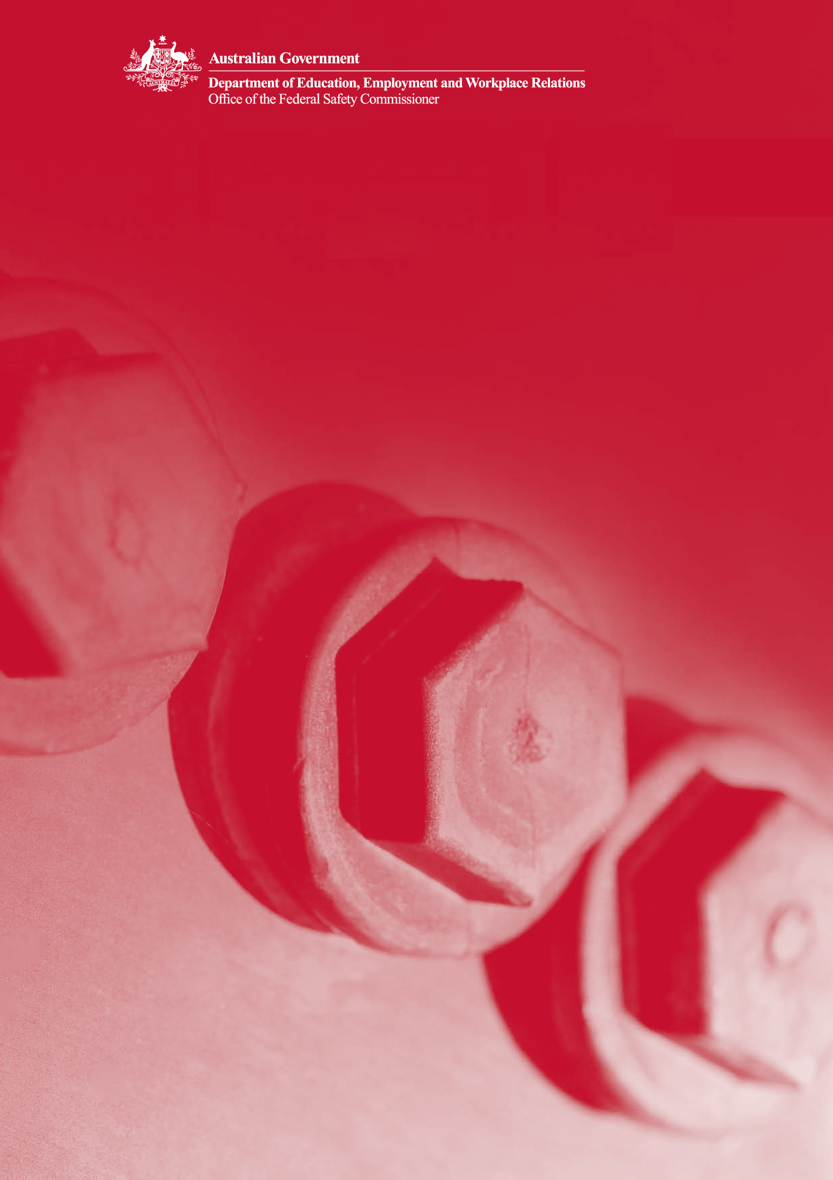

1 The Model Client Framework

The model client: Promoting safe construction
Contents
Introduction 4
Booklet one—The Model Client Framework 4
Background 5
Who is a ‘model client’? 6
Safety principles 7
Principle 1: Developing a safety culture 7
Principle 2: Leadership and commitment 7
Principle 3: Developing cooperative relationships 7
Principle 4: Promoting OHS in planning and design 8
Principle 5: Consulting and communicating OHS information to project stakeholders 8
Principle 6: Managing OHS risks and hazards 8
Principle 7: Maintaining effective OHS measures across the project lifecycle 8
Principle 8: Monitoring and evaluating OHS performance 10
The Model Client Framework 10
Agency OHS management process 11
Step 1: Corporate OHS policy 12
Step 2: Strategic OHS planning 12
Step 3: Organisation and resourcing 12
Step 4: Monitoring and benchmarking 12
Step 5: Management review 12
Project OHS Process Map 13
The project OHS process 15
Stages 15
Stage reviews 15
Phases 15
Key management actions 15
KMA A1 16
Appoint OHS team 16
How to use the Model Client Framework 18
Level 1 model client 18
Level 2 model client 18
Level 3 model client 18
Level 4 model client 18
Self-assessment tool 19
Performance reporting 19
LEVEL 1 model client 20
LEVEL 2 model client 20
LEVEL 3 model client 20
LEVEL 4 model client 21
Applying the Model Client Framework for different contracts 21
Entrenching OHS excellence and spreading the message 22
Conclusion 22
Model client self-assessment checklist 23
Level 1 23
Level 2 23
Level 3 23
Level 4 24
Further information 24

Introduction

The Australian Government aims to achieve world-class occupational health and safety (OHS) in the building and construction industry. It is committed to working cooperatively with industry to promote, build and sustain a culture of safety in all construction projects in Australia.

The latest available data shows that the incidence of workplace fatalities in Australia’s building and construction industry is nearly three times higher than the national average for all industries. Furthermore, the incidence of compensated claims for the industry is almost twice the national average for all industries. While there is evidence that industry performance is improving, it is clear that the Australian building and construction industry is still a long way short of best practice.

The Office of the Federal Safety Commissioner (OFSC) was created in 2005 to oversee the Australian Government Building and Construction OHS Accreditation Scheme (the Scheme) which is aimed at improving safety in Australia’s building and construction industry. Through this initiative, the Australian Government wants to use its influence and lead by example in improving OHS outcomes on all its construction projects. Consequently, Australian Government agencies now only contract with head contractors who are able to demonstrate a high level of commitment to OHS.

The OFSC is committed to working with Australian Government agencies in developing expertise in construction procurement, and in particular the management of OHS through the identification of processes and strategies to improve and integrate safety into construction projects.

The implementation of safety requirements throughout all the stages of the lifecycle of a project is vitally important. Success in OHS management can only be achieved through teamwork between all the project stakeholders—the client, the designer and the contractor (including subcontractors and suppliers). Therefore, it is incumbent on Australian Government agencies—as clients—to drive strong and positive safety cultures through their procurement processes. All efforts will be made to ensure that the major stakeholders work constructively to appropriately allocate responsibility for OHS and integrate safety considerations into all project decision-making processes.

While this series of booklets has been prepared specifically for the Australian Government as a client of building and construction services, the principles and materials prepared and contained in each of these booklets are equally applicable to any client of these services.

Booklet one—The Model Client Framework

The OFSC has developed a process to identify key client management actions to improve OHS performance in the Australian building and construction industry. This is known as the Model Client Framework (the framework).

This booklet—the first of five booklets—sets out the principles of the OFSC’s model client approach. Booklets two to five describe the actions that should be taken through each of the stages of a project planning, design and procurement, construction and completion—in implementing the framework.

The complete series is as follows:

- The Model Client Framework

- The planning stage

- The design and procurement stage

- The construction stage

- The completion stage

Background

Many construction incidents can be attributed to professional or management failures arising well before work commences on site, most notably in the planning and design stages of a project. Consequently, there is a growing trend in OHS legislation for OHS management responsibility to be driven up the supply chain to reside, not only with contractors, but also with clients, designers and owners of buildings and facilities.

Following collaboration between the Australian Government and construction industry bodies, the National Occupational Health and Safety (OHS) Strategy 2002–2012 (the strategy) was developed to raise OHS performance in all industries. The strategy is aimed at strengthening the role of governments to influence improved OHS outcomes across all Australian jurisdictions. It states that:

‘Governments are major employers, policy makers, regulators and purchasers of equipment and services. They have a leadership role in preventing work-related death, injury and disease in Australia.’

Stated outcomes expected of the strategy include:

- continuous improvement in governments’ OHS performance as employers

- whole-of-government approaches to ensure OHS implications are considered and accounted for in all areas of government

- where practicable, the improvement of OHS in the supply chain through the engagement and actions of governments, project managers and contractors

- practical guidance on measuring and reporting OHS outcomes for Australian Government agencies

- continuous improvement in governments’ performance as OHS policy makers and regulators.

In addition, the Australian Safety and Compensation Council’s National Standard for Construction Work establishes clear OHS responsibilities for construction clients. These responsibilities include requirements for clients to:

- consult with designers to ensure that any construction work in connection with the design can be undertaken without risk to the health and safety of any person undertaking the construction work

- consult with contractors to ensure that persons undertaking the construction work can do so without risk to health and safety, as well as to ensure that no person on or near the construction site is put at risk from the construction work

- communicate OHS risk information arising in the planning and design stages to the contractor and the eventual owner/operator of the facility.

These requirements are also consistent with the recommendations of the Cole Royal Commission into the Building and Construction Industry (2001) which investigated practices in the Australian building and construction industry, including OHS. The report described OHS as an ‘issue of fundamental importance’ and identified the need for cultural and behavioural change in the industry in regard to health and safety.

Who is a ‘model client’?

A model client is one which is openly and transparently committed to the principles of best practice in its organisational safety culture.

These safety principles are intended to operate at an industry level and establish broad values by which Australian Government agencies should operate. They also establish a foundation for the development of shared understandings among all project stakeholders on the importance of safety and the development of a safety culture in construction project teams.

Safety principles

The Federal Safety Commissioner’s best practice safety principles are:

Principle 1: Developing a safety culture

Model clients should demonstrate a tangible commitment to developing a safety culture in their own organisation and across the building and construction industry.

The model client process described in this booklet is driven by the overarching aim of creating a strong safety culture in all the stakeholders on a construction project. It demonstrates that they will all be expected to treat safety as an integral part of project management and that safety objectives stand on a similar footing to other project objectives such as quality, cost and timeliness. It also demonstrates the importance of collaboration and teamwork among all stakeholders.

A safety culture describes a shared set of organisational values, assumptions and beliefs. It is characterised by high levels of communication, confidence and trust. One threat to the development of positive safety cultures in the building and construction industry is a lack of inter- and intra-organisational understanding of the importance of safety. Consequently, senior managers should actively demonstrate their commitment to safety through participation in their organisation’s safety management processes, with the allocation of safety responsibilities throughout the project organisation from senior management down to the members of various teams.

Principle 2: Leadership and commitment

Model clients should demonstrate OHS leadership at all stages of a project lifecycle by acting as exemplars in their relationships with other industry participants. Leadership and commitment by a model client can be demonstrated by:

- incorporating OHS considerations at every level of decision-making in construction projects, from procurement to completion

- articulating an OHS policy and ensuring that contracts for the supply of goods and services clearly reflect the expectation of high standards for OHS

- actively monitoring OHS through all stages of the project lifecycle, acknowledging good OHS performance and correcting sub-standard performance.

Principle 3: Developing cooperative relationships

Model clients should strive to develop cooperative business relationships to ensure that time, cost and quality objectives do not compromise a commitment to OHS. Development of cooperative relationships by a model client can be demonstrated by:

- facilitating the establishment of an integrated project OHS management team including designers, contractors and model client representatives at the earliest stage practicable

- ensuring that managers lead by example and communicate the importance of OHS in interactions with all project stakeholders including designers, contractors and suppliers throughout all stages of the project lifecycle

- establishing long-term relationships with service providers to support the development of OHS capability in the supply chain.

Principle 4: Promoting OHS in planning and design

Model clients should ensure that safe design and constructability are considered at the planning and procurement stages to reduce or eliminate hazards and control risks before construction commences. A model client’s planning and design processes ensure that OHS issues are considered by:

- clearly specifying OHS as a criterion in the project design brief and selecting design consultants who have a demonstrated capacity to consider OHS risks

- collaborating with stakeholders to eliminate or reduce OHS risks by making decisions on the basis of careful consideration of the OHS implications of available design options

- overseeing OHS design reviews at appropriate stages during the project life—especially where changes to the design are proposed during the construction phase.

Principle 5: Consulting and communicating OHS information to project stakeholders

Model clients should ensure that effective consultation and communication arrangements are in place so that all stakeholders are aware of OHS considerations and of their responsibilities. A model client makes sure that OHS information is communicated to all project stakeholders by:

- ensuring that clients pass on information to designers and designers pass on information to contractors— and further through the supply chain to sub-contractors—about OHS risks associated with proposed materials, substances or construction methods

- ensuring that mechanisms are established to convey and record OHS risks to all stakeholders throughout the project lifecycle

- facilitating bottom-up communication of safety issues and consultative processes to enable workers to participate in making decisions that impact on OHS.

Principle 6: Managing OHS risks and hazards

Model clients should ensure that a systematic approach is taken to the management of OHS risks and hazards. A model client manages OHS risks by:

- ensuring that hazards are identified and OHS risks are systematically assessed and controlled at all stages in the project lifecycle

- ensuring that identified risks are eliminated or, where elimination is not practicable, reduced so far as possible— preferably through the implementation of technological controls

- ensuring that project decision-making that could have an impact upon OHS risk involves input from those people or groups of people that could be affected by that risk.

Principle 7: Maintaining effective OHS measures across the project lifecycle

Model clients should ensure they maintain effective OHS measures across the construction project lifecycle and are able to respond to changes in the construction environment. A model client will maintain effective OHS measures and continuously improve OHS performance by:

- requiring regular reporting of project OHS performance, using both ‘leading’ and ‘lagging’ OHS performance measures

- conducting regular, ongoing and project completion reviews

- using OHS performance data to identify problems and implement improvement strategies before the occurrence of incidents

- seeking feedback from service-providers and contractors on their own performance as a client and acting on identified weaknesses.

Principle 8: Monitoring and evaluating OHS performance

Model clients should monitor, report on and benchmark OHS at the site, project and company levels to improve and compare OHS performance. A model client will monitor and evaluate OHS performance by:

- establishing meaningful and reliable OHS Key Performance Indicators (KPIs) to measure performance against industry, organisational and project benchmarks

- providing stakeholders with accurate comparative OHS performance information

- ensuring that performance measures cover the whole project and include feedback from workers and sub-contractors.

All these safety principles are incorporated in the Model Client Framework described below.

The Model Client Framework

The Model Client Framework will assist Australian Government agencies to develop and integrate OHS into their construction projects through a clearly defined process of risk management, planning, organising and resourcing, monitoring and reviewing. It provides a step by step process which enables government agencies to develop their OHS processes and management skills to become a complete model client.

Model clients play a key coordination role in ensuring that OHS issues are managed and information is shared throughout the construction supply chain. As the drivers of projects—from concept through to completion—and as purchasers of the building and construction industry’s services, model clients are in the best position to drive the cultural change needed to bring about improvements in OHS in the building and construction industry. Model clients make key decisions concerning project budget, quality, performance criteria and time-lines, all of which are influential in creating pressures and constraints which can affect OHS during construction.

In the past, OHS management has tended to concentrate on the construction stage where the contractor was held fully responsible for OHS strategy and management. However, it is now widely recognised that better OHS outcomes can be achieved on a project where there is a collaborative approach among all stakeholders throughout all the stages of a project. The involvement of a model client in pre-construction planning, promoting a collaborative and participative safety culture in all project decision-making, and participating proactively in OHS strategy, monitoring and evaluation is important for excellent project OHS performance.

The framework operates at two levels. First, it identifies an agency OHS management process in a continuous improvement model. This process establishes the basic building blocks for the management of OHS within the government agency and provides the foundation for the implementation of the framework.

Second, the framework establishes a project-level OHS process to firmly embed OHS into the management of construction projects undertaken by the government agency. This process adopts a project lifecycle approach, establishing the activities of a model client during the planning, design and procurement, construction and completion stages of a project.

Agency OHS management process

The agency OHS management process is depicted in Figure 1. The key elements are briefly described below.

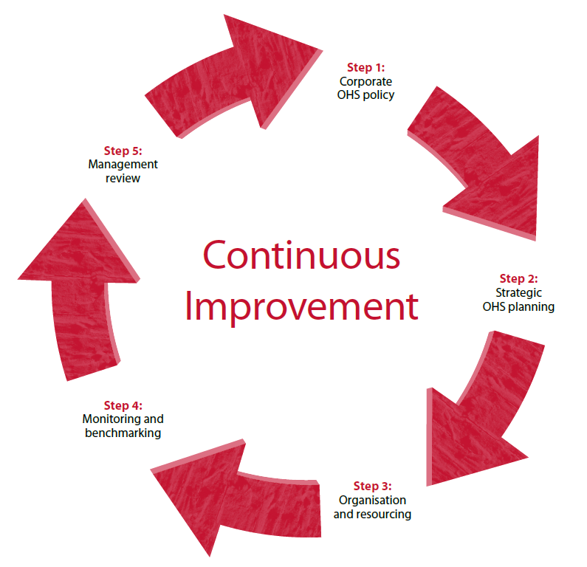

Figure 1: Agency OHS management process

Step 1: Corporate OHS policy
Each Australian Government agency should formulate a corporate OHS policy committing them to the highest levels of OHS performance. The policy should set the tone for OHS management in the agency by:

- clearly stating the agency’s commitment to achieving excellent OHS performance in its day-to-day operations as well as on its construction projects

- explicitly stating the agency’s commitment to the OHS of employees as well as contractors

- establishing clear responsibilities for OHS performance in the agency and on its projects.

Step 2: Strategic OHS planning

Agencies should plan to fulfil their corporate OHS policy by:

- planning the implementation of the framework as well as ensuring that proper OHS planning occurs in individual construction projects

- establishing ambitious but achievable OHS objectives, targets and KPIs for the agency, as well as for individual construction projects

- clearly designating responsibilities and time-frames for the attainment of OHS objectives and targets.

Step 3: Organisation and resourcing

For plans to be implemented effectively, appropriate organisational supports and resources must be provided. Agencies should provide for the implementation of OHS plans by:

- allocating suitable and sufficient resources in financial, human and physical terms, to OHS activities

- establishing arrangements for training, staff development and communication in support of the OHS effort

- integrating OHS into existing agency processes, such as purchasing, procurement and reporting.

Step 4: Monitoring and benchmarking

Agencies should establish reliable processes for the ongoing measurement of OHS performance. Measurement should provide a feedback mechanism to enable the continuous improvement of OHS performance in operations and projects by:

- developing consistent measures for OHS outcomes (injuries, illnesses and incidents) as well as the quality of the OHS management processes

- providing for the early detection, diagnosis and correction of OHS problems before they result in harm

- enabling OHS activities to be benchmarked against other agencies or between construction projects in the same agency.

Step 5: Management review

OHS activities should be regularly reviewed and agencies should strive to continuously improve their performance in this area by:

- evaluating the suitability of the corporate OHS policy and making changes as appropriate

- reviewing agency OHS objectives, targets and KPIs and evaluating the effectiveness of agency OHS management activities in achieving these
- learning lessons from previous experiences and making changes as appropriate, for example by modifying approved provider lists.

Project OHS Process Map
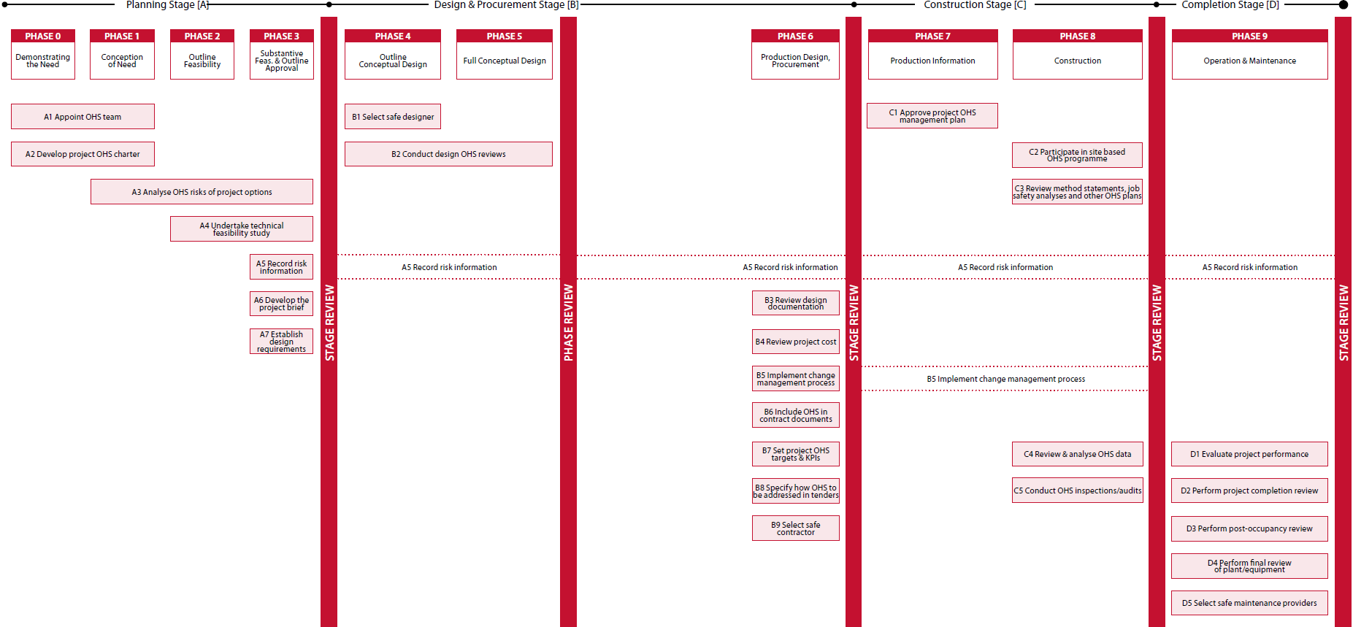

Figure 2: Project OHS process map
Adapted from A Generic Guide to the Design and Construction Process Protocol (Kagioglou et al., 1998) [www.processprotocol.com]

The project OHS process

The project OHS process is illustrated in Figure 2. The key elements are:

Stages

These are shown across the top of the page. They cover the project development stages of planning (Stage A), design and procurement (Stage B), construction (Stage C) and completion (Stage D). The design stage is separated into two sub-stages covering conceptual design, and production design and procurement.

Stage reviews

Between each stage (and sub-stage) are stage reviews denoted by the vertical bars. The purpose of these stage reviews is to ensure that all safety practices have been completed prior to moving to the next project stage. In this way, stage reviews act as ‘gateways’ in the project process. Before progressing to the next stage of the project, each stakeholder can check to see that all safety practices from the preceding stage have been completed. Stage reviews also provide an opportunity for project participants to reflect on the safety processes and outcomes of the preceding stage and to feed safety information forward for use in future stages of the project.

Phases

The phases are project development steps that occur in each stage of the project. They are shown in the boxes across the top of the page in the sequence that they occur during project development and delivery.

Key management actions

Under each project stage and development phase, there are a number of key management actions (KMAs). These are shown in the boxes with an identification number and a descriptor. They are strategically placed both horizontally and vertically to show their relationship with the phases and, on the descending scale, the order in which they are undertaken.

To become a complete model client, an agency will need to undertake all the KMAs shown in the framework and entrench them into its safety culture so that they are maintained and continuously improved. In booklets two to five, the KMAs are set out in a tabular format, an example of which is shown in Figure 3 on page 13.

KMA A1 | Appoint OHS team
Action | At the outset of a project, agencies should appoint senior team members from within the agency, who have appropriate OHS skills, and whose responsibility it will be to oversee OHS through the project lifecycle.
Phases | - Phase 0—Demonstrating the need  - Phase 1—Conception of the need
Description | A project OHS team should be formally appointed and a senior agency employee named as representing the agency throughout the project lifecycle. This person should have a keen interest in OHS and be fully committed to OHS processes and performance. Initially, the leader of the OHS team will be a senior-level representative from the agency although, as the project progresses, the position may rotate to a senior officer of one of the other major stakeholders (for example designer, construction contractor) as their contribution to the project increases.  Members of the project OHS team should have the necessary level of awareness and competence in OHS relevant to the management of the design and construction processes as well as the eventual operation of a facility.  Team composition may change during the various stages of the project. However, the agency will always have representation on the OHS team and members will be representative of a vertical slice of the project’s organisational structure, that is, from senior management through middle management to workforce and operational levels.
Key benefits | - Single point of contact  - Clear responsibilities for OHS  - Project OHS champion
Desirable  outcomes | - A client OHS champion for the project, who will provide OHS leadership and oversight throughout the life of the project.  - A client OHS team for the project that will provide OHS direction and oversight throughout the life of the project.
Performance  measure | - Appointment of appropriate people to form the OHS team  - Appointment of a senior agency representative with responsibility for OHS on the project
Documents | - A1.1 OHS team effectiveness checklist  - A1.2 Desired behaviours of OHS team members  - A1.3 Training requirements/competencies for OHS team members

Each KMA is identified by a number and a descriptor. In the case above, the number is KMA A1 and its descriptor is ‘Appoint OHS Team’. The terminology used in defining each KMA is as follows:

Action describes what has to be done

Phases indicate the development phases during which the action has to be taken

Description provides a short narrative of the rationale of the action covering aspects such as who is responsible, its importance and some suggested strategies for consideration

Key benefits provide the reasons why the action is effective

Desirable outcomes describe the behavioural and procedural changes created by the implementation of the action

Performance measure describes the outputs that can be measured and recorded as evidence that the action has been successfully implemented

Documents list the suggested documentation to assist in the effective implementation of the KMA.

How to use the Model Client Framework

Some agencies may already have effective OHS processes and behaviours in place which integrate best practice safety principles into construction projects. The Model Client Framework is not necessarily meant to replace any existing, effective safety processes and behaviours that an agency may already have. Rather, it should build on those effective processes and behaviours and provide additional guidance for strengthening Australian Government agencies’ capacity to improve OHS outcomes in the procurement and delivery of construction projects.

Not all agencies will be at the same level of OHS development in procuring and delivering construction projects. Those agencies involved in regularly procuring large construction projects will operate at more effective levels than those agencies that procure construction projects less often. The Model Client Framework enables all agencies to operate in a consistent framework and on a similar footing. It is an excellent tool which can be used by the more experienced agencies to coach and mentor less experienced colleagues in developing appropriate OHS strategies and processes, as part of a wider Australian Government agency network.

Using the framework is easy. It can be used by agencies to implement a culture of safety and guide them through four development levels—starting from a base, level 1—where there are no current model client behaviours or systems in place—through three progressive stages to a complete model client, level 4. At level 4, an agency will have a fully developed and systemic culture of safety that embraces the Federal Safety Commissioner’s safety principles and is an exemplar for OHS in Australia’s building and construction industry.

A starting point for implementing the framework would be to carry out a gap analysis to evaluate current OHS processes and behaviours, and how consistently they are applied in developing and delivering the construction projects they procure. To assist in assessing the status of an agency’s OHS development, four levels of performance of a model client have been identified. These are:

Level 1 model client
Few or no model client behaviours or initiatives; in fact not a model client at all but willing to start the journey

Level 2 model client
A basic stage of implementation of OHS processes and behaviours in the model client process

Level 3 model client
A good capability in effective OHS processes and behaviour

Level 4 model client
A robust set of processes and behaviours designed to ensure consistency and industry leadership in OHS.

Where gaps are identified, agencies should implement the KMAs identified in the framework at the appropriate development stage and implementation level. Therefore the framework can be used to progressively improve OHS processes and behaviour in a structured way—enabling an agency to progress from one level to the next as it improves. This progression continues until the agency achieves level 4 status. For those agencies that achieve Level 4 the framework also provides guidance in continuous improvement.

The Model Client Framework should be used not only to assess the current level of OHS performance in an agency but also to set the standard for model client development and OHS performance expectations. To assist in fast-tracking the implementation of the framework in Australian Government agencies, a number of ‘first step’ initiatives have been identified to enable an agency to take the first step from Level 1 to Level 2. These are shown in Figure 4. They are the KMAs that can be most readily implemented to yield an immediate impact. However, they should also be ongoing throughout the project lifecycle.

This is a new approach to OHS for construction projects. Although there is a considerable amount of work involved in planning, implementing and maintaining the framework, the results will be worth it. The benefits flowing from these new processes will positively reinforce safety behaviour and expectations, not only for Australian Government agencies but also for consultants and contractors engaged by agencies.

Self-assessment tool

To understand where an organisation is currently placed as a model client, it will be necessary to undertake a self-assessment of current practices and behaviour. This can be done using the self-assessment tool which comprises the matrix shown in Figure 4 and the key management actions provided in booklets two to five.

The self-assessment matrix clearly outlines the OHS processes required to achieve the various levels of development.

The recommended procedure is as follows:

- Start the assessment at Level 2. The KMAs listed are the most important ‘first steps’ along the way to adopting model client behaviours. By working through each of the KMAs, organisations will be able to evaluate their current level of OHS performance.

- Where it is considered that a KMA has not been implemented—or is not consistently undertaken—the agency should ensure that the KMA is implemented and entrenched in future construction projects.

- Complete the implementation of the KMAs in the groupings shown for each level, before progressing to the next category of model client.

Agencies must be vigilant that this process does not merely become an exercise of ‘ticking the boxes’. Internal audits must be carried out by those people responsible for OHS performance assessment to ensure that the KMAs are entrenched in the safety culture and systemically carried out.

To assist in determining minimum compliance levels for a KMA, performance measures are specified. These are prescriptive but their consistent application provides a common basis to measure performance across the full range of government agencies.

For self-assessment to be effective and to provide a useful tool to improve OHS performance, it is imperative that evaluations are honest and supported by evidence. Verification can be determined in a number of ways, such as examination of documents and records, by interviewing key practitioners through a vertical slice of the organisation, and through observation. If necessary, independent OHS specialists can be engaged to ensure that impartial evaluations are undertaken.

Performance reporting

Self-assessment should form part of the agency level OHS management review (step 5 in Figure 1) and be incorporated in internal management reporting by providing a ‘snap shot’ of current OHS performance. It can also be used to identify KMAs requiring further development. Planning for continuous improvement and progressively implementing new actions can then be undertaken, taking into account the organisation’s ability to resource those actions.

A program of regular self-assessment and reporting provides a method to measure the efficiency of an agency’s OHS processes and confirms that behaviours have been entrenched so as to achieve the goal of being a model client.

LEVEL 1 model client
Few/no model client behaviours or initiatives

Commence | Has a lack of OHS processes in place. Few or no model  client behaviours or initiatives being implemented
Continue

LEVEL 2 model client
‘First Step’ initiatives established. A basic implementation of OHS systems

Commence | A3 Analyse OHS risks of project options  A5 Record risk information  A6 Develop the project brief  B2 Conduct design OHS reviews  B6 Include OHS in contract documents  B7 Set project OHS targets and KPIs  C2 Participate in site-based OHS programme  C4 Review and analyse OHS data  C5 Conduct OHS inspections/audits  D1 Evaluate project performance
Continue

LEVEL 3 model client
A capable set of processes effective in imposing OHS requirements

Commence | A1 Appoint OHS team  A2 Develop project OHS charter  A4 Undertake a technical feasibility study  A7 Establish design requirements  B1 Select safe designer  B9 Select safe contractor  C1 Approve project OHS management plan  C3 Review method statements, JSAs and other OHS plans
Continue | A3 Analyse OHS risks of project options  A5 Record risk information  A6 Develop the project brief  B2 Conduct design OHS reviews  B6 Include OHS in contract documents  B7 Set project OHS targets and KPIs  C2 Participate in site-based OHS programme  C4 Review and analyse OHS data  C5 Conduct OHS inspections/audits  D1 Evaluate project performance

LEVEL 4 model client
A robust set of systems designed to ensure consistency and industry leadership in health and safety

Commence | B3 Review design documentation  B4 Review project cost  B5 Implement change management process  B8 Specify how OHS is to be addressed in tenders  D2 Perform project completion review  D3 Perform post-occupancy review  D4 Perform final review of plant/equipment  D5 Select safe maintenance providers
Continue | A3 Analyse OHS risks of project options  A5 Record risk information  A6 Develop the project brief  B2 Conduct design OHS reviews  B6 Include OHS in contract documents  B7 Set project OHS targets and KPIs  C2 Participate in site-based OHS programme  C4 Review and analyse OHS data  C5 Conduct OHS inspections/audits  D1 Evaluate project performance  A1 Appoint OHS team  A2 Develop project OHS charter  A4 Undertake a technical feasibility study  A7 Establish design requirements  B1 Select safe designer  B9 Select safe contractor  C1 Approve project OHS management plan  C3 Review method statements, JSAs and other OHS plans

Applying the Model Client Framework for different contracts

The framework can be used for all contract delivery models. Figure 1 illustrates the discrete stages for a traditional contract model where the client undertakes the planning, the designer carries out design, and the contractor builds the project.

The model can be readily adapted for other contract delivery models, as the stages of the project lifecycle are the same regardless of contractual arrangements. However, responsibilities and processes will merge for other delivery models.

For a design and construct model, the client undertakes the planning, and the contractor carries out both the design and construction. In this case, the KMAs for the construction and completion stages will still apply and, indeed, should be more streamlined in their implementation because there is a single entity for design and construction.

This should also be the case for a collaborative contract, such as an alliance, where the client, designer and contractor are responsible collectively for all project development stages. In fact, this model should provide full integration because all the key stakeholders are involved as equal partners from beginning to end of the project.

Entrenching OHS excellence and spreading the message

Australian Government model clients should ensure that best practice in OHS is transferred between other government agencies and widely disseminated in the building and construction industry at large. Therefore it is important to capture knowledge from construction project experience so that lessons learned can be used for the benefit of future projects.

Data collected during the phase and stage reviews and other OHS performance data relating to Australian government agency projects should be recorded in a project-specific register. Following analysis of this data, those actions that have been identified as having positive impact on project OHS performance can be disseminated for the benefit of other agencies and the community.

Similarly, a system for the dissemination of hazard information could be implemented to ensure that hazards arising in government projects are brought to the attention of project management teams and OHS personnel across all agencies.

Conclusion

This booklet has provided an overview of the approach and sets out the principles to the Model Client Framework.

The actions of a model client during each of the stages within a construction project are described in detail in booklets two to five and cover each stage of the project: planning (booklet two), design and procurement (booklet three), construction (booklet four) and completion (booklet five).

By following all the initiatives contained in the five model client booklets, Australian Government agencies can show strong OHS leadership and promote the development of a culture of OHS in the procurement and management of construction projects.

Model client self-assessment checklist

Level 1
Minimal OHS processes in place
Few or no model client behaviours or initiatives

Level 2
A3 Analyse OHS risks of project options
A5 Record risk information
A6 Develop the project brief
B2 Conduct design OHS reviews
B6 Include OHS in contract documents
B7 Set project OHS targets and KPIs
C2 Participate in site-based OHS programme
C4 Review and analyse OHS data
C5 Conduct OHS inspections/audits
D1 Evaluate project performance

Level 3
A1 Appoint OHS team
A2 Develop project OHS Charter
A4 Undertake a technical feasibility study
A7 Establish design requirements
B1 Select safe designer
B9 Select safe contractor
C1 Approve project OHS management plan
C3 Review method statements, JSAs and other plans

Level 4
B3 Review design documentation
B4 Review project cost
B5 Implement change management process
B8 Specify how OHS is to be addressed in tenders
D2 Perform project completion review
D3 Perform post-occupancy review
D4 Perform final review of plant/equipment
D5 Select safe maintenance providers

Further information
This booklet is the first in a series about clients promoting safe construction. Further information about the Model Client Framework is available from the Office of the Federal Safety Commissioner.
FSC Assist Line: 1800 652 500
Internet: www.fsc.gov.au
Email: ofsc@jobs.gov.au

ISBN (set) 978-0-642-32687-4 (print)
978-0-642-32693-5 (online)
ISBN 978-0-642-32627-0 (print)
978-0-642-32633-1 (online)

© Commonwealth of Australia 2008

This work is copyright. You may download, display, print and reproduce this material in unaltered form only (retaining this notice) for your personal, non-commercial use or use in your organisation. Apart from any use as permitted under the Copyright Act 1968, all other rights are reserved.

The Australian Government, its employees, officers and agents do not accept any liability of the results of any action taken in reliance upon, based on or in connection with this document. To the extent legally possible, the Australian Government, its employees, officers and agents, disclaim all liability arising by reason of any breach of any duty in tort (including negligence and negligent misstatement) or as a result of any errors and omissions contained in this document.

Acknowledgements
The authors would like to acknowledge that the project process map is based upon A Generic Guide to the Design and Construction Process Protocol developed by Kagioglou et al. (1998), The University of Salford, UK. Boxed and shaded descriptions of project phases are quoted directly from this Protocol. The Office of the Federal Safety Commissioner would like to thank Dr Helen Lingard, Dr Nick Blismas, Ms Tracy Cooke and Mr David Jellie from the School of Property, Construction and Project Management, RMIT University, who contributed to the development of this resource.

