General Details
Person undertaking work |  |  |  |  |  |  |  | Company Name
SWMS Prepared by |  |  |  |  |  |  |  | Date
Description of Work
Location of Work | Building |  |  | Level |  |  | Room |  |  |  |  |  |  |  | Date
Is a Permit required? | Yes |  | No |  | Licence Required? |  |  |  | Yes |  |  | No |  | List:
If yes, please select permit  (more than one can be selected) | Hot Work |  | Confined Space |  |  | Working at Height |  |  |  |  | Excavation |  |  |  |  | Isolation |  | Other (specify)
Instructions
- Discuss with relevant employees, contractors and HSRs what work will be high-risk, the tasks, and associated hazards, risks and controls.
- In the ‘Tasks’ column, list the work tasks in sequence to how they will be carried out.
- In the ‘Hazards’ column, list the hazards and risks for each work task.
- In the ‘Risks control Measures’ column, select the hazard or risk and then work through the control levels (below) 1 – 4 from top to bottom. Choose a control measure (and how it is to be used) that is as close to level 1 as is reasonably practicable.
- Brief each team member on this SWMS before commencing work. Ensure team knows that work is to immediately stop if the SWMS is not being followed.
- Observe work being carried out. If controls are not adequate, stop the work, review the SWMS, adjust as required and re-brief the team.
- Retain this SWMS for the duration of the work.

Pre- Task Safety Checks

Controlling the Hazards
What you should do when assessing the hazards: | Hierarchy of Control
- Provide description of the hazards for each task in the activity or process you plan to undertake.
- Determine the risk score (i.e. the risk without any controls in place) by referencing the Risk Score Matrix (page 3).
- Specify the risk control type and control description for each hazard.
- Determine the residual risk score by again referencing the Risk Score Matrix.
- Refer to the Hierarchy of Controls to decrease the level of risk as follows:
- Eliminate any risk to health or safety associated with the work.
- Substitute with a new activity, procedure, plant, process, chemical or substance
- Isolate persons from the hazard, such as barricading, fencing or guard railing, or use engineering controls, such as mechanical or electrical devices.
- Use Administrative controls – such as changing the way the work is done.
- Provide appropriate personal protective equipment.

- Select the most effective controls in preference to least effective ones, as much as practicable.
- One control or a combination of control measures may be required to effectively reduce the risk.
- PPE must only be used in addition to controls 1 – 4 (i.e. Hierarchy of Controls)

Risk Score Matrix
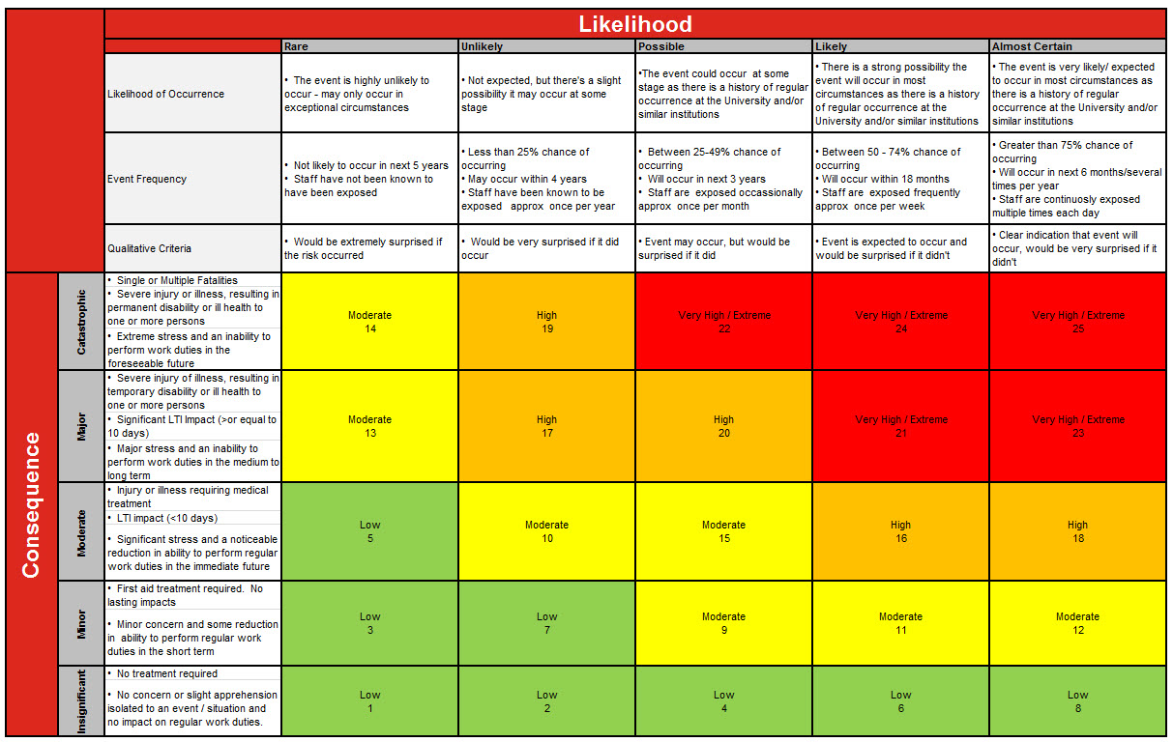

Please Note: 1. ALL risks must be reduced to as low as reasonably practicable. 2. If the residual risk is High or Very High /Extreme, the activity is not to proceed until higher level controls are in place 3. Residual Risks that are Moderate must be signed off by the responsible/accountable Manager
Assessment
Tasks  List the tasks required to perform the activity in the sequence they are carried out. | Hazards  List the hazards that could cause injury when the task is performed. | Consequence | Likelihood | Risk Score | Risk Control Measures  List the control measures required to eliminate or minimize the risk of injury arising. | Consequence | Likelihood | Risk Score | Responsibility  Name of the person responsible to implement the control measure identified.

Personal Protective Equipment (PPE) Required
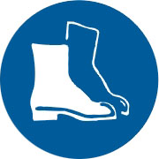 |  | 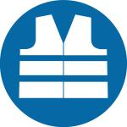 |  | 
 |  |  |  | 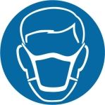
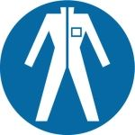 |  | 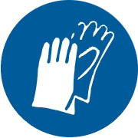 |  | Other:

Personnel Inducted (Signatures of employees trained in the work covered by this SWMS)
PRINT NAME | SIGNED | LICENCE NUMBER | EMPLOYER (Name of Company) | DATE

Training Required (Please list & Confirm personnel inducted have completed required training)

Authorising Manager
PRINT NAME | SIGNED | EMPLOYER (Name of Company) | DATE

