VC Indigenous Pre-Doctoral Research Fellowship Applicant Guide

Bundjil Statement
RMIT recognises and acknowledges the laws of Bundjil, the Kulin Nation’s ancestral creator, who travels as an eagle hawk. These laws help all RMIT staff to respectfully work, live and study on Aboriginal country.

Introduction
This guide sets out the application process and timelines for the RMIT Vice-Chancellor's Indigenous Pre-Doctoral Research Fellowship scheme for 2022.
The Indigenous Pre-Doctoral Research Fellowship scheme aims to further build and develop Indigenous knowledges and perspectives and Indigenous academic capability at RMIT and forms part of RMIT’s commitment to providing Indigenous researchers early career opportunities through the ‘Grow Our Own’ career pathway strategy. It is embedded in RMIT’s Enterprise Agreement and Aboriginal & Torres Strait Islander Employment Plan 2021-22.

Application process and timelines
There are four stages to the recruitment process for the Fellowship.
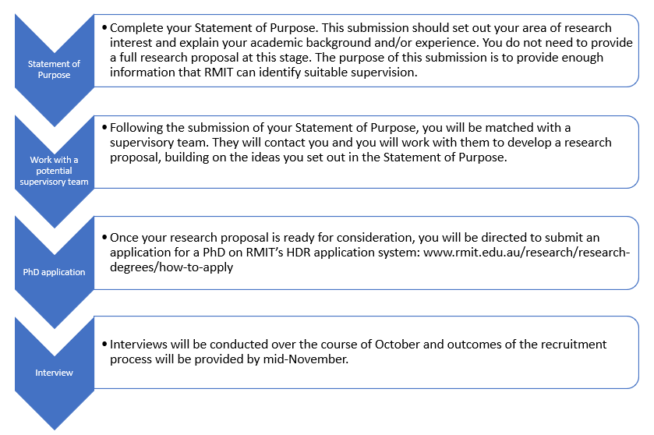
The deadlines for each stage are set out below:
Statement of Intent | Open until places filled
Working with proposed supervisory team | From August until places are filled
Lodge PhD application | As soon as research proposal is ready
Interviews | October until places filled
Outcomes communicated to applicants | Mid November onwards
PhD/employment commences | February/March 2023 (with the possibility of later commencement if necessary)

Unsuccessful applicants may be offered an RMIT Indigenous HDR Scholarship.

Frequently Asked Questions

Do Fellows have to be enrolled and employed full-time during the Fellowship?
The Fellowships are full time roles, however flexible work options, including part-time arrangements are available for the successful applicant.

Do Fellows have any other responsibilities other than completing their PhD?
Typically, pre-doctoral fellows may be asked to conduct teaching tasks such as tutoring, demonstrating or lecturing (if skilled to do so). This activity is capped at 10% of workload allocation. Each College has their own approach to workload allocation so activities and workload allocations may vary.

What is the structure of an RMIT PhD program?
The RMIT PhD program is made up of enabling coursework and three milestone reviews. The milestone reviews are an opportunity for you to present your research to other discipline experts who will provide feedback and advice. Broadly speaking the structure of an RMIT PhD degree looks like this:
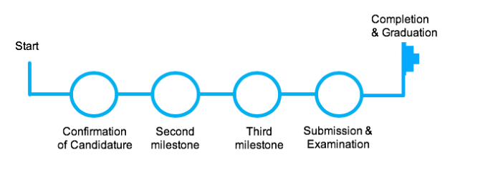
Coursework is required at the commencement of your program and depending on your enrolling School, may also be required later in the program. You can read all about RMIT’s HDR curriculum here.

Am I expected to write a research proposal as part of my application?
RMIT requires a research proposal as part of the PhD application. You will be matched with some RMIT academics who will be able to assist in the preparation of this document and, who, if you are successful, will form part of your supervisory team.

What support is available to me once I enrol and start my employment?
In addition to joining the academic community in your School, you will also have access to support from the wider VC Indigenous Pre-doctoral Fellows network, other early career networks across the University relevant to your research discipline. RMIT’s early career advisors will ensure you are connected with the relevant networks and provide introductions to key people.
Ngarara Willim Centre provides a community space and 'home away from home' for the Aboriginal and Torres Strait Islander people who study and work at RMIT. The Centre is contributing to the next generation of Indigenous leaders, who are proud of their cultural heritage and strong in their identity; and is a cultural gathering place for Indigenous peoples of the University.

Can I be considered for other HDR scholarships if I am unsuccessful in my application for a pre-doctoral fellowship?
Yes, all applicants will be considered for an RMIT Indigenous HDR Scholarship (RIHS). These scholarships can be used to support a PhD or Masters by Research. The RIHS provides the following benefits to recipients:
- a stipend of $44,737 per annum pro rata (full-time study) which represents a generous RMIT top-up of approximately $15,000 above the RTP (Research Training Program) rate
- All candidates are provided with an RTP Fee Offset scholarship. Applicants in receipt of an RTP Fee Offset scholarship are not required to pay tuition fees for the maximum duration of their candidature
- a relocation allowance for the cost of relocating in order to take up their postgraduate research program, up to $515 per adult and $255 per child to a maximum of $1,540
- paid sick, maternity and parenting leave (within the limits of the Scholarship Terms and Conditions).
The duration of a RMIT Indigenous HDR Scholarship depends on the degree undertaken. The duration of support for a PhD is three and a half years full-time. The duration of a Masters by Research is two years full-time. These allowances will be reduced by any periods of study undertaken towards an equivalent research degree prior to the commencement of the program at RMIT University.

Do I have to be based in Melbourne to be considered for this position?
RMIT’s purpose is to provide life-changing experiences for our students, and to shape the world with research, innovation, teaching and industry engagement. Central to this purpose is connection; connection to our students, our community and our teams. We want to provide a vibrant campus experience for our staff and students, as well as provide flexibility and options for how, when and where we study and work. Every staff member is expected to have a regular presence on campus – whether it’s to teach, research, connect or collaborate, innovate and celebrate as a team. This will be dependent on the requirements of your role and should be discussed with your manager.

I have some more questions. How do I contact the University?
Feel free to contact us on VCIPFS@rmit.edu.au.

Acknowledgment of Country
RMIT University acknowledges the people of the Woi Wurrung and Boon Wurrung language groups of the eastern Kulin Nation on whose unceded lands we conduct the business of the University. RMIT University respectfully acknowledges their Ancestors and Elders, past and present. RMIT also acknowledges the Traditional Custodians and their Ancestors of the lands and waters across Australia where we conduct our business.

