Collections Unit Responsible Practice Projects
2024 End of Year Report

2024 Project Summary – Amanda Martimbianco (Project Lead) 2
Events and Spaces – Steve Thomas (Team Lead) 3
Team 3
Scope 3
Achievements and implementations 3
2025 recommendations 4
Collections – Jennifer Hurley (Team Lead) 5
Team 5
Scope 5
Achievements and implementations 5
2025 recommendations 6
Primo/LibrarySearch - David Witteveen (Team Lead) 6
Team 6
Scope 6
Achievements and implementations 7
2025 recommendations 8
RMIT Library achievements and implementations 8
Project Modern – Library representation (Keely Chapman) 8
Teaching Support Team 8
Digital Learning Team 9
Discovery Systems Team 9
Archives 9
Web Services Team 9
Acquisitions & Access Team 9
Study Support Team 9
Information Services Team with Information Literacy Team 10

2024 Project Summary – Amanda Martimbianco (Project Lead)
- Reflection and Review
This summary aims to provide a summarisation of the project approach goals for 2024 and how they were achieved. Goals are identified by the following symbol ü.

- Consultation Feedback and Endorsement.
- Principles document approval.

Consultation and feedback of the Responsible Principles document occurred for approximately 4 months of 2024. The document was updated and then sent to a copyeditor in July. The final document was presented at a dedicated Townhall event on 19 September 2024. All attendees were talked through the document and were required to think about what the document means to their work. This goal was completed the consultation, endorsement, approval and implementation of the Responsible Practice Principles for RMIT Library document and Responsible Practice webpage.

- Identification of short and long-term projects (Collections specific).
Running parallel to the Principles document finalisation and approval was a Collections Unit brainstorming meeting on 28 February. The meeting was held to identify short and long-term projects. The identified 18 projects were ranked by impact and timeframe. This resulted in seeking Expressions of Interest (EOI) for 3 project teams, each with an individual focus. More information about the 3 projects teams, their achievements, and implementations, can be found later in this report.

- Iterative and agile.
An EOI for project team participation in April resulted in 3 project leads and 16 participants spread across three teams. EOI applications, from all units and teams of the Library, showed keen interest and highlighted expertise and knowledge already held by staff. It was clear all team members wanted to be part of achieving our 6 guiding principles to create physical and virtual environments where Aboriginal and Torres Strait Islander voices, ideas and concerns can be safely expressed, heard and amplified.
The project began with two main meetings:
- 24 April - Project Leads first met to discuss project outlines, ways of working and meeting schedules
- 1 May - Meeting regarding consultation process with Executive Director, Library Services, the Library Business Partners (BPs) and all project team members
Meetings for project leaders continued monthly until 27 November 2024. The individual teams worked around their BAU schedules to achieve their project team outcomes.

- Iterative and agile.
At the 5 September Senior Leadership Team (SLT) meeting a feedback mechanism for Responsible Practice was discussed. This resulted in a feedback form being publicly available on our Library Responsible Practice webpage with the Ask the Library (ATL) Service triaging any form submissions. The form collects feedback on spaces, services, collections and the Responsible Practice Principles document allowing information to be captured in a traceable format.

In 2024 RMIT Library worked on and achieved great things related to Responsible Practice. The rest of this report shares the Collections Unit project work and ends with submissions from Library staff on what they and their teams have worked on, showing an entire Library approach to Responsible Practice in 2024.

Events and Spaces – Steve Thomas (Team Lead)

Team
Steve Thomas (Lead), Charles Barnett, Ro Hueston, Miranda Fracis, Peter Gravestock

Scope
- Defining events needing Welcome to Country or other ceremonies
- Native plants in spaces, including information plant description and significance
- Events that could be hosted with Ngarara Willim
- Connect with Library staff who run existing events
- Acknowledgement of Country on display at Library entrances, increasing visibility

Achievements and implementations
Defining events needing Welcome to Country or other ceremonies.
Regarding processes to organise a Welcome to Country we have been advised by Tara Corcoran (Communications BP) "The general process for organising a Welcome to Country is to make a request with the Wurundjeri Council”- https://www.wurundjeri.com.au/request-council-traditional-ceremony [Anyone at RMIT can complete and submit the form to request a Welcome to Country. There is a pricing chart at the bottom of the page.]
Native plants in spaces, including information plant description and significance.
Studies show numerous psychological and physiological benefits of plants such as helping to reduce stress, anxiety, and depression, while enhancing mood, pain tolerance, productivity, and cognitive and perceptual abilities (Aydogan & Cerone, 2011; Gubb et. Al., 2020).
Incorporating indoor plants in the library is also a quick, effective and relatively low-cost way to aesthetically improve the space, making it welcoming and comfortable.
The advice we received from several nurseries was that it would prove difficult to successfully grow and maintain local Australian native plants within the library spaces. Following this advice we widened our selection options to any Australian native plant that was robust, attractive and naturally suited to the lower light conditions of the library.

Events that could be hosted with Ngarara Willim.
The consideration of ‘hosting’ events needs to be a part of the ongoing relationship with Ngarara Willim. Nicole Shanahan (Manager, Ngarara Willim) is keen to set up a Library and Ngarara Willim Centre quarterly meeting so that we can all come together at the one time to discuss future planning.
Agency is important here. We do not run events for Ngarara Willim. We need to offer spaces and support.

Connect with Library staff who run existing events.
We recommend keeping a central record with details of upcoming events. It might look something like this spreadsheet: Indigenous Events
Ideally this document would be accessible to all Library staff so perhaps best housed in: Teams>GRP-LIB-Library Staff (RP channel).

Acknowledgement of Country on display at Library entrances, increasing visibility.
The location of Acknowledgement of Country displays at all Library sites is inadequate. They are displayed in areas that are concealed, or which have poor visibility.

2025 recommendations
Defining events needing Welcome to Country or other ceremonies.
When/if the library is ever to open a new space or hold a significant event, we should consider a “Welcome to Country” and in those considerations the process is as per stated above (see “Achievements & Implementations”).
If advice is required on whether a Welcome to Country is needed, or whether an Acknowledgement is suitable, the RMIT Events team can advise (see https://www.indigenous.unsw.edu.au/strategy/culture-and-country/acknowledgement-country-and-welcome-country).
Native plants in spaces, including information plant description and significance.
Ambius (Indoor Plants Melbourne) have quoted for installation and on-going maintenance of a “native garden” located at Swanston building 12 levels 5 & 6 outdoor balconies. They can also provide information of plants origin etc. Install January/February 2025.
Due to native indoor plants sourcing issues, we recommend sourcing native flowers from Indigenous suppliers (TBA) and promoting this via Viva Engage each month as an alternative.
Longer term: a statement plant, with unique or striking form and foliage, could be considered as a focal point near the Acknowledgement of Country.
Events that could be hosted with Ngarara Willim.
Recommend an audit of spaces for events and exhibitions which we can share with Ngarara Willim to consider.
Longer term: consider a specific, dedicated space for events and exhibitions.

Connect with Library staff who run existing events.
As Responsible Practice is across the whole library and not just Spaces we recommend that an Indigenous Events document is located in the Teams>GRP-LIB-Library Staff (RP channel), so all library staff have access.

Acknowledgement of Country on display at Library entrances, increasing visibility.
Recommend to re-locate Acknowledgement of Country signage to more prominent locations. Ideally, as close to entry points as possible. This could be coupled with a scheduled or permanent display on Library screens.
Concept: Display the AIATSIS map alongside an interactive piece enabling visitors to indicate which Aboriginal and Torres Strait Islander lands they live and work on.
Community or cultural space exploration: A concept that came from strategic space planning and would require a collaborative approach.
Recommend: Engaging Indigenous artists to design soundscapes or AV installations for entrances to the library.
Consider changing the library sites names from site to an Indigenous name. Refer to https://blogs.deakin.edu.au/article/renaming-library-spaces-in-local-language/ (supports APPENDIX item ‘Library as Place Strategic planning statement’).

APPENDIX
Native Plants Info
Library as Place Strategic Planning statement

Collections – Jennifer Hurley (Team Lead)

Team
Jennifer Hurley (Lead), Pauline King, Rebecca Rata, Mare Maticevski, Ryan McLean, Epi Dowling, Katie Finch

Scope
- Scope/investigate and start to piece together procedures for harmful content, identifying content and cataloguing items
- House the Principles of Aboriginal and Torres Strait Islander Perspective in Learning & Teaching
- Liaise with Primo project team on content searches

Achievements and implementations
- Investigated and developed draft procedures and a draft workflow for cataloguing new content according to responsible practice principles. The documents developed to support the procedures are:
- Draft Responsible Practice Cataloguing Procedures
- Draft Workflow: Responsible Practice Cataloguing Procedures

- Housing the Principles of Aboriginal and Torres Strait Islander Perspectives in Learning & Teaching Collection
The rationale for including Indigenous Perspectives in the Curriculum at RMIT University is found within RMIT’s Education Plan to 2025, for example, Action Area 2>Curriculum – what we teach>2.1 RMIT Capabilities> 1. Employ globally inclusive perspectives and a commitment to diversity, inclusion, and respect. In response, the Principles of Aboriginal and Torres Strait Islander Perspectives in Learning & Teaching Collection was established to house guides for RMIT teams to include Indigenous Perspectives in the curriculum. Each resource identifies a set of guiding principles, presented as a helix, and informed through domains of action.

Authors and requestors looking to contribute guides to the collection complete a form for ‘Indigenous Perspectives in Curriculum’. The essential fields on the form have been developed in consultation with the Office of Indigenous Education, Research and Engagement. Upon completion and ingestion documents display in the Library Digitised Collections making the documents available to users via the library catalogue.

The documents developed to support this collection are:
  - Background
  - Draft Workflow
  - Metadata form for submission of requests to add content to the Collection

The Library Digitised Collection of Indigenous Perspectives in Curriculum is accessible via LibrarySearch.

- The Collections Project Team met with the Primo Project Team twice during the project, to identify each team’s role and align our respective activities; and garnered feedback from the Primo Project Team on the draft procedures to ensure their viability.

2025 recommendations
This document identifies activities that would further enhance the Library’s cataloguing procedures in relation to responsible practice: 2025 Recommendations_Responsible Practice Cataloguing Procedures.docx

Primo/LibrarySearch - David Witteveen (Team Lead)

Team
David Witteveen (lead), Bryony Marshall-Radcliffe, Hannah Nuridin. Heather Evans, Michelle Matheson, Pinipa NK.

Scope
The Library Search Responsible Practice team’s goal was to add three features to RMIT’s Library Search service:
- Add an Acknowledgement of Country to Primo
- Display Content Advice icons and message on culturally-sensitive records in Primo
- Create a search filter for Aboriginal and Torres Strait Islander material in Primo, to assist in identifying such material to include in Curriculum Architecture

This image shows how the proposed changes will look:

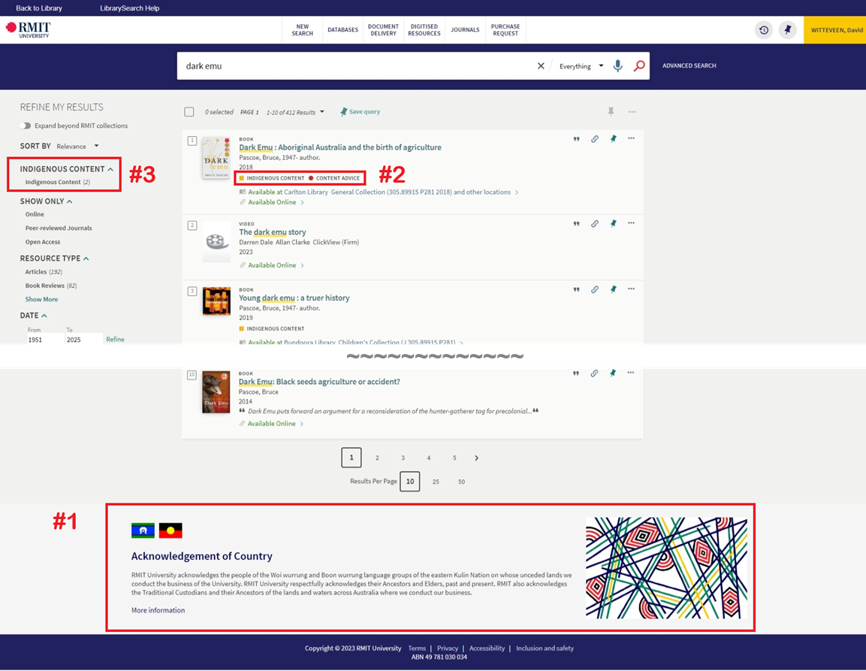

Achievements and implementations
As of 26 November 2024, the project team has:
- Complied examples of how other institutions handle Responsible Practice in their discovery layers
- Determined work required
- Discussed appropriate terminology to use
- Met with the Collections team to clarify what each team was doing and how each team’s work impacted the other
- Briefed the Discovery & Library System team on the changes needed in Primo

The Discovery & Library Systems team then worked on the technical side of implementing the Responsible Practice features in Primo. Most of this work was based on work done by Bond University, who have shared their Primo configuration files via GitHub.

Implementing the changes in Primo has proven to be a complex task that has taken several months. At the time of writing, the project is not yet complete. The changes have been made in Primo Sandbox (testing environment) but we still need to:
- Tweak the new features in Primo Sandbox
- Send them out for feedback to Primo stakeholders
- Deploy changes to Primo Production

We expect this work to be complete by December 2024.

Note that the Cultural Sensitivity icons depend on specific metadata being added to the records for items in our collection. That work is outside the scope of the 2024 Responsible Practice project, and so the icons are unlikely to be displayed until sometime in 2025.

2025 recommendations
- Consider displaying the Content Advice icon for other types of sensitive potentially offensive material
- The customisations required to display these features may need to be rewritten when RMIT moves to the Primo Next Discovery Experience, as it uses a different JavaScript framework

RMIT Library achievements and implementations
Along with the Collections Unit achievements and implementations, the following was completed by staff across the RMIT Library in 2024 and align to our Responsible Practice Principles.

Project Modern – Library representation (Keely Chapman)
- The new Figshare based Research Repository will include the ability for authors to select and display on their publication records:
  - AIATSIS Subject Headings
  - A sensitivity or cultural advisory statement using a free-text field
  - A sensitivity or cultural advisory statement using a pre-set statement via a pull-down menu
- Library staff ensured that Elements went live in April of this year, with the above options available.

Teaching Support Team
- Conscious decision to ensure that our service conveyed that we provided support with course resource material. This has been addressed on the Teach webpage in the section 'Do you need teaching support?' indicating curation of learning material with Indigenous perspective and links to relevant library guides.
- Built into our request form the curation of resources with an Indigenous perspective, with reference in the preamble and then seen once 'course resource support' is chosen there is an Indigenous perspectives option to select.

Digital Learning Team
- Addition to Easy Cite with a section titled “Indigenous knowledges” to each style guide which Information Literacy team is adding content to at present
- Starting the development of procedures and processes for the following:
  - Procedures for culturally sensitive materials in legacy learning resources
  - Building more representation in the Learning Lab and other resources i.e. through examples in images, infographics and writing topics where consent is granted
  - Building features into the Learning Objects Repository project including access/restriction, notifications and alerts.
  - Discussing how we encourage stakeholders to allow learning resources related to Indigenous knowledges and culture to be “collected” and reused in the repository
- Started an investigation into a Learning Lab section for Indigenous knowledges and locating appropriate subject matter experts.

Discovery Systems Team
- Addition of the AAITSIS language codes into Alma (Sun Young Baik)
- Attended the 2024 Kummargii Yulendji Symposium (Sun Young and Katie Finch)

Archives
- Work on Ethical Guidelines for Researchers, including accessing Indigenous records. The draft guidelines will be completed in November 2024 (with Mare Maticevski – Learning Team)

Web Services Team
- Worked on the Responsible Practice webpage including the embedded feedback form
- Responsible Practice page on the Intranet to collate the guidelines along with reports and the recent Town hall recording (Myly Nguyen)

Acquisitions & Access Team
- Monographs & Digital Collections ordered 30 new Indigenous children's picture books in March to support the School of Education students for their placements
- Subscriptions Team introduced Acknowledgement of Country at team meetings
- Senior Coordinator, Subscriptions and Manager, Acquisitions & Access worked on a targeted recruitment support document for all people leaders
- Two staff attended the 2024 Kummargii Yulendji Symposium

Study Support Team
- Participated in in Gama Dji orientation sessions for Higher Education and Vocational Education
- Contributed to the Indigenous Student Success strategy

Information Services Team with Information Literacy Team
- Participated in in Gama Dji orientation sessions for Higher Education and Vocational Education
- Attended the 2024 Kummargii Yulendji Symposium (Mare Maticevski)
- RMIT representative on the CAVAL CRIG group planned third workshop on the Indigenous Referencing Guidelines that was held at RMIT University (Mare Maticevski). Attendees Vivan Luker, Meagan Wyke and Bryony Marshall-Radcliffe.
- Participation in the CACIK working party responsible for the work on the Indigenous Referencing Guidelines and the consultation with the Indigenous Archives Collective (Mare Maticevski)
- Updated the Aboriginal and Torres Strait Islander Resources LibGuide to include the IKAT toolkit with two H5P activities focused on the IKAT Decision Tree and critical evaluation of resources
- Planning and Delivery of workshop for a new Foundation course titled Locating Knowledges that focused on the IKAT Decision Tree as part of the core course teaching
- Presentation to the Indigenous Stem Committee (with Pauline King) on the IKAT Toolkit (Mare Maticevski)
- Working on the integration of the Indigenous Referencing Guidelines into EasyCite (with the Digital Learning Team)
- Indigenous events planning committee lead by Information Services team members working across the library teams including Reconciliation week, NAIDOC week and the Great Book Swap. Connected with Events and Spaces to collaborate and cross-promote.

