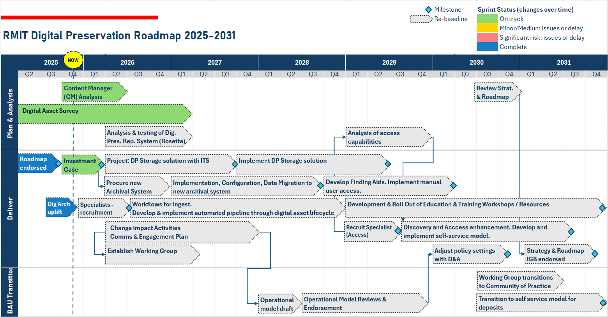
 | 2026 - 2028 | 2029 - 2031
Staff  Workflows | 1 x Lead Digital Archivist (uplift)  1 x Specialist (Ingest)  1 x Specialist (Repository) | 1 x Specialist (Access)
Staff  Workflows | Improve access to metadata.  Manual access to content. | Automated pipeline through digital asset lifecycle.  Self-service model for user access to metadata and content.
Systems | Procure Archival Management System.  Analyse/Upgrade functionality of current Digital Preservation Repository system. | Implementation of fully functioning Digital Preservation Repository System Service.
Storage & Backup | 1 x on-premises copy  1 x cloud copy (400TB) and 1 x tape copy | 1 x on-premises copy  1 x cloud copy (800TB) and 1 x tape copy
Service Description: Development and implementation of a digital archiving service including storage and systems by 2031 that meets Australian standards and laws, activates digital records now, preserves RMITs significant legacy and history, and builds on RMITs reputation. The service is maintained by the Digital Archivist (uplifted with additional KPIs) and three new specialist roles. Ingest and Repository roles address the urgent need to improve the digital preservation processes from acquisition to preservation in a fit-for-purpose storage and digital preservation repository system. The Access specialist would join the team in 2029, instituting access protocols and streamlining the user experience.

