Using the RMIT Harvard preference file on a personal device
To ensure consistency between the RMIT Harvard EndNote reference style and the Library’s Easy Cite referencing tool, it is recommended that the RMIT Harvard preference file is downloaded and imported into your EndNote Library on your personal device.

Instructions for using the EndNote Preference File
To use the RMIT_Harvard_EndNote reference style, you will need to do the following:
- Download the RMIT_Harvard_EndNote reference style file and save it in the Styles folder within the EndNote program.
- Download the RMIT Harvard Preference File and save it in the Download folder on your computer.
- Download the RMIT Harvard Minimum Fields document.
- Download the original EndNote Preference File and save it in the Download folder on your computer. This original file will be required if you use multiple referencing styles. For example, RMIT Harvard and also, IEEE.

Notes:
- To download these files, right-click on the file link and select the Save Link As … option.
- Import the RMIT Harvard Preference File, when using the RMIT_Harvard_EndNote reference style.
Complete the following steps to import the RMIT Harvard Preference File into an EndNote Library:

Step 1 for PC/Windows devices:
On a PC / Windows device, from the EndNote program, select the Edit menu and choose Preferences:
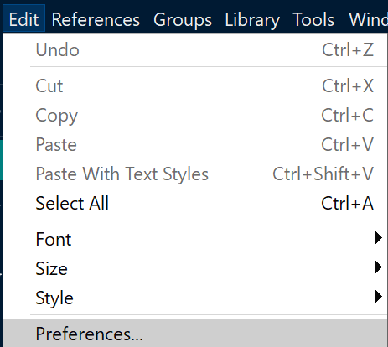

Step 1 for MAC/OS devices:
On a MAC / OS device, from the EndNote program, select the EndNote Menu and choose Preferences:
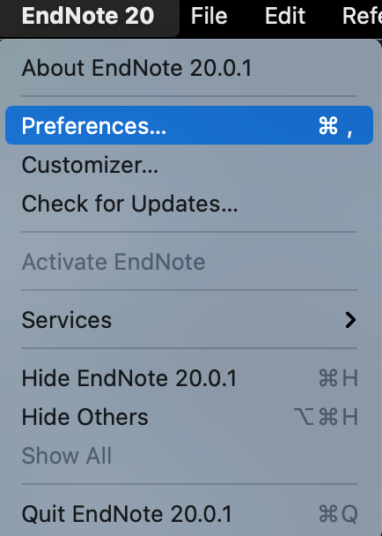

Step 2: In the EndNote Preferences window, select Reference Types from the left-hand menu.
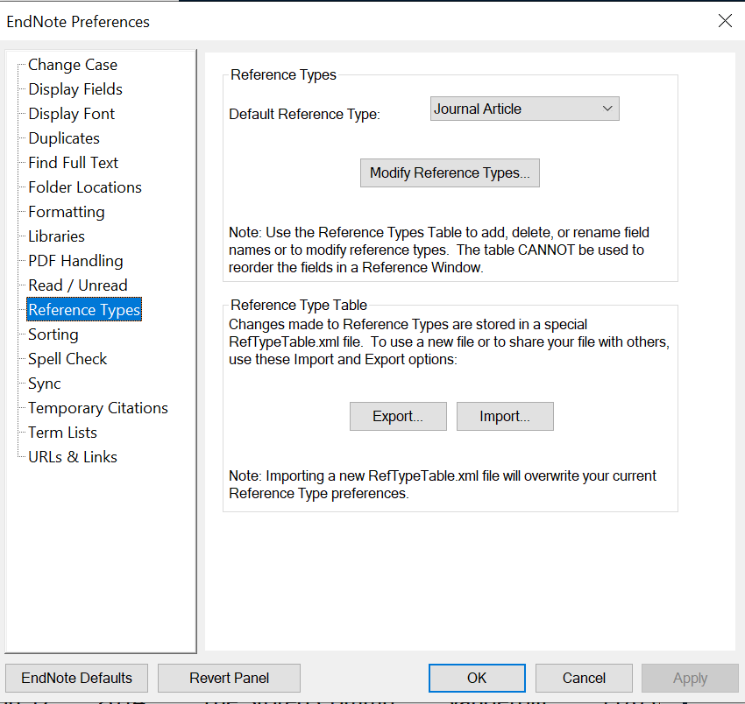

Step 3: Press the Import button from the Reference Type Table section.
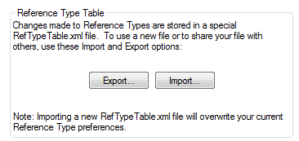
Step 4: From the Downloads folder on your computer, find the RMIT Harvard Preference File and open the file.
Step 5: On a Windows device, select Apply from the EndNote Preferences window or on a MAC / OS device, select Save.
Step 6: On a Windows device, select OK or on MAC / OS device, close the EndNote Preferences window.

Changing from the RMIT_Harvard_EndNote reference style to another reference style (for example IEEE) on a personal device
Use the original EndNote Preference File if you are changing from RMIT Harvard to another referencing style in your EndNote Library.
To import the EndNote Preference File, follow the steps below:
- From the EndNote program, On a Windows device, select the Edit Menu and choose Preferences or on a MAC / OS device, select the EndNote Menu and choose Preferences
- In the EndNote Preferences window, select Reference Types from the left-hand menu.
- Press the Import button from the Reference Type Table section
- From the Downloads folder on your computer, find the EndNote Preference File and open the file.
- On a Windows device, select Apply from the EndNote Preferences window or on a MAC / OS device, select Save.
- On a Windows device, select OK or on MAC / OS device, close the EndNote Preferences window.

