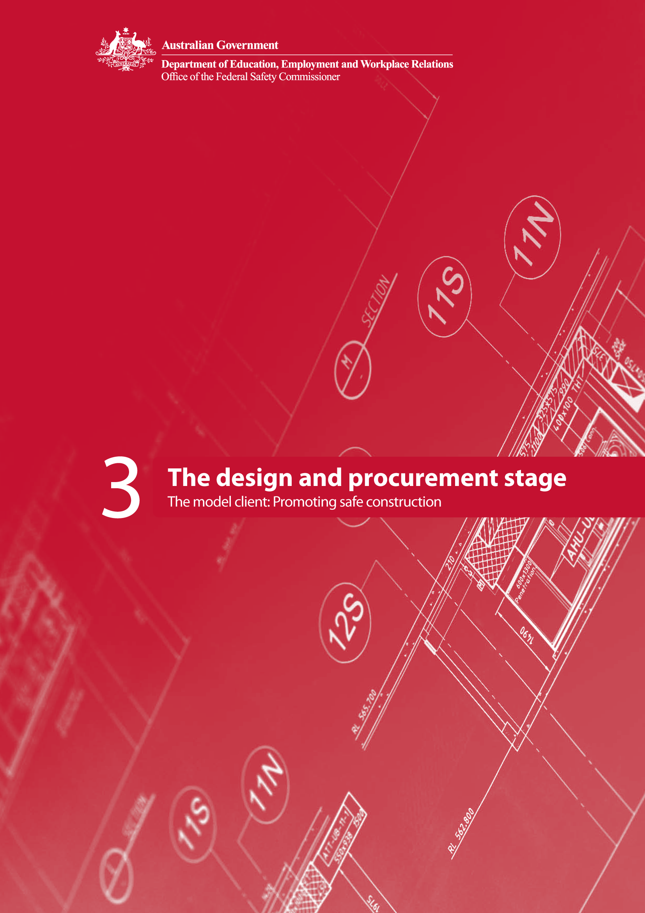

Contents
Introduction 1
The design and procurement stage 1
How to use this booklet 1
What is the design and procurement stage? 2
Project OHS Process Map 4
Phase 4—Outline conceptual design 5
KMA A5 Record risk information 5
KMA B1 Select safe designer 6
KMA B2 Conduct design OHS reviews 7
Phase 5—Full conceptual design 8
Phase 6—Production design and procurement 8
KMA B3 Review design documentation 10
KMA B4 Review project cost 11
KMA B5 Implement change management process 12
KMA B6 Include OHS in contract documents 13
KMA B7 Set project OHS targets and key performance indicators (KPIs) 14
KMA B8 Specify how OHS is to be addressed in tenders 15
KMA B9 Select safe contractor 16
Stage review 17
Conclusion 17
APPENDIX: Supporting documents 18
Document B1.1 Selection criteria for design consultants 19
Document B2.1 Design OHS review guidelines 21
Document B2.2 Process for design OHS review workshops 22
Document B2.3 Design OHS review checklist 23
Document B2.4 OHS risk prompt sheet 28
Document B3.1 Design documentation review 31
Document B4.1 OHS cost criteria 33
Document B5.1 Change management procedure 37
Document B6.1 Example contract provisions establishing specific OHS requirements for the construction stage 38
Document B7.1 Guidelines on setting project OHS KPIs 40
Document B7.2 Standard OHS report format 42
Document B8.1 Project OHS management plan guide 45
Document B9.1 Contractor selection checklist 47
Stage Review 50
Design and procurement stage review template 50

Introduction
Decisions made during the design and procurement stage of a construction project can have a significant impact on OHS during the construction stage (as well as the occupation, maintenance and demolition stages). Clients select the design team, develop the design brief and make important decisions about the schedule, budget and design features of the facility to be constructed. Recent analysis identifies design as a causal factor in fatalities and serious injuries in the construction industry and the National OHS Strategy 2002–2012 establishes the elimination of physical hazards at the design stage an area of national priority.

As the clients of construction projects, Australian Government agencies are ideally placed to drive OHS into the projects they procure. The Model Client Framework is designed to provide Australian Government agencies with guidance and resources to help them manage OHS in construction projects.

The design and procurement stage
This booklet, The design and procurement stage, is the third in a series of five booklets explaining what it means to be a model client. The first booklet, The Model Client Framework, provides a Project Process Map establishing key management actions (KMAs) for promoting OHS throughout the lifecycle of a construction project, from the planning stage to completion.

Booklet two sets out KMAs for the model client during the planning stage of a construction project. This booklet follows booklet two in explaining the actions of a model client during the design and procurement stages of a construction project.

The remaining two booklets in the series provide more detail about the KMAs of the model client, as well as providing resources and tools that can be used during the construction and completion stages.

The complete series is:

- The Model Client Framework

- The planning stage

- The design and procurement stage

- The construction stage

- The completion stage

While this series of booklets has been prepared specifically for the Australian Government as a client of construction services, the principles and materials prepared and contained in each of these booklets are equally applicable to any client of the construction industry.

How to use this booklet
This booklet provides a description of what happens in the design and procurement stage of a project and sets out the KMAs that a model client could implement during this stage of a construction project.

The KMAs are documented using a standard tabular layout as explained in booklet one. Each KMA is identified by a number and a descriptor. The terminology used in defining each KMA is as follows:

- Action describes what has to be done

- Phases indicate the development phases during which the action has to be taken

- Description provides a short narrative of the rationale of the action covering aspects such as who is responsible, its importance and some suggested strategies for consideration

- Key benefits provide the reasons why the action is effective

- Desirable outcomes describe the behavioural and procedural changes resulting from the implementation of the action

- Performance measure describes the outputs that can be measured and recorded as evidence that the action has been successfully implemented

- Documents outline the suggested approach to assist in the effective implementation of the KMA.

Documents relevant to each KMA are numbered for easy reference and can be found in the Appendix to this booklet.

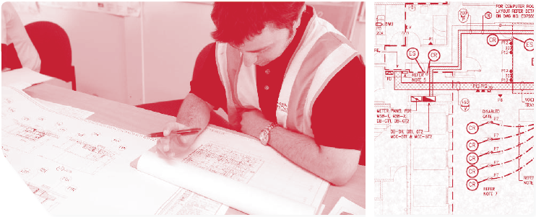

What is the design and procurement stage?
During the design and procurement stage of a construction project, the client selects a designer (or design team). The design of the permanent facility to be constructed is developed from the selection of design solutions. Design develops from an outline to a full conceptual design. Design documentation is prepare and the costs of constructing the designed facility are reviewed. Tender documents and contracts are developed for the construction stage.

Recognising the impact on OHS that design decisions can have, the OHS implications of a design should be subject to a staged review. The greatest opportunity for OHS risk reduction often occurs at the conceptual design stage. As the design progresses and design decision making becomes more fine-grained and detailed, there are still opportunities for OHS risk reduction. The OHS risk management should be built into the design process and designs should be subject to staged review. OHS risks that are identified but cannot be resolved through judicious design should be recorded, especially where these are not risks a contractor would usually consider in their usual assessment of site OHS risks. The particular OHS issues associated with the design can then be reflected in the requirements of contract documents for the construction stage and aid the selection of a suitable and safety-competent contractor for the project.

As Figure 1 shows, the planning stage is further divided into three phases. These are:

- Phase 4 – Outline conceptual design (for the construction project)

- Phase 5 – Full conceptual design (for the construction project)

- Phase 5 – Production design and procurement.

In each phase the Model Client Framework suggests a number of KMAs. The framework does not prescribe in which phase each KMA must be implemented. In fact, some KMAs span more than one project phase, indicating that they could occur in any or even all of these phases. However, by the end of the design and procurement stage, a model client would have implemented all of the KMAs described in this booklet.
A stage review is conducted to ensure that this has occurred before moving to the next project stage: construction.

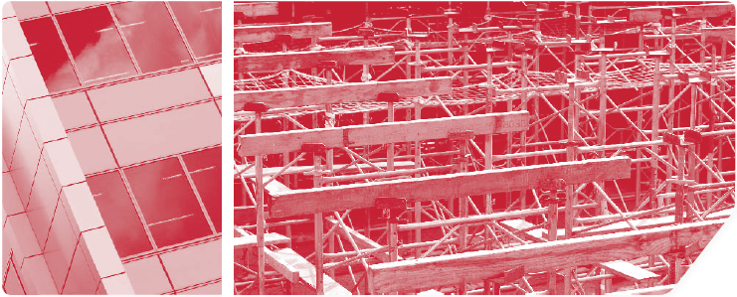

Project OHS Process Map
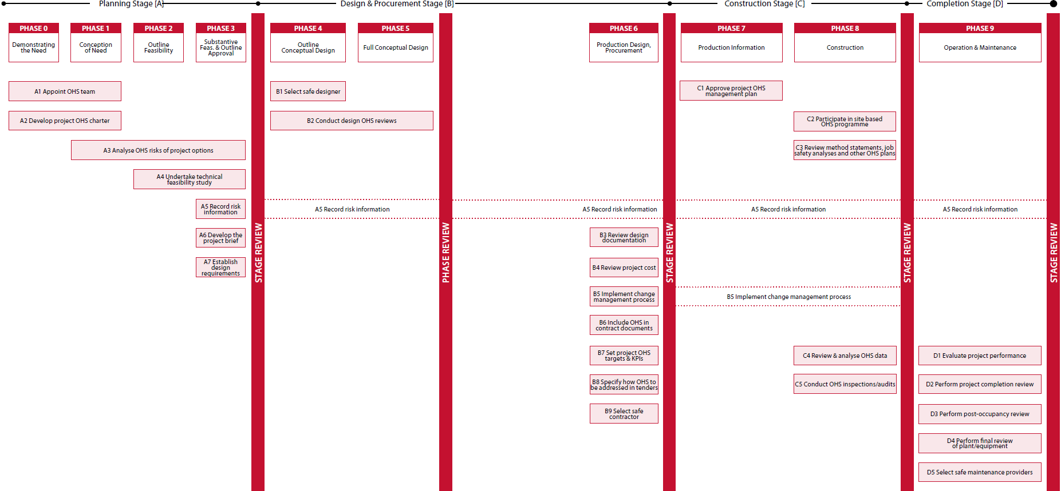
Figure 1: Project OHS process map
Adapted from A Generic Guide to the Design and Construction Process Protocol (Kagioglou et al., 1998) [www.processprotocol.com]

Phase 4—Outline conceptual design
‘How does the solution translate to an outline design?’
The purpose of this phase is to translate the chosen option into an outline design solution according to the project brief. A number of potential design solutions are identified and presented for selection. Some of the major design elements should be identified.
Kagioglou et al. (1998)

Construction design is a complex and iterative process. However, it generally follows a series of stages in which each stage reflects an increasing level of detail. As the design progresses, the extent to which fundamental changes can be made to reduce OHS risk typically reduces.

The first step by the design team is to develop an outline conceptual design of the facility to be constructed. In this phase, simple diagrammatic documents are developed. In the case of a building, these might indicate the designer’s proposal for the number and layout of internal spaces, line diagrams of systems (water mains, electrical risers etc) to be incorporated, preliminary elevations of the building exterior, and drawings of special interior spaces. The outline conceptual design should be carefully reviewed for its ability to satisfy the requirements of the project brief, including cost, functionality, aesthetics and OHS.

KMA A5 Record risk information
Although not initiated in the design and procurement stage, the project risk register will have been developed in the planning stage (in accordance with KMA A5). The project risk register is an important communication tool in which OHS risk information is captured and communicated to different stakeholders who are engaged in the project over its lifecycle. The project risk register should already contain information about OHS risks identified during the substantive feasibility analysis for the project. The project risk register is maintained during the design stage. OHS risk information arising from design OHS reviews performed at both the outline conceptual design and full conceptual design phases should be recorded in the project risk register. An analysis of this historical record of OHS issues during the course of the project will reveal lessons that can be learnt and fed into OHS management processes for future projects. It is important that this risk record continue throughout the project.

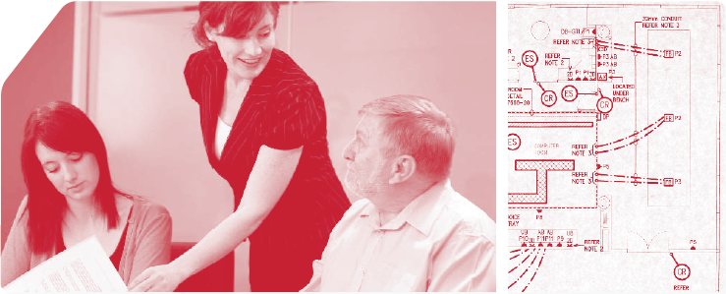

KMA B1 Select safe designer
The first step in the design and procurement stage is the selection of design consultants for the project. Design consultants should be carefully selected based on their ability to satisfy OHS requirements specified in the project brief. Australian Government agencies should ensure that, when a design consultant is appointed, information about site hazards and preliminary risk assessments undertaken in the pre-project stage is communicated to the design team. In particular, the project risk register provides a useful mechanism to communicate this information and should be made available to designers.

KMA B1 | Select safe designer
Action | Agencies should select OHS competent and committed designers. Agencies should adopt a preferred provider scheme in which designers able to display competence in and commitment to design OHS are identified.
Phases | - Phase 4 – Outline conceptual design
Description | In selecting the designer, an agency needs to be satisfied that the designer has the appropriate knowledge and resources to identify and manage OHS risk in design. The responsibilities of design consultants/s in regard to designing for OHS should be specified in the contract for design services. Clear requirements for OHS performance and competence should be included in selection criteria for design consultants.  Australian Government agencies may undertake a prequalification process for the selection of design consultants/s, in which case prospective designers may be asked to submit evidence of their previous track record, competence and performance in designing for OHS. In determining whether a designer is suitably qualified to undertake the project, an agency should consider:  - the size and technical complexity of the project  - the designer’s previous experience and the OHS performance of their designs  - the designer’s demonstrated knowledge of and commitment to OHS  - the quality of the designer’s management processes for addressing safety in the design.  Before a designer is appointed, an agency should have communicated the expectation that the designer must actively participate in design OHS reviews and work in accordance with the project safety charter (see KMA A2). The agency might choose to define specific ‘hold’ points in the design process to enable OHS review. Specific OHS requirements for design documentation should be communicated to prospective design consultant/s in KMA A7.
Key benefits | - Designers competent in OHS will be selected.  - Client expectations for the elimination/reduction of OHS risk at the design stage are clearly communicated to prospective design consultant/s.

Desirable  outcomes | - Design consultant/s fully integrate OHS into design decision-making.  - The elimination/reduction of OHS risk through design modifications is maximised.  - Residual OHS risks are clearly identified and managed effectively.
Performance  measure | - Selection decisions based on OHS competence/performance
Documents | - B1.1 Selection criteria for design consultants

KMA B2 Conduct design OHS reviews
Design OHS reviews should be carefully structured to ensure that design implications for all major areas of OHS risk are considered. People who will be involved in construction, use and maintenance of facilities can often provide valuable information into OHS risks inherent in design decisions. Thus, integrated focus groups, comprising designers and other relevant stakeholders are a recommended format for design OHS reviews. Participants might include construction contractors, OHS consultants, worker representatives and maintenance personnel.

KMA B2 | Conduct design OHS reviews
Action | Agencies should review designs at both the outline and detailed design stages. These reviews should identify OHS hazards associated with design elements and assess the risks presented by these hazards.
Phases | - Phase 4 – Outline conceptual design  - Phase 5 – Full conceptual design
Description | Design OHS reviews should consider OHS in the construction, operation and maintenance of the building/facility. Constructability and maintainability should be carefully assessed. As a minimum, the following issues should be considered:  - proposed construction methods and stages  - the potential to produce components offsite  - the selection of safe and durable materials  - arrangements for site access, material storage and traffic management  - clearances for construction and maintenance equipment, considering adjoining properties, overhead powerlines etc  - access for maintenance of the facility and services installed  - access to structural elements which may need maintenance or replacement.  Wherever possible, design OHS reviews should involve the people who will eventually construct, occupy or maintain the facility. However, where this is not possible, agencies should make every effort to include persons with knowledge and experience in the construction and/or maintenance processes in the design OHS reviews. Using the knowledge and experience gained by those with exposure to OHS risks during construction and maintenance can assist in identifying OHS issues that may be overlooked by designers.  Design OHS reviews should follow a systematic approach to OHS risk management, that is, the identification of hazards, the assessment of risks, the evaluation of these risks against pre-established levels of tolerance and, where practical, the selection of measures to eliminate/reduce risks through design modifications. Residual OHS risks should be recorded in the project risk register (see KMA A5).
Key benefits | - OHS risks inherent in a design are systematically assessed.  - Where practical, OHS risks are eliminated or reduced through design modification.  - The designed facility can be safely constructed and maintained.
Desirable  outcomes | - OHS risks arising from the design of a facility are minimised.
Performance  measure | - Design OHS review conducted.  - Risk elimination/reduction design changes recorded.
Documents | - B2.1 Design OHS review guidelines  - B2.2 Process for design OHS review workshops  - B2.3 Design OHS review checklist  - B2.4 OHS risk prompt sheet

Phase 5—Full conceptual design
‘Can we apply for planning permission?’
The conceptual design should present the chosen solution in more detailed form to include
M&E [mechanical and engineering services], architecture, etc. A number of buildability and design studies
might be produced to prepare the design for detailed planning approval.
Kagioglou et al. (1998)

A full conceptual design contains definitive plans and elevations. Design details, such as colours, patterns, materials, lighting fixtures, and special equipment and building elements are included. Detailed floor plans, sections and elevations are developed and materials, finishes and systems are specified. There are no unique KMAs for this phase. However, in keeping with the staged design review process, a review of the OHS implications of the full conceptual design of the facility to be constructed should be performed (see KMA B2). Risk information arising as a result of this review should be added to the project risk register (see KMA A5, booklet two).

Phase 6—Production design and procurement
‘Are the major design elements fixed?’
The purpose of this phase is to ensure the coordination of the design information. The detailed information
provided should enable the predictability of cost, design, production and maintenance issues, among
others. Full financial authority will ensure the enactment of production and construction works.
Kagioglou et al. (1998)

OHS risk information should be included in design outputs and documentation. This can be used to inform prospective contractors of OHS risks that they might encounter and provide the basis for realistic allocation of resources to OHS by contractors tendering for the project, and preparing for managing OHS in the construction stage. Design consultants should be required to communicate the ways in which they have mitigated OHS risks at the outline and full conceptual design stages and report on residual OHS risks in their designs (that is, those remaining after OHS risks have been eliminated or reduced by design decision). Residual risks should be recorded in the project risk register.

KMA B3 Review design documentation
Design documentation should be reviewed to ensure that OHS risk information arising as a result of design OHS risk reviews is fully reflected.

KMA B3 | Review design documentation
Action | Agencies should review all design documentation produced to ensure that OHS issues and information about residual risks has been recorded in the project risk register.
Phases | - Phase 6—Production design and procurement
Description | The agency OHS team should conduct a final review of the production design documentation. This review should ensure that this documentation clearly and comprehensively identifies OHS risks inherent in the design. OHS hazards should be marked on drawings and information about the stage and sequence of construction should be provided. Design documentation should also include information about any hazardous materials or construction processes required in the design.  Where applicable, arrangements for traffic management or road diversions should be indicated. The agency should be a signatory on the design documentation and any design that does not achieve acceptable OHS standards should not proceed until these standards are met. The agency should review the reports arising from design OHS review processes and incorporate any identified residual OHS risks in information provided to prospective contractors. Any OHS risks that were not resolved at the design stage, and which arise as a result of unique features of the site or design, should be brought to the attention of prospective contractors via the project risk register.
Key benefits | - Design documentation contains detailed information about OHS risks.  - Designers’ specifications for OHS in construction, operation and maintenance are clearly documented.
Desirable  outcomes | - Design OHS information is clearly recorded and can be fully communicated to other project stakeholders, for example construction contractors, maintenance providers, occupants/users of the facility.
Performance  measure | - Design documents have recorded appropriate OHS issues and information about residual risks.
Documents | - B3.1 Design documentation review

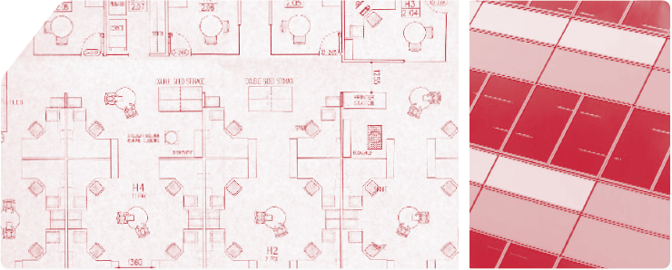

KMA B4 Review project cost
In order for project OHS objectives to be achieved, OHS must be adequately resourced. Unfortunately, under the competitive tendering system, pressures on tenderers to reduce their costs to win work can result in ‘cutting corners’ with regard to OHS. To prevent this from happening, as model clients, Australian Government agencies should carefully assess tenders to ensure that prospective contractors have adequately planned for and priced the OHS requirements of the project.

KMA B4 | Review project cost
Action | Agencies should prepare cost estimates for constructing the building/facility safely. This estimate should be used to ensure that prospective contractors have priced OHS issues appropriately in their bids. The estimate should be prepared against specific OHS items that contractors will be required to price in their tenders.
Phases | - Phase 6—Production design and procurement
Description | The agency should conduct a review of costs associated with the design. The review is to estimate costs associated with the construction of the building/facility. In this review, all OHS requirements should be costed to allow a comprehensive and meaningful analysis of prospective tenders. The cost review should confirm that pre-tender estimates fall within allowable budgetary levels for the project.
Key benefits | - Benchmarking provided to assess the bids of prospective contractors.  - Identification of contractors who have failed to price OHS into their bids responsibly.
Desirable  outcomes | - Contractors’ bids reflect realistic estimates of OHS costs.
Performance  measure | - Cost estimates, with comprehensive OHS-related costs, prepared for the assessment and comparison of contractors’ bids.
Documents | - B4.1 OHS cost criteria
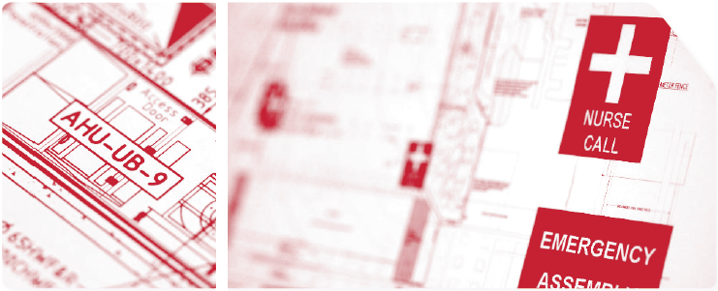

KMA B5 Implement change management process
When the project reaches full conceptual design stage it is generally recognised that it has reached a certain state of completeness. However, inevitably, changes to materials and methods and other aspects of the design will subsequently occur. It is important that the OHS implications of these changes are identified and carefully assessed and that any newly introduced or substantially increased OHS risks are managed appropriately.

KMA B5 | Implement change management process
Action | Agencies should implement a change management process for the project. This change management process should be adopted to ensure that any changes to the design are referred to the designer and subject to an OHS risk assessment.
Phases | - Phase 6—Production design and procurement
Description | The change management process must require that requests for changes to the design be referred to the designer. Once the full conceptual design has been agreed on, no further changes can be made unless formal change management processes are followed. Where changes are requested, they should be subject to a review of the impact on project OHS risks.  Changes made directly by an agency may deem the agency a designer, and as such take on some of the responsibilities of a designer. All changes and associated risks should be recorded in the project risk register.
Key benefits | - All design changes are reviewed for their impact on OHS risks.  - Designs are not altered without consideration of OHS.
Desirable  outcomes | - Changes to the design do not introduce higher levels of OHS risk.
Performance  measure | - Change management process implemented with full procedure documentation.  - All design changes comply with the change management procedures.
Documents | - B5.1 Change management procedure

KMA B6 Include OHS in contract documents
Contract documents identify the roles and responsibilities of the parties (and their agents) and establish the rules of governance for the project. Contracts have legal consequences if things go wrong. It is very important that contracts for construction work reflect an agency’s OHS expectations for a project and clearly specify roles and responsibilities in relation to OHS.

KMA B6 | Include OHS in contract documents
Action | Agency contract documents should include specific OHS requirements.
Phases | - Phase 6—Production design and procurement
Description | Most standard construction contracts do not establish specific OHS requirements beyond compliance with relevant legislation. OHS performance is better when clients include detailed requirements for OHS in contracts. Agencies should carefully assess their standard construction contracts and consider the inclusion of specific OHS requirements in contracts. For example, contracts could:  - specify reporting requirements for OHS against project KPIs  - require OHS reports to accompany all invoices  - establish requirements/processes for the immediate reporting of injuries or incidents to the client  - require specific OHS management processes be implemented.
Key benefits | - Contractors are contractually bound to implement OHS measures over and above those required by OHS legislation.  - The inclusion of detailed OHS requirements in construction contracts reinforces the importance that agencies place on OHS during the construction stage.  - Procedures for non-compliance and issue resolution are clearly stipulated in contract documents and would apply to the OHS requirements.
Desirable  outcomes | - Contractors understand OHS requirements as conditions of contract with agencies.
Performance  measure | - All construction contracts contain specific OHS clauses.
Documents | - B6.1 Example contract provisions establishing specific OHS requirements for the construction stage

KMA B7 Set project OHS targets and key performance indicators (KPIs)
Measurement and monitoring of performance is critical to the effective management of OHS. Proactive measurement of OHS performance enables problems to be detected early, before injuries or illnesses occur. It also enables an assessment of OHS management activities and allows agencies to determine ‘what works and what doesn’t’.

KMA B7 | Set project OHS targets and KPIs
Action | The agency should establish OHS targets and key performance indicators (KPIs) for the project, in consultation with the project OHS team, and communicate these to prospective contractors.
Phases | - Phase 6—Production design and procurement
Description | Agencies should identify KPIs (metrics) by which to measure project OHS performance. These KPIs should include leading and lagging indicators. Leading indicators measure pro-active OHS management processes (such as hazard spotting exercises, training etc). Lagging indicators measure negative events (such as lost time injuries). For each of these KPIs, targets should be set and communicated to prospective contractors.
Key benefits | - Standard methods of measurement for OHS performance on agency projects in order to facilitate continuous improvement.  - Ability to benchmark/compare performance between projects.  - Measurement of positive OHS performance rather than reactive identification of things that have already gone wrong.
Desirable  outcomes | - All contractors use standard OHS reporting processes.  - Leading KPIs focus contractors’ attention on OHS management.  - Benchmarking will provide the opportunity to transfer OHS best practice between projects.
Performance  measure | - KPI performance against agency targets  - Completeness and consistency of reporting against KPIs
Documents | - B7.1 Guidelines on setting project OHS KPIs  - B7.2 Standard OHS report format

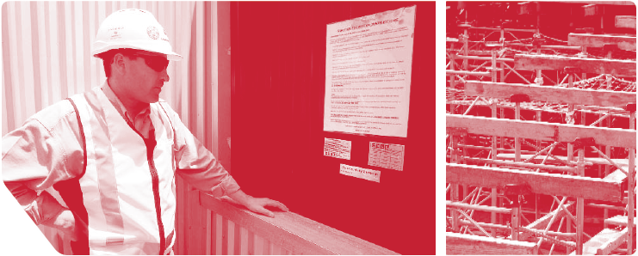

KMA B8 Specify how OHS is to be addressed in tenders
Construction clients may find it difficult to assess the adequacy with which OHS has been addressed in the tenders of prospective contractors if tenderers have addressed these OHS issues in different ways. To allow for a systematic comparison between the OHS provisions in tenders for construction work, Australian Government agencies should clearly specify how OHS is to be addressed in tenders.

KMA B8 | Specify how OHS is to be addressed in tenders
Action | For projects to be tendered, agencies should clearly state how OHS issues are to be addressed in tenders.
Phases | - Phase 6—Production design and procurement
Description | It is recommended that, when projects are to be competitively tendered, agencies specify in tender documentation how tenderers must address OHS issues, including the pricing of OHS aspects of a construction project. This provides some standardisation and enables easier comparison of prospective contractors’ OHS processes. Client agencies should take steps to ensure that prospective tenderers’ price OHS responsibly in their bids, by comparing prospective contractors’ pricing of OHS with an estimate (see KMA B6).
Key benefits | - OHS requirements of the project are addressed in tenders.Tenders can be readily compared because all tenderers are required to submit the same OHS information.
Desirable  outcomes | - Tenders that do not comply with OHS requirements can be excluded from further consideration.  - All tenders will contain pricing that includes realistic costings for implementation of OHS for the project.
Performance  measure | - All tenders contain complete, detailed, OHS information in a standard format.
Documents | - B8.1 Project OHS management plan template guide into which contractors must insert project specific details about the management of OHS  - Note: See document B4.1 for OHS costings

KMA B9 Select safe contractor
Construction clients sometimes equate price with value, selecting the lowest bidding tenderer in all cases. It is important to recognise that price should not be the sole criteria for selection, and that contractors’ ability to perform the work to the required OHS standard should be considered by a model client. The Office of the Federal Safety Commissioner’s (OFSC) register of accredited contractors lists those companies whose OHS management systems have been assessed as meeting the requirements for accreditation under the Australian Government Building and Construction OHS Accreditation Scheme and should be used as a first step in selecting a suitable contractor.

KMA B9 | Select safe contractor
Action | Agencies should select the contractor based, in part, on assessment of the OHS competencies of the contractor’s proposed project team and the contractor’s approach and ideas for the management of OHS in the project.
Phases | - Phase 6—Production design and procurement
Description | The Australian Government Building and Construction OHS Accreditation Scheme (the Scheme) will ensure that all contractors tendering for Government construction work over a specified value will have already been subjected to a rigorous accreditation process. This system ensures that the companies bidding for agency work will have a recognised OHS management system in place. Thus, all tenderers for projects that exceed this threshold can be assumed to have organisational OHS management policies and procedures.  However, the Scheme does not enable an evaluation of the OHS competence of personnel named in a tender to be deployed on a particular project. Neither does the Scheme assure agencies that OHS aspects of a particular project have been adequately addressed in contractors’ project planning processes. It is therefore essential that the OHS components of prospective contractors’ tenders are carefully assessed and considered in the contractor selection decision.
Key benefits | - Contractor selection decisions are influenced by the OHS competence of the proposed team and the quality of OHS content of tender submissions.
Desirable  outcomes | - Contractors with OHS competence are selected to construct the proposed facility.  - Selection decisions are always contingent on OHS aspects of tender submissions.
Performance  measure | - Weight of consideration of OHS against other tender evaluation criteria (especially price)
Documents | - B9.1 Contractor selection checklist

Stage review
A stage review should take place to review, confirm and approve all major decisions taken in the design and procurement stage of the project. KMAs and their performance measures should be reviewed to ensure that the requirements of the Model Client Framework have been met.

A suggested design and procurement review template is in the appendix of this booklet.

Conclusion
Having completed all of the KMAs in the design procurement stage, a strong foundation will have been laid for the management of OHS during the next stage, construction. The actions of a model client during the construction stage of a construction project are described in detail in booklet four of the model client series.

APPENDIX: Supporting documents
The following documents are available in electronic versions and can be downloaded from the OFSC website at fsc.gov.au.

Document B1.1 Selection criteria for design consultants 19
Document B2.1 Design OHS review guidelines 21
Document B2.2 Process for design OHS review workshops 22
Document B2.3 Design OHS review checklist 23
Document B2.4 OHS risk prompt sheet 28
Document B3.1 Design documentation review 31
Document B4.1 OHS cost criteria 33
Document B5.1 Change management procedure 37
Document B6.1 Example contract provisions establishing specific OHS requirements for the construction stage 38
Document B7.1 Guidelines on setting project OHS KPIs 40
Document B7.2 Standard OHS report format 42
Document B8.1 Project OHS management plan guide 45
Document B9.1 Contractor selection checklist 47
Design and procurement stage review template 50

Document B1.1 Selection criteria for design consultants
A final selection is made after a number of potentially suitable design consultants are identified. The table below provides guidance on making an informed decision.

About the design company/organisation
Key Aspects | Evidence provided? Yes/No
About the design company/organisation
Company OHS policy and strategic objectives
Certified AS4801 or equivalent OHS system
Commitment to and enthusiasm for OHS
Workload and resources
Relevant OHS experience (including examples of past projects)
Ability to innovate
References
Compatibility with agency’s needs

Project-specific — the design team
Key Aspects | Evidence provided? Yes/No
Make up of the design team
Authority levels of team members
Logistics related to site, client and other consultants
Expertise and demonstrated competence in and commitment to safety in design

Key project personnel
Key aspects | Evidence provided? Yes/No
Qualifications and experience in considering safety in design relevant to the project
Understanding the OHS project needs
Innovation, flair, commitment and enthusiasm for balancing OHS with other project objectives, for example aesthetics, quality, cost
Communication skills
References
Details and experience of any sub-contractors

Project execution
Key Aspects | Evidence provided? Yes/No
Program, method and approach, that is consultation and communication with stakeholders throughout project, setting of OHS goals and targets, etc
Integration of OHS into the whole lifecycle of the project, that is design, construct, use and demolition
OHS risk management methodology, that is how will they identify, evaluate and manage OHS risk
OHS management and control procedures
Dedicated OHS resources to be applied to the project (personnel, costing etc)

Completed by:

Signature

Date:

Witnessed by:

Signature

Date:

Document B2.1 Design OHS review guidelines

Overview
The identification of OHS hazard/risks should involve a critical appraisal of activities involved in all stages of the lifecycle of the building/structure to be constructed, including construction, occupation, maintenance and demolition. Comprehensive hazard/risk identification requires a good understanding of the working situation, whether it is during construction, use, maintenance or demolition. Pooling knowledge and experience is a key aspect of hazard/risk identification and control. It is highly recommended that input be sought from people who are directly involved at each stage, for example contractors, maintenance personnel, facilities managers and prospective occupants. The collective analysis of a group of people, with differing perspectives, is usually better than an individual, single perspective analysis. This is because participants interact with one other, bring different viewpoints and experiences and produce a more balanced analysis of a hazard/risk.

Different projects will require different expertise and input. The relevant stakeholders who should participate in a project design OHS review should be carefully considered. Consideration also needs to be given to how the different participants to the design OHS review will work together. Participants should be sure that they fully understand the OHS objectives of the project and the management structure and contractual obligations.

Once OHS hazards/risks have been identified, the seriousness of each of these should be assessed using a robust and appropriate risk assessment method. An example of a way in which a risk assessment can be undertaken is provided in booklet two, KMA A5. This risk management approach uses a three step process of:

- identifying the hazard/risk

- assessing the risk using a risk matrix

- determining whether further action is required based on the outcome of risk rating and any supporting information.

Where OHS risks are too high to be accepted, the design team should consider ways in which they can modify the design so that these OHS risks can be eliminated or reduced. A safer design will reflect the practical implementation of appropriate measures to control OHS risk.

At the conclusion of the OHS design review, the OHS aspects of the design relevant to the construction of the project should be detailed fully and correctly on the design documents. Thus it is vitally important that the designer is aware of the OHS information, content and use requirements of these documents. It is important that there is clear OHS information in project documents, particularly the working drawings, and that this information is sufficiently detailed. It is helpful to consider the following questions when assessing whether this is the case.

- Is the OHS information consistent across all plans?

- Is there a better way of showing the OHS information?

- Are the dimensions complete?

- Are systems compatible (for example, can you run telecommunications in the same void as the plumbing)?

- Are the OHS specification notes on the drawings complete and accurate and adequately cross referenced?

- Have all the residual OHS risks to contractors arising as a result of non-standard design feature been included in the project documents?

Document B2.2 Process for design OHS review workshops
The diagram below represents the step-by-step process suggested to review the design OHS aspects of the project. The risk identification part of this process is the most important of all being undertaken. If not identified a risk cannot be effectively managed. A design checklist (document B2.3) and additional risk prompts (document B2.4) have been developed to assist the facilitator and workshop participants to identify relevant risks. When assessing the risk you may choose to use the risk management methodology presented in booklet two, KMA A5. If it is not a large scale project, workshop 1 and workshop 2 may be combined.

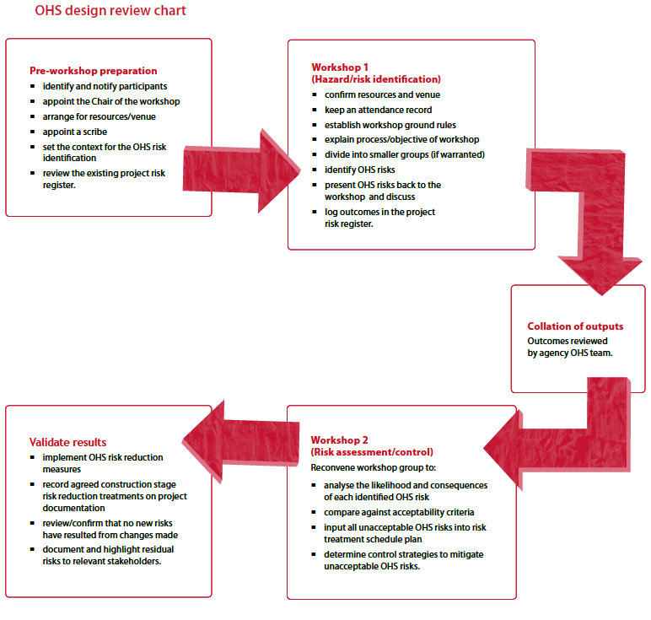

Document B2.3 Design OHS review checklist
In most projects a number of different design consultants contribute to the design of the permanent structure/building to be constructed. Each consultant’s area of design responsibility should be included in the design OHS reviews. The table below provides key contractors with prompts for the various design areas that may need consideration of OHS risk and for inclusion of relevant details on project drawings.

Please note that the table is designed to be used as a guide only for identifying hazard/risks and should not be treated as an exhaustive list. Further risk prompts are available in document B2.4—The OHS risk prompt sheet.

Designers

Architect/draftsperson
Construct | Yes/No/NA | Use | Yes/No/NA | Redevelop/  demolition | Yes/No/NA
Proximity to other building/plant/equipment | Yes  No  N/A | Finishes schedule (for users) | Yes  No  N/A | Ability to redevelop for alternative uses/agencies | Yes  No  N/A
Main services layout | Yes  No  N/A | Compliance with building regulations | Yes  No  N/A | Proximity to buildings/plant/etc | Yes  No  N/A
Proximity to other activities | Yes  No  N/A | Expected passenger use (lifts) | Yes  No  N/A | Public protection requirements | Yes  No  N/A
Proximity to overhead/buried services | Yes  No  N/A | Access to risers | Yes  No  N/A | Vehicular movement | Yes  No  N/A
Access and vehicular movement | Yes  No  N/A | Finishes schedule (for maintenance/cleaning) | Yes  No  N/A | Pitch of roof | Yes  No  N/A
Elevations of all facades showing the characteristics and relationships between spaces | Yes  No  N/A | Pitch of roof (maintenance/work space) | Yes  No  N/A
Perimeter protection | Yes  No  N/A | Room sizes | Yes  No  N/A
Construction site layout and  emergency access | Yes  No  N/A | Access requirements to all services and exterior of the building | Yes  No  N/A
Adjoining property protection | Yes  No  N/A | Pedestrian access and vehicular movement | Yes  No  N/A
Falls from heights | Yes  No  N/A | Future landscaping hazards (roots) | Yes  No  N/A

Engineer
Construct | Yes/No/NA | Use | Yes/No/NA | Redevelop/  demolition | Yes/No/NA
Loading requirements | Yes  No  N/A | Acoustics | Yes  No  N/A | Type of reinforcement | Yes  No  N/A
Foundation design | Yes  No  N/A | Long-term maintenance requirements | Yes  No  N/A | Method of de-construction | Yes  No  N/A
Construction design/connections | Yes  No  N/A |  |  | Loading requirements | Yes  No  N/A
Restrictions on space for erection | Yes  No  N/A |  |  | Access to external areas for demolition | Yes  No  N/A
Safe means of connecting components | Yes  No  N/A
Safe handling of components | Yes  No  N/A
Effect of erection sequence on stability | Yes  No  N/A
Incorporate offsite construction | Yes  No  N/A
Build into design features that contribute to safe access and work platforms | Yes  No  N/A

Mechanical
Construct | Yes/No/NA | Use | Yes/No/NA | Redevelop/  demolition | Yes/No/NA
Safe means of connecting components | Yes  No  N/A | Location and size of plant rooms | Yes  No  N/A | Isolation/disconnection | Yes  No  N/A
Safe handling of components | Yes  No  N/A | Nomination of type of plant | Yes  No  N/A | Access for removal/upgrade | Yes  No  N/A
Installation methods that generate hazardous substances | Yes  No  N/A | Exhaust/Intake requirements | Yes  No  N/A
Hot work | Yes  No  N/A | Access to services for maintenance | Yes  No  N/A
 |  | Confined spaces | Yes  No  N/A
 |  | Maintenance requirements for services | Yes  No  N/A
 |  | Heating and cooling | Yes  No  N/A

Electrical
Construct | Yes/No/NA | Use | Yes/No/NA | Redevelop/  demolition | Yes/No/NA
Safe means of connecting components | Yes  No  N/A | Lighting internal/  external | Yes  No  N/A | Isolation/disconnection | Yes  No  N/A
Safe handling of components | Yes  No  N/A | Security | Yes  No  N/A | Access for removal/upgrade | Yes  No  N/A
Temporary lighting requirements | Yes  No  N/A | Access to services for maintenance | Yes  No  N/A
Installation methods that generate hazardous substances | Yes  No  N/A | Confined spaces | Yes  No  N/A
Hot work | Yes  No  N/A | Maintenance requirements for services | Yes  No  N/A

Other issues

Cost and time
Construct | Yes/No/NA | Use | Yes/No/NA | Redevelop/  demolition | Yes/No/NA
Expected completion times for each stage | Yes  No  N/A | Ongoing maintenance requirements | Yes  No  N/A
Temporary structures (scaffolding) | Yes  No  N/A
Protection structures (hoarding) | Yes  No  N/A
Security structures (hoarding) | Yes  No  N/A

Approvals
Construct | Yes/No/NA | Use | Yes/No/NA | Redevelop/demolition | Yes/No/NA
Legislative restrictions on design | Yes  No  N/A | Legislative restrictions on design | Yes  No  N/A

Other identified risks
Construct | Yes/No/NA | Use | Yes/No/NA | Redevelop/  demolition | Yes/No/NA
Effects on surrounding properties | Yes  No  N/A | Impact on surroundings (for example, reflective glass causing glare) | Yes  No  N/A

All design consultants should be required to acknowledge any residual OHS risks arising as a result of their contribution and ensure relevant OHS information is recorded on project drawings and specifications.

All OHS risks are to be recorded in the project risk register (A5.2).

Client:

Name:

Signature:

Date:

Architect:

Name:

Signature:

Date:

Engineer:

Name:

Signature:

Date:

Mechanical:

Name:

Signature:

Date:

Electrical:

Name:

Signature:

Date:

Trade/profession:

Name:

Signature:

Date:

Trade/profession:

Name:

Signature:

Date:

By signing this document you endorse that:

- An OHS review of the design has been completed and OHS risks identified have been eliminated or reduced so far as is practical. Where OHS risks have been accepted, this should be clearly stated in the project risk register.

- All relevant OHS risks are included in the project drawings and specifications.

Document B2.4 OHS risk prompt sheet
Below is a list of guide words to assist you in identifying hazards/risks associated with the design. These prompts can be used for the various stages of a project, ranging from possible construction safety hazards, through to maintenance safety hazards. Any risks identified from this prompt sheet should be incorporated into document B2.3 —the design OHS review checklist and reflected on the project drawings, where appropriate.

Hazardous chemicals/dangerous goods
- pesticides
- fuel storage
- cleaning products
- dangerous goods
- air pollution/water/waste water
- explosives
- asbestos
- labelling

Slips and trips
- electrical cables
- uneven ground/finishes
- cable covers
- weather
- use of amusement equipment
- flooring design
- poor design of barriers
- poor lighting
- gutters/steps
- trees
- branches
- different flooring surfaces
- outdoor event
- access/egress
- hidden hazards
- edge protection
- climbing
- footwear

Working at height
- scissor lifts
- safety harness
- scaffold
- abseiling
- winches
- flying systems
- prop zones
- ladders
- gantries
- rigging on top of vehicles
- overhead lines
- raised platforms
- appropriate certifications
- edge protection
- loading docks
- platforms
- lighting
- type of materials used

Accessibility
- lifts
- ramps
- parking
- public transport
- signage
- disability
- egress

Site/equipment
- layout
- signage
- advertising/displays
- traffic management
- safe crossings
- overloading site
- appropriateness of signage
- access to site
- exclusion zones
- weather
- emergency egress
- site communication
- storage
- waste

Security
- site access
- building access
- vandalism

Plant
- training
- certification
- personal protective equipment
- supervision
- maintenance
- isolation/segregation — people
- hand tools
- registered plant eg lifts, escalator

Materials handling
- mechanical handling
- plant
- construction
- furniture fixtures and equipment
- precinct design
- functionality
- transport between precincts/locations and storage
- inaudible alarms
- excess weight and height
- method of erection

Vehicle safety
- site layout
- forklifts accidents (rollover etc)
- road closure
- vehicle/people segregation
- speed
- refuelling/recharging locations
- scissor lifts — driving from height
- permits and certification/licensing
- inappropriate use of paths
- accessibility during emergency management
- loading operations — docks and people

Fire safety
- evacuation plans
- fires — fire effects
- fire prevention plan — dangerous goods storage
- knowledge and use of equipment
- plant failure (air conditioning, electrical sub-station, etc)
- obstructing fire equipment
- pyrotechnics
- inappropriate fire fighting equipment
- security of fire prevention equipment
- isolating fire equipment/early warning
- appropriate location of fire equipment
- cutting and welding
- policies and procedures
- temporary electrical installations
- flammable goods
- lack of fire retardant

People
- first aid
- training
- hours of work
- fatigue
- weather — heat, cold
- competency/ suitability
- working alone
- confined spaces
- resources
- cultural conflict
- transport

Manual handling
- garbage/waste disposal
- trolleys
- waste materials

Electrical safety
- power supply — no spiking, lack of continuity
- overloading systems
- power tools
- underground services
- generators
- earthing
- unauthorised access
- lighting
- lack of power boards
- weather
- protection of leads
- cables/height/pathways
- location to other equipment

Maintenance
- materials nominated
- access
- lighting
- vibration
- lifting
- plant registration
- slips and trips
- discharges including temperature
- noise
- frequency of maintenance
- operational requirements eg air intake
- storage facilities

Document B3.1 Design documentation review
The features below should be included in design documentation. The OHS risk issues associated with these features should be documented. This list may vary depending on the scope of the construction project and should only be used as a guide.

Architects

- floor plans showing the details of all spaces and their uses

- details of the main cores and risers

- sections through the building showing key relationships between spaces

- elevations of all facades showing the characteristics and relationships of all components

- site layout

- workspace layout including provisions and dimensions for telecommunication, computers etc

- main services layout

- existing overhead/buried services

- separation of public from construction site

- construction site layout

- finishes schedule for all spaces

- acoustic treatments (if applicable)

- protection works

- details of additional features that contribute to safe access and working places, for example handrails, attachment points for ladders, anchors for safety harnesses etc

- other OHS risks as identified.

Engineer

- floor plan showing layout and sizes of all structural components

- key sections through the structure of the building

- sequenced construction program

- construction details including connections

- details of additional features that contribute to safe access and working places, for example areas doubling as temporary work platforms

- highlight special or unusual stability considerations

- identify the stage at which the permanent structure is self supporting

- principles of the foundation design

- schedule and specifications of all services systems and key components

- geotechnical survey

- acoustic treatment

- other OHS risks as identified.

Mechanical services

- the principles of the heating, ventilation, cooling and plumbing systems together with critical dimensions in ceiling, floor and wall voids

- use of particular materials

- the principles of the fire protection and fire alarms systems together with critical dimensions

- plant room locations, sizes and weights and any installation requirements

- type, location and size of principal service ducts and risers together with critical dimensions in ceiling, floor and wall voids

- other OHS risks as identified.

Electrical services

- the principles of lighting and power distribution, tenant and client supplies, power and lighting to common areas

- dimensions of electrical service voids

- emergency lighting details

- lighting protection

- security systems

- electrical intake and transformer with sizes and position of switch rooms along with critical dimensions

- other risks as identified.

Document B4.1 OHS cost criteria
All parties involved in the construction of a project must recognise that there are both implicit and explicit OHS costs.

Tender/contract costs: These issues and their costs, where possible, should be included in the tender documents. The checklist below provides the model client with examples of OHS items a project team should consider. These items will vary with each project and should only be used as a guide. Use the checklist to ensure that a tenderer has met client expectations by acknowledging the safety requirements of the project and has allocated appropriate costs.

Project stage: Management cost
OHS issue | Agency considered? Yes/No/NA | Cost ($) | Contractor considered? Yes/No/NA | Cost ($)
Adequate site safety supervision | Yes  No  N/A |  | Yes  No  N/A
Experienced safety professionals | Yes  No  N/A |  | Yes  No  N/A
Adequate resources to undertake safety requirements | Yes  No  N/A |  | Yes  No  N/A
Total cost $ = |  |  | Total cost $ =

Project stage: Project costs
OHS issue | Agency considered? Yes/No/NA | Cost ($) | Contractor considered? Yes/No/NA | Cost ($)
Project specific health and safety plan | Yes  No  N/A |  | Yes  No  N/A
Inductions | Yes  No  N/A |  | Yes  No  N/A
Training | Yes  No  N/A |  | Yes  No  N/A
Subcontractor management | Yes  No  N/A |  | Yes  No  N/A
Provision for personal protective equipment | Yes  No  N/A |  | Yes  No  N/A
Monitoring and inspection program | Yes  No  N/A |  | Yes  No  N/A
Audit and performance measuring | Yes  No  N/A |  | Yes  No  N/A
Meetings and reporting | Yes  No  N/A |  | Yes  No  N/A
Incident and accident reporting | Yes  No  N/A |  | Yes  No  N/A
Adequate insurance | Yes  No  N/A |  | Yes  No  N/A
Total cost $ = |  |  | Total cost $ =

Project stage: Construction costs
OHS issue | Agency considered? Yes/No/NA | Cost ($) | Contractor considered? Yes/No/NA |  | Cost ($)
Permits for example occupy footpaths, roads, etc | Yes  No  N/A |  | Yes  No  N/A
Notifications (letter drops to adjoining properties) | Yes  No  N/A |  | Yes  No  N/A
Adjoining property protection | Yes  No  N/A |  | Yes  No  N/A
Demolition/removal of materials | Yes  No  N/A |  | Yes  No  N/A
Removal of hazardous substances | Yes  No  N/A |  | Yes  No  N/A
Site layout (separation of people from plant/vehicles) | Yes  No  N/A |  | Yes  No  N/A
Traffic management | Yes  No  N/A |  | Yes  No  N/A
Scaffolding | Yes  No  N/A |  | Yes  No  N/A
Hoarding/barriers | Yes  No  N/A |  | Yes  No  N/A
Security | Yes  No  N/A |  | Yes  No  N/A
Site and perimeter lighting | Yes  No  N/A |  | Yes  No  N/A
Dust control | Yes  No  N/A |  | Yes  No  N/A
Odours/fumes | Yes  No  N/A |  | Yes  No  N/A
Hours of operation (there may be restrictions imposed by local authorities) | Yes  No  N/A |  | Yes  No  N/A
Excavation/substructure protection | Yes  No  N/A |  | Yes  No  N/A
Fall protection for working at heights ie handrails | Yes  No  N/A |  | Yes  No  N/A
Working platforms | Yes  No  N/A |  | Yes  No  N/A
Plant provisions | Yes  No  N/A |  | Yes  No  N/A
Loading/unloading provisions | Yes  No  N/A |  | Yes  No  N/A
Transportation considerations (wide loads etc) | Yes  No  N/A |  | Yes  No  N/A
Specific construction techniques | Yes  No  N/A |  | Yes  No  N/A
Temporary power supply (site and each floor) | Yes  No  N/A |  | Yes  No  N/A
Commissioning testing and certification | Yes  No  N/A |  | Yes  No  N/A
Total cost $ = |  |  |  | Total cost $ =

Model client costs: The following provides the model client with examples of some of the OHS costs that they should allocate sufficient financial resources to. These items should be factored into the allowable budget for the project, but are not included in the tender/contract documents:

- development of contract documents

- adequate OHS resourcing

- training (as required)

- project specific safety plan

- review of reports

- onsite monitoring and control.

Project costing

Model client project costing: $

OHS contractor project costing: $

Total $

Budgeted allowance for OHS $

Acceptance of OHS project costings:

Project name/number:

Project address:

Name:

Signature:

Date:

Name:

Signature:

Date:

Document B5.1 Change management procedure
When the full conceptual design stage has been completed, the design of the facility to be constructed is understood to have reached a state of acceptance of constructability whereby any further changes should not be permitted to the design without a formal change management process being followed.

Australian Government agencies should track the status of any design change requests through to implementation, or rejection, and should effectively assess and forecast the OHS impact of any proposed changes on the constructability, stakeholder impact and ability to achieve OHS KPIs.

A change management process should include the following steps:

Formalised mechanism for proposing a design change

Whenever any stakeholder determines that some safety aspect of the project should be changed, that stakeholder is to submit a change proposal to the project OHS team. The change proposal should:

- identify the work process in question

- describe the aspect of the work process that the stakeholder wishes to change

- include a description of the OHS impact of the proposed change.

Assessing the impact of the proposed design change

The change proposal should be circulated to all project stakeholders who the applicant has identified as being affected by the proposed change, along with any other stakeholders the OHS team decides should be consulted. Feedback to the project OHS team is invited on the possible OHS effects of implementing the proposed change.

Approving or rejecting proposed changes

Once the impact of the proposed change/s has been assessed by all of relevant project stakeholders, the project OHS team should decide whether to recommend the acceptance or rejection of the proposed change. The project OHS team may reject a proposed change if it is determined that OHS risk to project participants (construction workers, maintenance personnel or facility users/occupants) would be unacceptably increased by the change.

Regardless of whether a change is approved or rejected, the following information should be recorded:

- the date, description, and stakeholder submitting the proposed change

- the proposed solution considered

- the estimated OHS impact of the change on the proposal

- the recommendation made (that is, acceptance or rejection)

- if recommended for acceptance, the overall impact on OHS in the project

- if recommended for rejection, the reason for rejection.

Document B6.1 Example contract provisions establishing specific OHS requirements for the construction stage
The model client should clearly establish the OHS requirements for the contractor and these should be identified at the tender stage in the tender documentation. This will ensure that the contractor understands their OHS responsibilities well in advance of any contract being negotiated and signed. To ensure that these requirements are met throughout construction stage they should be included as part of the contract documents. If the contractor is expected to comply with the agency’s internal OHS processes, information about these processes should also be included in the construction contract documents. Below is a list of suggestions for inclusion.

OHS responsibilities

- requirements to carry out the work with the highest regard for the safety of employees and other people on the site or in the vicinity of the site

- requirements to comply with all relevant statutory obligation

- commitment to the model client’s safety charter (a copy of the charter is to be included in the contract documents)

- allocation of resources to fulfil OHS requirements

- OHS roles and responsibilities.

OHS training

- commitment that employees (and others that the contractor is responsible for) have been trained in working safely and provide evidence that this has taken place

- requirement to ensure that all employees (and others the contractor will be responsible for) are competent in the tasks required

- requirements to attend client and site-specific inductions.

Supervision

- arrangements to ensure adequate supervision of people carrying out tasks

- engagement and management of subcontractors.

Communication and consultation

- requirement to maintain effective consultation and participation with their employees and with you, the model client

- requirement to participate in design, construction and post construction meetings

- commitment to the model clients that all processes and formats forming part of the contract package will apply

- acknowledgement of model client’s onsite participation throughout project.

Reporting

- requirement to report data in specified formats and at specific times. Copies of report templates should be included as part of the contract package (for example change management, risk management). A list of templates should be included

- nominate targets and KPIs (see document B7.1 for guidelines on setting project OHS KPIs)

- requirements to regularly report OHS performance against project targets and KPIs.

OHS planning

- requirement to develop and submit a project-specific OHS plan. No works will commence until the OHS plan hasbeen reviewed and accepted by the model client based on the project and associated risks

- requirement for model client to review risk assessments and safe work method statements

- requirement to incorporate risks already identified into their OHS planning.

Stop work

- acknowledgement of either party’s right to stop the job on safety and health grounds where necessary

- model client’s provisions for enforcement action of repeat OHS breaches.

Administration

- required relevant insurances

- the cost of implementing the expected OHS requirements

- criteria that will be used to evaluate tender response.

Document B7.1 Guidelines on setting project OHS KPIs
OHS key performance indicators (KPIs) can vary widely in their characteristics and their utility. The following characteristics are suggested as a basis for judging the quality of an OHS performance indicator:

- reliable -indicators should be based on well-established principles and be applicable over a wide range of project situations

- relevant - indicators should relate to the important OHS features of the project

- simple - they should not be overly complex otherwise they will be less used and take more time and effort to apply. Simple indicators can facilitate communication and feedback about OHS

- direct - they should be closely linked to project OHS objectives and targets

- understandable - users should know exactly what indicators represent and how to determine their value

- practical - the information required should be easily available and well based.

Example ‘lagging’ OHS indicators

- number of fatalities

- medically treatable injuries

- first aid incidents

- lost time injuries

- total days lost

- total recordable injury frequency rate (TRIFR)*

- members of the public injured

- low duration or severity rate and/or outstanding improvement trend

- safety infringements/fines

- number of accident investigations conducted

- follow-up of corrective actions including application of lessons learnt.

Example ‘leading’ OHS indicators

- project incident reporting - percentage incident reports acted on by the relevant project manager

- incident action tracking - the percentage of near miss incidents which have been closed out with appropriate records

- site safety inspections - number by supervisors, management and/or OHS representatives completed against a pre-agreed number

- management safety walks/inspections - number completed against a pre-agreed number
- site safety inspections - outstanding issues identified from previous period which have been closed out

- hazard identification - percentage reported rectified within the defined timeframe

- risk assessments - percentage of planned risk assessments completed

- site safety management walk - percentage of observations closed out

- safety audits (internal/external bodies) - percentage of audits completed as identified in the OHS project plan for the project

- review of audit reports—percentage of total internal/external audit reports reviewed by senior management

- outstanding issues identified through safety audit—the number closed out within a defined period
- (period to be nominated depending on severity of breach)

- sharing/communication of information—the number of toolbox talks, safety committee meetings conducted during a defined period

- demonstrated use of adopting a successful idea, practice or initiative from other construction sites—the number implemented across all other construction sites

- communication with the public—percentage of notifications completed as identified during the course of the project

- inductions—percentage of employees who have received site-specific OHS induction

- safety training—number of employees/managers who have received OHS training commensurate with their OHS responsibilities

- contracts—percentage of contracts with OHS specific clauses

- design changes—percentage of design changes made to address identified OHS issues over the life of the project.

* The Total Recordable Injury Frequency Rate represents the total number of fatalities and injuries resulting in lost time, restricted work duties or medical-treatment per million work hours.

Document B7.2 Standard OHS report format
Reporting period:

Site/project details:

Workgroup/contractor details:

Task/s being performed:

The table below provides an example in the reporting of project OHS KPIs back to the model client.

Number of fatalities
KPI description | Outcome | Target/measure | Results | Compliance achieved?  Yes/No
The number of workers sustaining fatal injuries in the course of undertaking work related tasks. | To have no loss of  life during the course  of construction | - Zero fatalities |  | Yes  No

Number of Lost Time Injuries
KPI description | Outcome | Target/measure | Results | Compliance achieved?  Yes/No
The number of days/shifts not worked due to an injury sustained at the workplace. | To have no occurrences  that result in a persons  not being able to continue  their work | - Zero Lost Time Injuries (LTIs) |  | Yes  No

Number of Medically Treated Injuries
KPI description | Outcome | Target/measure | Results | Compliance achieved?  Yes/No
A work-related occurrence that results in treatment by, or under the order of, a qualified medical practitioner, or any injury that could be considered as being one that would normally be treated by a medical practitioner. | To have no occurrences  that result in a persons  needing to be treated by a medical practitioner | - Zero medically treated injuries |  | Yes  No

Number of notifications
KPI description | Outcome | Target/measure | Results | Compliance achieved?  Yes/No
The number of OHS related notices, such as improvement, prohibition or infringement notices as issued by the relevant OHS authority and defined in the relevant legislation for the jurisdiction. | To have no incidents occur during the project for which the relevant OHS authority would issue a specific notice | - Zero notices issued |  | Yes  No

Training
KPI description | Outcome | Target/measure | Results | Compliance achieved?  Yes/No
Formalised safety training hours committed to maintaining or improving safety. | To help ensure that all employees (including visitors) are appropriately trained and educated. Training is to include inductions, competency assessments and any other training requirements identified through the site-specific safety management plan. | - All employees inducted  - All subcontractors inducted  - All workers hold relevant qualifications  - Annual competency assessments |  | Yes  No

Communication
KPI description | Outcome | Target/measure | Results | Compliance achieved?  Yes/No
An open and two-way exchange of information between management and workers. | To help ensure that:  - all employees are well-informed, and can participate in decision making related to safety management  - there is an open atmosphere for cooperation and communication. | - Desired number of safety toolbox talks per month (for example 1 per week)  - Desired number of worker safety suggestions implemented (per month)  - Desired number of safety committee meetings held, including attendance details |  | Yes  No

Site Safety Inspection
KPI description | Outcome | Target/measure | Results | Compliance achieved?  Yes/No
To develop and maintain a good working environment, including the appropriate design of workspace and plant interfaces, and good housekeeping. | To establish an inspection program to help ensure the site and construction are operating according to requirements and best safety practices | - Desired number of site safety inspections conducted per month (for example 1 per week) |  | Yes  No

Investigations
KPI description | Outcome | Target/measure | Results | Compliance achieved?  Yes/No
To ensure that the ‘root’ and contributing causes of all incidents and near misses are identified and used to inform preventive efforts. | To investigate all accidents for root and contributing causes and capture the ‘lessons learnt’ | - All recommendations arising from OHS incident investigations and root cause analyses are implemented in the allocated time frame |  | Yes  No

Submitted by

Name:
Signature:
Position:

Document B8.1 Project OHS management plan guide
Provided below are some suggested content for the Project OHS Management Plan. However, it is recommended that agencies devise their own template, identifying relevant information to be included and leaving space for the construction contractor to respond. This will provide you standardised plans and enable easier comparison of prospective contractors’ OHS management planning and processes. The requirements of each project will differ. Depending on the specific OHS risks, additional information may need to be sought.

Contractor profiles
- company/business name
- street address
- postal address
- contact person (including phone number, mobile number, fax, email)

Project management and leadership
- project details, such as address, work being undertaken, etc
- OHS roles and responsibilities
- OHS objectives and accountabilities for key positions
- how agency initiatives will be integrated into contractor program
- a project schedule that includes provisions for OHS

Training
- safety induction details relevant to site/project
- the allocation of adequate resources/facilities to conduct OHS training
- a training needs analysis specific to the project
- how training records will be reviewed, maintained and stored for the project

Design controls
- details on how design changes will be undertaken and recorded. Reference to the agency change management process should be made
- OHS considerations with purchase/operations of plant, equipment and supplies
- controls to ensure all plant and equipment on site is safe and compliant

Risk management
- description of how hazards will be identified and risks assessed during the contract
- details on how the agency’s risk management processes and risk register will be integrated into the contractors procedures

Emergency procedures
- site-specific emergency plan. Note: the contractor should identify what procedures will be used during the course of their contract. Clarification should be sought regarding the details/type of emergency plan, for example does the plan only cover response or is it a full emergency management plan that includes preparation, response and recovery. An emergency response plan may not cover the statutory requirements of some states
- identification of specific equipment required for the contract
- testing and reviewing of emergency plan
- site security provisions
- contact details in the event of an emergency (including after hours details)

Inspections and audits
- audit program
- inspection program
- environmental monitoring program based on project, site conditions, adjoining property, etc

Work procedures/statements
- details of existing Safe Work Method Statements (SWMS) and their relationship to the contract
- acknowledgement and commitment to undertaking any new SWMS as identified
- traffic management and site layout details
- work permit processes

Consultation and communication
- how OHS information will be communicated to all relevant stakeholders and how they intend to identify who the relevant stakeholders are
- what methods of communication will be employed throughout the contract and the stakeholder involvement
- enforcement provisions for non-compliances/breaches/dangerous acts
- details of training and competency requirements
- targets and reporting of OHS
- communications plan applicable to surrounding properties

Incident reporting and investigation
- describe how incidents will be reported and investigated during the contract
- acknowledgement and inclusion of the agency in incident investigations
- details on the processes/procedures relating to the management of incidents including proactive and reactive processes
- details on the processes/procedures relating to the management of injury/illness
- details of the first aid program

Subcontractor OHS management
- roles and responsibilities of subcontractor to principal contractor
- subcontractor training requirements

Construction costs
- acknowledgement of and allocation of appropriate resources for effective OHS implementation throughout the contract. Refer to document B4.1 — OHS cost criteria.

Documentation
- how and where records will be kept relating to the dealings and operations associated with the contract.

Document B9.1 Contractor selection checklist
To aid in the selection of a contractor the following checklist has been developed. The checklist is not exhaustive and particular attention should be paid to project specific OHS issues.

Contractor details

Company/business name:
Street address:
Postal address:
Contact person:
Phone:
Mobile:
Fax:
Email:
Brief description of contract:
Duration of contract:
From:
To:

Insurance Requirements

Insurance requirement | Not required | Required | Sighted | Suitable coverage* | Expiry date | Policy number
Workers compensation
Professional Indemnity
Public/and or product liability

Contractor project-specific OHS management

Criteria | Sighted? Yes/No | Comments
OHS policy and procedures
- contractor acknowledges at director level the client’s strong commitment to OHS and is committed to achieve the requirements of the OHS contract specifications
- inclusion of model client participation of site safety monitoring program
- contractor demonstrates commitment to OHS charter
- confirmation that the contractor’s OHS policy and procedures are of a standard not less than those required and expected for the project
- contractor confirms that the same standard will be required for subcontractors
- contractor confirms an understanding of and commitment to the client’s procedures and relevant legislative requirements
- allocation of appropriate resources, for example personnel, equipment, etc
- allocation of OHS roles and responsibilities
- injury management
- OHS policy and procedures (continued)
- First Aid procedures
- procedures for hazard identification
- procedures for assessing risk of hazards
- procedures outlining use of hierarchy of controls for risk minimisation and review
OHS training
- all contract staff (and those responsible for them) are adequately trained and are competent to undertake the required work/s
- make available training and qualification records on request
- a commitment to attend model client project inductions
- contractor project site-specific inductions program including agency residual risks
- includes a process for inducting subcontractors onto project site
- process for identifying and delivering training needs during the project
Reporting
- ensure contractor is committed to the model client’s templates, that is change management, risk management, any other documents nominated in the contract specifications
- details on how health and safety performance will be monitored during works (including inspections and audits)
- procedures on reporting project wide OHS performance
- incident reporting and investigations (model client may require involvement in investigations)
- acknowledgement of and commitment to review of risk register prior to commencement of works
Enforcement and stop work
- understanding that any infringements of law, regulations or safe operating standards are to be remedied by the contractor
- understanding of the model client’s right to stop work until any unsafe act or situation has been rectified
- understanding of enforcement provisions due to infringements of OHS requirements
- process for enforcing site safety rules and dealing with non-conformance
OHS planning
- project-specific OHS plan
- identification of the nominated senior manager with OHS responsibilities
- records the responsible person/s for onsite OHS and their responsibilities
- copy of current OHS policy
- procedures for design risk assessment
- process for incorporating and communicating design changes during project life
- acknowledgement of model client residual risks
- site-specific emergency management plan, as well as First Aid procedures
- details of policy for use of plant, materials and substances used in the project
Communication and consultation
- process for ensuring subcontractors are involved in developing SWMS, or are inducted into head contractor SWMS
- procedures for consultation on OHS during project life
Administration
- appropriate funds have been allocated for effective OHS implementation
- details of management structure and key staff with roles and responsible for safety

Evaluation and sign off

Evaluation and/or comment:

Submitted by:
Name:
Signature:
Date:
Position:

Stage Review

Design and procurement stage review template
This stage review template can be used to verify that the design and procurement stage KMAs have been implemented, before proceeding to the next project stage: construction. Where appropriate, outstanding actions in relation to the KMAs can be recorded.

Design and procurement stage review
B1 Select safe designers | Assessment | Actions
- selection decisions based on OHS competence/performance

B2 Conduct design OHS reviews | Assessment | Actions
- design OHS review conducted
- risk mitigation design changes recorded

B3 Review design documentation | Assessment | Actions
- design documents have recorded appropriate OHS issues and information about residual risks

B4 Review project cost | Assessment | Actions
- cost estimates, with comprehensive OHS-related costs, prepared for the assessment and comparison of contractors’ bids

B5 Implement change management process | Assessment | Actions
- change management process implemented with full procedure documentation
- all design changes comply with the change management procedures

B6 Include OHS in contract documents | Assessment | Actions
- all construction contracts contain specific OHS clauses

B7 Select project OHS targets and KPIs | Assessment | Actions
- KPI performance against agency targets
- completeness and consistency of reporting against KPIs

B8 Specify how OHS is to be addressed in tenders | Assessment | Actions
- all tenders contain complete, detailed, OHS information in a standard format

B9 Select safe contractor | Assessment | Actions
- weight of consideration of OHS against other tender evaluation criteria (ensuring safety has been priced appropriately)

Further information
This booklet is the third in a series about clients promoting safe construction. Further information about the Model Client Framework is available from the Office of the Federal Safety Commissioner.
FSC Assist Line: 1800 652 500
Internet: www.fsc.gov.au
Email: ofsc@jobs.gov.au

ISBN (set) 978-0-642-32687-4 (print)
978-0-642-32693-5 (online)
ISBN 978-0-642-32651-5 (print)
978-0-642-32657-7 (online)

© Commonwealth of Australia 2008

This work is copyright. You may download, display, print and reproduce this material in unaltered form only (retaining this notice) for your personal, non-commercial use or use in your organisation. Apart from any use as permitted under the Copyright Act 1968, all other rights are reserved.

The Australian Government, its employees, officers and agents do not accept any liability of the results of any action taken in reliance upon, based on or in connection with this document. To the extent legally possible, the Australian Government, its employees, officers and agents, disclaim all liability arising by reason of any breach of any duty in tort (including negligence and negligent misstatement) or as a result of any errors and omissions contained in this document.

Acknowledgements
The authors would like to acknowledge that the project process map is based upon A Generic Guide to the Design and Construction Process Protocol developed by Kagioglou et al. (1998), The University of Salford, UK. Boxed and shaded descriptions of project phases are quoted directly from this Protocol. The Office of the Federal Safety Commissioner would like to thank Dr Helen Lingard, Dr Nick Blismas, Ms Tracy Cooke and Mr David Jellie from the School of Property, Construction and Project Management, RMIT University, who contributed to the development of this resource.

