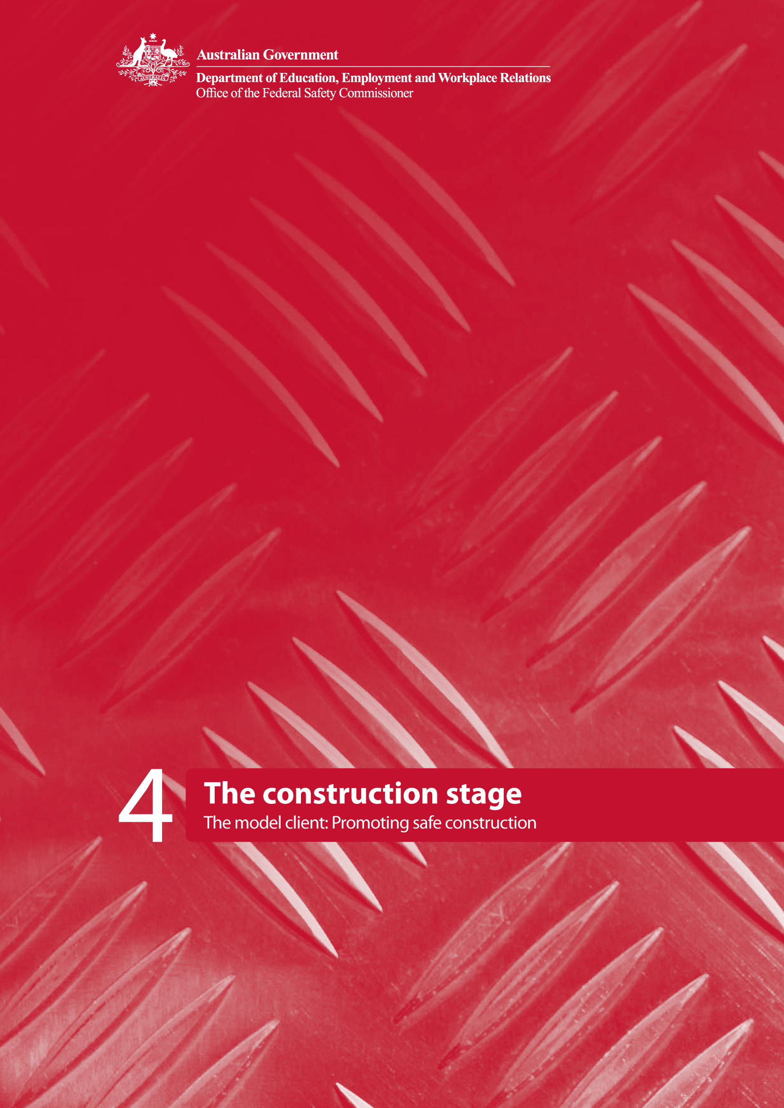

Contents

Introduction 1
The construction stage 1
How to use this booklet 2
What is the construction stage? 3
Project OHS Process Map 4
Phase 7—Production information 6
KMA C1 Approve project OHS management plan 6
Phase 8—Construction 8
KMA C2 Participate in site-based OHS program 9
KMA C3 Review method statements, job safety analyses and other OHS plans 10
KMA A5 Record risk information 11
KMA B5 Implement change management process 11
KMA C4 Review and analyse OHS data 12
KMA C5 Conduct OHS inspections/audits 13
Stage review 14
Conclusion 14
APPENDIX: 15
Document C1.1 Project OHS plan review checklist 16
Document C2.1 Guidelines for agency participation in construction project OHS 22
Document C2.2 Agency ‘site safety walk’ protocol 24
Document C2.3 Site safety walk template 26
Document C2.4 Incident investigation guidelines 27
Document C2.5 List of possible incident causes 29
Document C3.1 Agency checklist for safe work method statement/job safety analyses 34
Document C4.1 OHS reporting template 37
Document C5.1 Site OHS inspection checklist/report 38
Stage Review 49

Introduction
The construction stage of a project commences after the planning and design of the facility has been finalised and after a building contractor has been appointed. The contractor is responsible for all construction planning and implementation, and controls the worksite until construction work is complete and the facility is handed over to the client.

In the past, safety efforts have focused almost entirely on the construction stage. This approach was, no doubt, prompted by the fact that it is during the construction stage that the workforce is actually exposed to the OHS hazards/risks of building a facility. Likewise, occupiers of adjacent property and the public also become exposed to physical OHS risks for the first time. During the construction stage, clients (and designers) traditionally adopted a ‘hands off’ approach to OHS, by shifting full responsibility for OHS to the contractor. However the previous booklets in this series demonstrate the importance of decisions made during the planning, design and procurement stages of a construction project and the significant impact on OHS that these have on the construction stage. The model client approach is predicated on the emerging empirical evidence that suggests that a more active engagement and involvement by the client in OHS activities during the construction stage leads to improved OHS performance.

As the clients of construction projects, Australian Government agencies are ideally placed to drive OHS into the projects they procure. The Model Client Framework is designed to provide Australian Government agencies with guidance and resources to help them manage OHS in construction projects.

The construction stage
This booklet, The construction stage, is the fourth in a series of five booklets explaining what it means to be a model client. The first booklet, The Model Client Framework, provided a project process map establishing key management actions (KMAs) for promoting OHS throughout the lifecycle of a construction project, from the planning stage to completion. Booklet two set out KMAs for the model client during the planning stage of a construction project and booklet three described the KMAs to be undertaken during the design and procurement stage. This booklet explains the actions of a model client during the construction stage of a project.

The remaining booklet in the series provides more detail about the KMAs of the model client during the completion stage, as well as providing resources and tools that can be used during that stage.

The complete series is:

- The Model Client Framework
- The planning stage
- The design and procurement stage
- The construction stage
- The completion stage

While this series of booklets has been prepared specifically for the Australian Government as a client of construction services, the principles and materials prepared and contained in each of these booklets are equally applicable to any client of these services.

How to use this booklet
This booklet provides a description of what happens in the completion stage of a project and sets out the KMAs that a model client could implement during this stage of a construction project.

The project OHS process map shown in Figure 1 identifies the operation and maintenance of the facility as Phase 9 of the project, under which a number of KMAs are to be undertaken as described below.

The KMAs are documented using a standard tabular layout as explained in booklet one. Each KMA is identified by a number and a descriptor. The terminology used in defining each KMA is as follows:

- Action describes what has to be done
- Phases indicate the development phases during which the action has to be taken
- Description provides a short narrative of the rationale of the action covering aspects such as who is responsible, its importance and some suggested strategies for consideration
- Key benefits provide the reasons why the action is effective
- Desirable outcomes describe the behavioural and procedural changes resulting from the implementation of the action
- Performance measure describes the outputs that can be measured and recorded as evidence that the action has been successfully implemented
- Documents outline the suggested approach to assist in the effective implementation of the KMA.

Documents relevant to each KMA are numbered for easy reference and can be found in the appendix to this booklet.
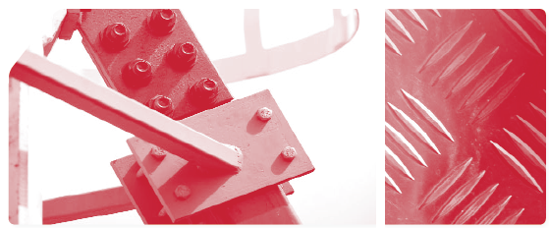

What is the construction stage?
The construction stage commences after the finalisation of the design and in a traditional model leads to the appointment of a contractor to undertake the construction of the facility. It encompasses all works on the site including any specialist tasks which may be carried out by subcontractors or equipment suppliers. The contractor is usually responsible for undertaking all of the works including provision of all materials, labour, plant and equipment required to complete the works. The contractor also controls the sequence and coordination of works to ensure that construction is undertaken in an ordered and logical way. The contractor is also responsible for coordination with the works of other parties which may be involved in the project, such as service authorities relocating their assets or contractors on adjacent projects.

Construction covers all the works required to deliver the final project, including new civil engineering infrastructure, alterations to existing facilities and installation of services and fittings. Construction covers not only the building of the facility itself but also associated activities such as delivery and removal of goods to and from the site; site access; excavations; temporary works such as false-work, formwork and working platforms; clearing and grubbing; temporary and permanent fencing; landscaping and ancillary works. Of vital importance to OHS is the proper use of construction plant and equipment in accordance with statutory obligations and manufacturers’ recommendations.

During the construction stage, a model client will have the benefit of planning, design and procurement decisions that have taken OHS into account—as described in booklets two and three—where opportunities to reduce OHS risks have occurred during project planning, conceptual and detailed design, and procurement. All reasonably foreseeable OHS risks will have been identified in pre-construction activities and, where these cannot be resolved, residual OHS risk information should be passed on to the contractor in the form of a project risk register. This is important for OHS risks which a contractor would not usually consider in the assessment of normal site OHS risks.

As Figure 1 shows, the construction stage is further divided into two phases. These are:

- Phase 7—Production information
- Phase 8—Construction.

The Model Client Framework suggests a number of KMAs for each phase. The production information phase essentially covers the development of OHS management plans while the construction phase covers OHS management during construction activities, including review and adjustment of plans, inspection and auditing of contractors’ OHS activities, and recording risk information to be passed on to the next project stage—the completion stage. As can be seen, some KMAs span both construction stage phases, indicating that they could occur in one or even both phases.
However, by the end of the construction stage, a model client would have implemented all of the KMAs described in this booklet.

A stage review is conducted to ensure that this has occurred before moving to the next project stage: completion.

Project OHS Process Map

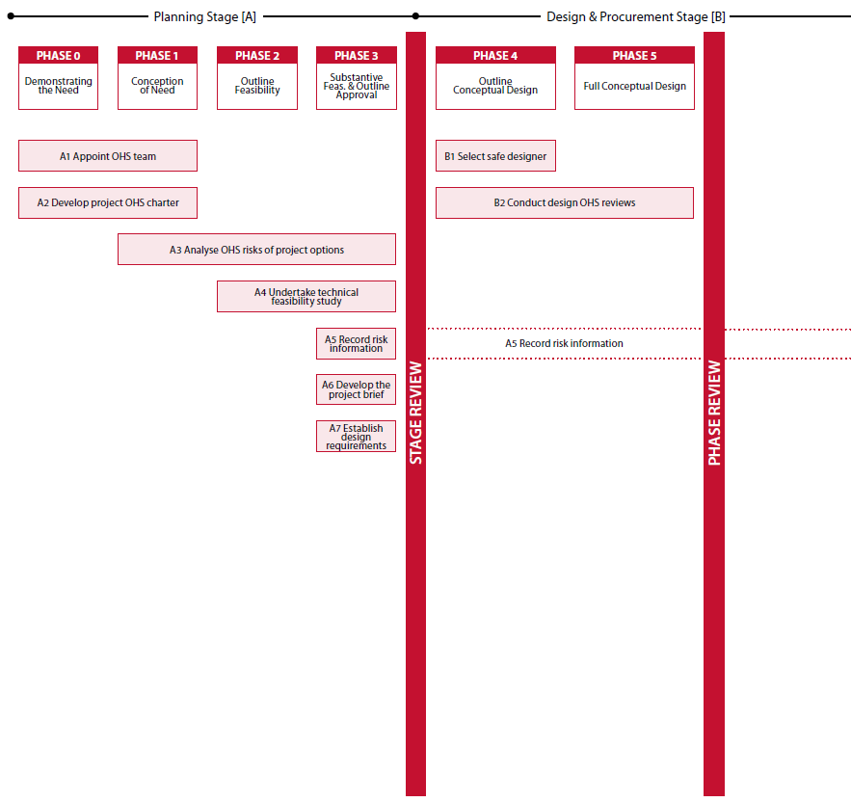

Figure 1: Project OHS map
Adapted from A Generic Guide to the Design and Construction Process Protocol (Kagioglou et al., 1998) [www.processprotocol.com]

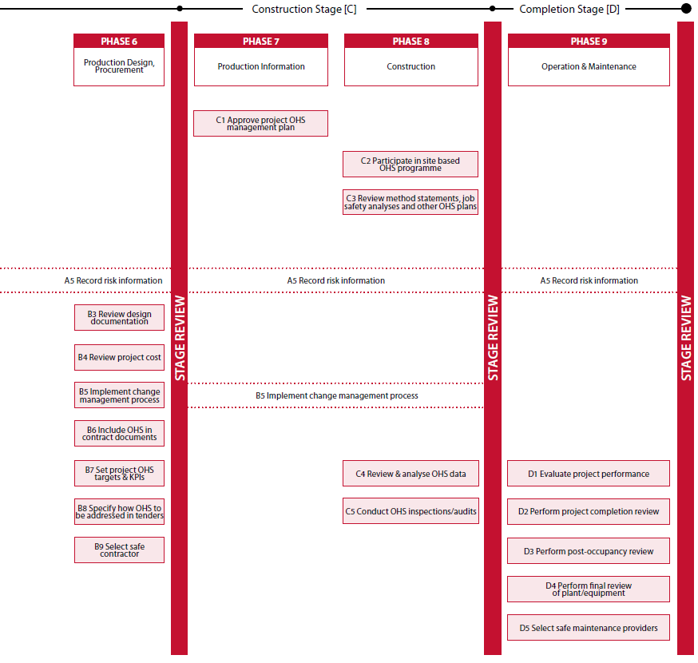

Figure 1 (continued): Project OHS map
Adapted from A Generic Guide to the Design and Construction Process Protocol (Kagioglou et al., 1998) [www.processprotocol.com]

Phase 7—Production information

‘Is the detail “right” for construction?’
The detail of the design should be determined to enable the planning of construction including assembly and enabling works. Preferably no more changes in the design should occur after this stage. Every effort should be made to optimise the design after consideration of the whole lifecycle of the product. –
Kagioglou et al. (1998)

Australian Government agencies—as model clients—should require contractors to prepare a project-specific
OHS management plan prior to the project commencing, to be approved by the client agency before the start of construction. The OHS management plan should describe how the contractor proposes to manage all areas of OHS risk on the project as well as site management, induction, training and communication strategies to minimise the risks for all personnel working on the project.

KMA C1 Approve project OHS management plan
The project specific OHS management plan should express explicit management/corporate commitment and be
developed with employee participation.

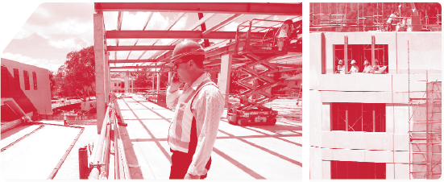
KMA C1 | Approve project OHS management plan
Action | Agencies should require contractors to submit a project OHS plan prior to taking control of the site. This plan must be checked and approved by the agency project OHS team.
Phases | - Phase 7—Production Information.
Description | The site-specific OHS management plan should specifically address:  - OHS responsibilities  - OHS policy  - management of subcontractors  - management of any design changes  - processes for employer–employee consultation  - processes for ensuring site safety compliance  - OHS monitoring and reporting processes  - audits/inspections  - major areas of hazard/risk and proposals for control  - emergency planning  - injury management and rehabilitation  - OHS training needs analysis and plan  - requirements for plant/machinery  - site logistics  - resources for OHS.
Key benefits | - OHS issues are comprehensively considered by the contractor prior to the commencement of construction.  - Responsibilities for the management of OHS in the construction team are clearly established.  - OHS management processes are identified and resources allocated to them.  - Contractors’ implementation of the OHS plan can be monitored through the construction stage.
Desirable  outcomes | - Onsite OHS issues are managed through careful pre-construction planning.
Performance  measure | - Comprehensive OHS management plan, approved prior to commencement of construction.
Documents | - C1.1 Project OHS plan review checklist

Phase 8—Construction

‘Are we ready to hand over the facility?’
The design fixity and careful consideration of all constraints achieved at the previous phase should ensure the ‘trouble-free’ construction of the product. Any problems identified should be analysed to ensure that they do not recur in future projects.
Kagioglou et al. (1998)

Once construction work commences, a model client should ensure that OHS objectives for the project are being met.
Australian Government agencies should take an active interest in project OHS activities. This involvement can take many forms and Australian Government agencies will have to determine their level of involvement based on available resources and the magnitude of project OHS risks. Examples include:

- participating in OHS training
- participating in team-based OHS risk assessment processes, such as job safety analyses
- conducting regular OHS inspections/hazard-spotting exercises or ‘safety walks,’
- participating in the investigation of any incidents that occur during construction
- establishing and chairing a project OHS committee
- including OHS as a priority item on the agenda of all client–contractor meetings relating to the project.

In most construction projects, the contractor engages in a process of ‘rolling wave planning’ in which progressively more detailed OHS plans are developed as construction activities evolve. At the start of each major construction process, a detailed safe work method statement will be produced and prior to the start of each work task, a job safety analysis will be conducted, in consultation with the work crew responsible for carrying out the task. Both the detailed safe work method statements and job safety analyses should adopt the same systematic approach to the management of OHS risk.

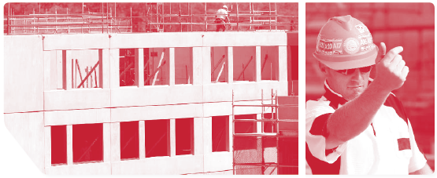
KMA C2 Participate in site-based OHS program
KMA C2 | Participate in site-based OHS program
Action | Agency personnel should actively participate in the onsite OHS program during the construction phase.
Phases | - Phase 7—Production Information.  - Phase 8—Construction
Description | The active involvement of agency personnel in OHS programs during the construction phases can play a very large part in reinforcing the importance placed on OHS by Australian Government agencies. While the contractor is primarily responsible for OHS during the construction phase, there are many things that agencies can do to support the contractor’s OHS program.  Activities linked to improved OHS performance are:  - client participation in OHS training and induction programs  - client participation in safety walks, site inspections and hazard-spotting exercises  - client participation in project OHS meetings  - client involvement in the investigation of incidents and near misses.  The involvement of agency personnel in such activities demonstrates that Australian Government agencies are genuinely committed to OHS and not solely interested in transferring OHS risk to the contractors they engage.
Key benefits | - Demonstration of agency leadership in construction OHS  - The development of agency–contractor ‘partnerships’ with regard to OHS
Desirable  outcomes | - Strong project OHS cultures driven by a shared understanding that OHS is ‘everyone’s responsibility.’  - Visible demonstration that Australian Government agencies are ‘caring clients’
Performance  measure | - Records of agency involvement in onsite OHS programs
Documents | - C2.1 Guidelines for agency participation in construction project OHS  - C2.2 Agency ‘site safety walk’ protocol  - C2.3 Site safety walk template  - C2.4 Incident investigation guidelines  - C2.5 List of possible incident causes

KMA C3 Review method statements, job safety analyses and other OHS plans
Contractors should use an appropriate methodology to identify hazards and assess the risks presented by those hazards. Strategies to eliminate or reduce OHS risks (based on the hierarchy of risk controls) should be selected and specified in method statements, job safety analyses and other construction planning documents. Client agencies should monitor and review the results of these processes to ensure OHS risks are being systematically managed duringthe construction stage.

KMA C3 | Review method statements, job safety analyses and other OHS plans
Action | Agencies should monitor contractors’ risk assessments and OHS planning processes to ensure that OHS risks are being systematically managed during the construction phases.
Phases | - Phase 8—Construction.
Description | Reviewing method statements, job safety analyses and other OHS plans for key elements important to each allows the agency to confirm that OHS is being considered before the commencement of construction work processes and that contractors are resourcing the OHS aspects of construction work appropriately.  Method statements, job safety analyses and other OHS plans should be developed specifically for the project and agencies should ensure that contractors do not include ‘generic’ risk assessments in their OHS planning documents without considering the specific hazards associated with the site. ‘Generic’ risk assessments include those conducted on previous projects that are ‘transferred’ onto the next project, using the justification that the work being conducted is the same.  Agency personnel should also assess the extent to which contractors’ OHS planning processes involve genuine participation of operatives who will perform the construction work (including those working for subcontractors). Agencies should also examine the efficacy with which the contents of method statements, job safety analyses and other OHS plans are communicated and satisfy themselves that this communication is being undertaken effectively.  Finally, agencies should examine the extent to which contractors monitor the implementation of their project OHS plans.
Key benefits | - OHS risks are identified and project-specific OHS plans are developed.  - OHS risks are anticipated and assessed before they arise on site.  - Appropriate controls for OHS risks are identified and resourced prior to the start of construction work tasks.
Desirable  outcomes | - Each task is specifically planned to ensure safe execution through planned risk mitigation strategies.
Performance  measure | - Formal review of contractors’ method statements, job safety analyses and other OHS plans
Documents | - C3.1 Agency checklist for safe work method statements (SWMS)/job safety analyses (JSAs)

KMA A5 Record risk information
The recording of risk information was instigated in the planning stage of the project. This required the development and maintenance of a risk register containing a record of all OHS issues identified through all stages of the project. The project risk register is an important communication tool in which OHS risk information is captured and communicated to different stakeholders who are engaged in the project over its lifecycle. An analysis of this historical record of OHS issues during the course of the project will reveal lessons that can be learnt and fed into OHS management processes for future projects. It is important that this risk record continue throughout the project.

KMA B5 Implement change management process
Similarly, KMA B5 was instigated during the design and procurement stage. This establishes a change management process for managing OHS aspects of changes to materials and methods and other aspects of the design. It is important that this change management continues throughout the construction stage.
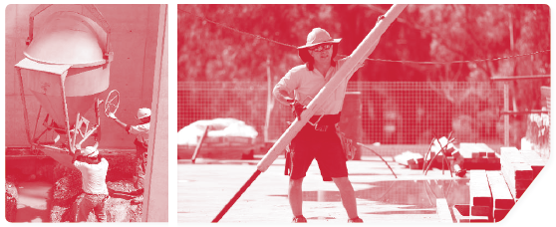

KMA C4 Review and analyse OHS data
Effective OHS management of construction projects also requires the measurement and monitoring of project OHS performance. This helps to identify weaknesses in OHS programs and enables timely corrective measures to be implemented.

Requirements for contractors to report project OHS performance regularly throughout the construction phase should already have been established in contract documents (see KMA B7). Agencies should monitor this reporting and undertake regular analysis of data provided. This data analysis should identify trends in OHS performance or recurring problems. Where OHS problems are detected, agencies should investigate the causes of problems and ensure that problems are rectified in an appropriate timeframe.

KMA C4 | Review and analyse OHS data
Action | Agencies should enforce contractual requirements for OHS reporting and analyse data to identify opportunities for the improvement of OHS processes or performance.
Phases | - Phase 8—Construction.
Description | Reviewing and analysing OHS data is an essential aspect of monitoring and evaluating contractors’ OHS performance. Collecting and analysing OHS data enables model clients to:  - get an indication of how individual contractors are performing in relation to OHS issues  - identify problem areas and appropriate improvement strategies  - measure the effectiveness of agency or contractor OHS management interventions  - give timely feedback to contractors regarding their OHS performance.  It is recommended that the OHS records of contractors are included in the agency’s own performance statistics, reflecting the philosophy that any injuries on the project are a negative reflection on the agency’s own OHS performance.  OHS performance reporting should include both ‘lead’ and ‘lag’ indicators, with the emphasis being on lead indicators. Lag indicators measure negative OHS outcomes, such as incidents, while lead indicators measure positive OHS processes, such as JSAs undertaken, safety walks or training.
Key benefits | - Early and accurate diagnosis of project OHS problems  - Focused development of OHS improvement strategies  - Evidence-based evaluation of the impact of agency/contractor OHS improvement interventions
Desirable  outcomes | - The use of project OHS data for benchmarking and comparative performance reviews
Performance  measure | - Agency OHS reports, including data gathered from contractors  - Agency OHS statistics, including contractors’ OHS performance  - Agency OHS reports, including both lead and lag indicators, with an emphasis on lead indicators
Documents | - C4.1 OHS reporting template

KMA C5 Conduct OHS inspections/audits
Agency representatives should participate jointly with the contractor in regular audits of OHS management processes on site and physical inspections of OHS aspects on worksites. Where unsafe practices are observed or management practices are found to be deficient, the agency and the contractor should agree on rectification measures within an appropriate time frame.

KMA C5 | Conduct OHS inspections/audits
Action | Agencies should undertake active monitoring of contractors’ OHS performance through planned inspections and audits.
Phases | - Phase 8—Construction.
Description | Active monitoring of project OHS performance should be undertaken through inspections of the physical work environment as well as through the audit of contractors’ OHS management processes and performance.  Active monitoring reinforces the agency’s interest in the OHS performance of their construction projects and is one aspect of agency leadership in OHS.  Where possible, it is recommended that ‘cross audits’ be conducted at regular intervals. Cross audits would be conducted by agency OHS team members, OHS specialists and construction personnel from other projects. The benefit of cross audits is that they provide an independent review of OHS management processes and facilitate the sharing of OHS best practice between projects and agencies.  The results of agency OHS inspections and audits should be clearly communicated to contractors, enabling them to rectify non-compliance where found, or improve aspects of their OHS management.  Agency OHS inspections and audits should involve contractors’ personnel and be undertaken as a team-based activity with the focus on improvement rather than on casting blame.
Key benefits | - Inspections and audits provide for the systematic evaluation of project OHS performance, enable the timely identification and rectification of OHS problems, and provide a basis for feedback to contractors regarding their OHS performance.
Desirable  outcomes | - Identification and resolution of OHS issues before the occurrence of incidents
Performance  measure | - Client agency audit/inspection schedule  - Audit/inspection reports  - Agency-contractor communication regarding audit/inspection findings and follow up improvement processes.
Documents | - C5.1 Site OHS inspection checklist/report

Stage review
A stage review should take place to review, confirm and approve all major decisions taken in the construction stage of the project. KMAs and their performance measures should be reviewed to ensure that the requirements of the Model
Client Framework have been met.

A suggested construction stage review template is in the appendix of this booklet.

Conclusion
The construction stage of the project is when the designed structure or facility will be built. It is at this stage that the impacts of OHS risks that have not been properly managed during the planning, design and procurement stages will be realised. In addition, new and often unforeseen OHS hazards and risks become apparent. Therefore it is very important that OHS management activities are firmly embedded and continue throughout the construction stage.
Although the construction site will be under the control of a principal or head contractor during this stage, there is still much that a model client can do to promote OHS during the construction stage.

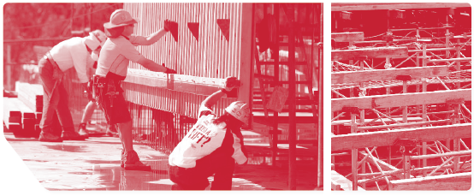

APPENDIX: Supporting Documents

The following documents can be downloaded from the OFSC website at fsc.gov.au.

Document C1.1 Project OHS plan review checklist 16
Document C2.1 Guidelines for agency participation in construction project OHS 22
Document C2.2 Agency ‘site safety walk’ protocol 24
Document C2.3 Site safety walk template 26
Document C2.4 Incident investigation guidelines 27
Document C2.5 List of possible incident causes 29
Document C3.1 Agency checklist for safe work method statement/job safety analyses 34
Document C4.1 OHS reporting template 37
Document C5.1 Site OHS inspection checklist/report 38
Construction stage review template 49

Document C1.1 Project OHS plan review checklist
This checklist has been developed to aid in the review of project-specific OHS plans. It is not exhaustive and particular attention should be paid to project-specific OHS risk areas. Formulation of the project-specific OHS plans should be based on details of the actual project and ‘generic’ project OHS plans are not acceptable.

Contractor details:

Project details:

Management and leadership
Issues | Yes/No | Comments  (details of decision to be recorded)
- Does the project OHS plan refer to the correct project and address?
- Have roles and responsibilities been designated for all key positions?
- Have OHS officers/advisors who are accountable to senior management been appointed to the project?
- Are OHS responsibilities clear between the agency and Contractor (acknowledgement of agency involvement in construction and completion stages)?
- Has a scheduling program been developed to enable work to be done safely, including any changes that may occur during the course of the project?
- Are there adequate arrangements to coordinate OHS aspects with other contractors and subcontractors on the project site?

Training
Issues | Yes/No | Comments  (details of decision to be recorded)
- Are resources and facilities provided and time allowed for project induction training, including OHS requirements and expectations?
- Have job/trade specific safety inductions necessary for safe completion of work been identified?
- Have training requirements for the project been identified? How will the contractor monitor training needs throughout the project?
- Are arrangements for maintaining records for inductions, training and competency appropriate?

Design controls
Issues | Yes/No | Comments  (details of decision to be recorded)
- Are there provisions to implement changes without introducing new OHS risks throughout the project (that is, is there an agency change management process)?
- How will approved changes be captured and incorporated on working drawings?
- Is the agency risk management methodology being used throughout the project, including details of any design risk assessment and resourcing for effective implementation?
- Is OHS a consideration in the purchasing and ordering of plant, equipment and supplies?
- Does the contractor have a suitable process to ensure that all plant and equipment brought on site is safe to use and complies with legislative requirements, that is, registration etc?

Risk management
Issues | Yes/No | Comments  (details of decision to be recorded)
- Is there a risk management process in place?
- Does the risk management process incorporate the agency’s risk management register as a minimum? To what extent have they incorporated the agency’s risk management requirements?
- Is there a process to facilitate the identification of risks throughout the project?
- Is the risk tolerance of the contractor compatible with the accepted risk tolerance of the agency? (refer to hierarchy of control)

Emergency procedures
Issues | Yes/No | Comments  (details of decision to be recorded)
- Has an emergency management procedure applicable for the site conditions and occupants been developed?
- Is there a program to ensure testing and revising of the emergency procedures?
- Has site security and public protection been addressed adequately, that is, hoarding, guarding etc?
- Have emergency contact details been provided?
- How will emergency situations be reported back to the agency and do the notification timelines meet the requirements of the agency?

Inspections and audits
Issues | Yes/No | Comments  (details of decision to be recorded)
- Has an OHS audit program involving appropriate levels of staff, together with independent safety and other experts, been set up?
- Has an inspection program involving appropriate levels of staff and agency personnel been developed?
- Does this allow for adequate time/resources to conduct and follow up identified issues?
- Has an assessment been undertaken to determine the need for environmental monitoring, both site-based as well as surroundings?
- How will the monitoring be implemented?
- Is there a plan to monitor frequency, thoroughness and results of inspections and audits?

Working procedures
Issues | Yes/No | Comments  (details of decision to be recorded)
- Are provisions to ensure a site layout plan covering temporary accommodation, storage, pedestrian and vehicular routes, plant location and emergency provisions devised prior to commencement of any works?
- Has a site-specific risk assessment been conducted?
- Does the risk assessment include hazards identified during the design stage?
- Is a Work Permit procedure required (that is, hot work, confined space etc)?
- Is this Work Permit procedure compatible with other contractors’ requirements?
- Are there safe working procedures for known activities? Do they meet the activity requirements of the project? If not, have the safe work method statements been changed to incorporate site-specific requirements?

Communication and consultation
Issues | Yes/No | Comments  (details of decision to be recorded)
- Have the agency’s KPIs been adopted with a commitment to report against each?
- Does the contractor’s OHS meetings/reporting reflect the agency’s requirements? (Does this include not only KPIs but also incidents and accidents?)
- Is there a process to inform adjoining and surrounding occupancies of changes due to the project that might impact upon OHS?
- How will information be disseminated across the site, including other contractors?
- How will incidents and accidents be reported? (This should include details on reporting to agency as well as legislative bodies.)
- Has the contractor acknowledged that the agency will be involved in accident/incident investigation and resolution?
- Has a schedule been developed of all meetings (including toolboxes) along with details of participants of the meetings — that is, will other contractors and subcontractors attend tool box talks, meetings etc? If not, why not?
- Will relevant OHS information be disseminated to employees, subcontractors and other contractors on site?
- Are agency OHS reporting requirements being met?
- Has a schedule outlining agency reporting requirements been developed?

Incident reporting and investigation
Issues | Yes/No | Comments  (details of decision to be recorded)
- How will hazards and incidents be reported?
- Are there details of how reports will be addressed, timelines for rectification/implementation and when investigations are to be carried out?
- Is there a strategy for informing the agency of investigation outcomes? Details should include both proactive and reactive strategies to ensure no repeat hazards or incidents occur.
- Are there details on how the contractor will manage any injury/illness?
- Is there a first aid program? (This may be covered in the emergency management plan depending on whether it is a full emergency management plan.)

Subcontractor management
Issues | Yes/No | Comments  (details of decision to be recorded)
- Are there provisions to ensure clear and decisive OHS responsibilities between the contractor and any subcontractors exist?
- Does the contractor have the safety requirements that any subcontractor working on the project needs to meet?
- Has the contractor clearly outlined the safety roles and responsibilities that a subcontractor is expected to perform? How will these requirements be communicated to the subcontractor?
- Has the contractor included subcontractor training and competency requirements in the site training requirements? (This may already be addressed under section 2, Training.)

Safety costs
Issues | Yes/No | Comments  (details of decision to be recorded)
- Has the contractor allocated sufficient resources (that is, finances, time, people etc) for effective safety implementation throughout the whole of the project, or to tasks in which they are involved in? (See also document B4.1 in booklet 3.)

Record management
Issues | Yes/No | Comments  (details of decision to be recorded)
- How and where will documentation be kept relating to the project? (Note: there are statutory requirements for storage of some documents.)

Other
Issues | Yes/No | Comments  (details of decision to be recorded)

Review details

Reviewer name:

Signature:

Title/position:

Reviewed: First review second review multiple reviews

Review Date:

Action

Has the project OHS management plan been accepted? Yes No

Does further information have to be submitted?

Management acknowledgement

Director/Manager:

Signature:

Has the project OHS management plan been accepted? Yes No

Date:

Comments:

Document C2.1 Guidelines for agency participation in construction project OHS
The following guidelines provide some suggestions as to how agencies could promote OHS during the construction
stage of projects. The suggested activities can easily be extended to include other OHS activities appropriate for a
particular project. Agencies should decide their level of involvement according to the inherent OHS risk, but innovative
ways to promote OHS are encouraged.

Why?
Building and construction is one of the highest risk industries in Australia and is one of the most dangerous sectors to work in. Through strong safety leadership a model client can positively impact on the safety of contractors they engage, contributing to the reduction of death, injury and work-related illness during the construction stage. By visibly demonstrating their commitment to OHS, model clients can communicate the importance of OHS and gain further insight into the OHS issues encountered during the construction of a facility.

Model client OHS leadership is about demonstrating agency support of contractors’ OHS programs, as well as providing an opportunity for ‘two way’ discussion between contractors and subcontractors. Active, visible OHS leadership and involvement contribute to the development of a robust OHS culture of projects undertaken on behalf of the agency.

How?
Agencies can show their commitment to safety by:
- attending OHS audits
- conducting ‘site safety walks’
- participating in toolbox talks
- attending site/project OHS committee meetings
- conducting/participating in accident and incident investigations.

A number of the activities listed above may be done in a single site visit. It should be noted that these activities are in addition to the standard obligations associated with contractual obligations such as safety data analysis, contractor safety meetings etc.

When?
The schedule below provides examples and frequencies at which agencies might get involved in site OHS programs.
These examples are the minimum involvement recommended and depend on the complexity and level of OHS risk presented by a particular project:

Example Activity | When to undertake activity
Site inspections | - every 4 months
Site safety walks | - every 3 months
Toolbox talks | - every 6 months
OHS site committee meetings | - every 6 months
Accident/incident investigation | - in the case of a Reportable Injury (as defined by legislation)  - in the case of a repeat injury (suggesting a recurrent OHS problem)  - in the case of a Lost Time Injury  - when a worker is rendered unfit for original duties as a result of a work exposure.

Who?
The agency needs to determine who is best to fulfil the OHS participation role. However, the agency representative should be a senior person with authority to make OHS decisions and be equipped with appropriate levels of OHS knowledge and competence to perform the required tasks.

Document C2.2 Agency ‘site safety walk’ protocol
A key initiative of the model client is to show OHS leadership, by supporting the OHS activities of contractors, and participating in these activities, as appropriate, during the construction stage. An area in which leadership can easily be demonstrated is in the conduct of ‘site safety walks’. Site safety walks require senior agency staff to visit the project site/s during the construction stage, observing OHS activities and discussing OHS with site personnel.

Through ‘site safety walks’, contractors and subcontractors will recognise a model client’s commitment to OHS as a key project value.

The Do’s | The Don’ts
- Comment on OHS activities, recognising good performance and questioning areas of concern. | - Avoid blaming OHS deficiencies on site-based personnel.
- Discuss OHS experiences and concerns with site-based personnel, especially issues associated with agency activity. | - Avoid making hasty judgements about the causes of safety problems observed — consider design and planning factors that could have contributed.
- Engage contractors and subcontractor personnel in conversation about the importance of OHS. | - Avoid making examples of site-based personnel — offer constructive comment during and after the safety walk.

The involvement of contractors and subcontractors in site safety walks is crucial. Advise the contractors of planned site safety walks well before they occur. Remember, unlike inspections, site safety walks are not about uncovering safety concerns but more about demonstrating the model client’s commitment to and interest in the OHS of project personnel during the construction stage. Focus should be on honest and open discussion.

What you need to do before visiting the project site
- Develop a schedule. The schedule will include the date of the walk, the time and location. The schedule should span the entire construction stage. Schedule visits to maintain high visibility. Note: the site visit does not need to take a whole day. Remember this is a working construction site and minimal interruption is your goal.
- Determine what aspects of the project you will be looking at. For example, you may want to talk to workers on the project and look at the incident register, or you may attend a toolbox talk and discuss a particular OHS process.
- Advise the principal contractor of your visit and what aspects you are planning to look at. Arrangements and resources may be needed to facilitate access to the desired areas.
- Allow time for any OHS requirements that may need to be undertaken, for example site induction.
- Familiarise yourself with the project. Know what construction activities are taking place and which subcontractors will be on site.
- Be aware of the OHS requirements of the operating site, that is, safety shoes, hard hat etc.

What should you discuss on your safety walk?
Discussion should be open and honest. You are there to listen, discuss the issues and gain insight into the OHS aspects of the construction stage.
- Talk to the contractors about the project.
- Find out about any OHS issues that are of concern, for example site design, tasks being performed etc.
- Ask how site personnel think OHS could be better improved in the project’s construction stage, in particular issues relating to the agency’s management activities.
- Find out what is working well.
- Record all relevant OHS information that emerges during the site safety walk.

What to do after the safety walk
- Once you have completed the safety walk you need to review and assess the information recorded. Information
- relevant to future agency projects should be recorded in the project risk register, allowing for continuous
- improvement of agency OHS practice.
- Share the learnings of your safety walk with the contractors and subcontractors. There may be project-specific OHS
- issues that need addressing.
- Thank all those involved in providing access and facilitating the site safety walk.

Document C2.3 Site safety walk template
It is important to involve contractors and subcontractors in site safety walks and to record observations made. Follow-up actions for OHS issues should be specified and recorded for implementation by appropriate persons involved in the project.

Project details:

Date of the site safety walk:

Person doing site safety walk:

Planned areas for the site safety walk:

Contractors/subcontractors involved:

Remember:

The Do’s | The Don’ts
- Comment on OHS activities, recognising good performance and questioning areas of concern. | - Avoid blaming OHS deficiencies on site-based personnel.
- Discuss OHS experiences and concerns with site-based personnel, especially issues associated with agency activity. | - Avoid making hasty judgements about the causes of safety problems observed — consider design and planning factors that could have contributed.
- Engage contractors and subcontractor personnel in conversation about the importance of OHS. | - Avoid making examples of site-based personnel — offer constructive comment during and after the safety walk.

Site safety walk observations:

No | Observation | Action
1
2
3
4
5
6

Document C2.4 Incident investigation guidelines
Incident investigation is a systematic approach that seeks to identify the cause/s of an OHS incident and to recommend remedial action to prevent a similar occurrence in the future. The focus of the investigation is on obtaining accurate information, including eyewitness accounts wherever possible. The purpose is to prevent further injuries or damage.

Objectives of a model client incident investigation
Once an agency has been notified of an incident they should make sure that the incident is thoroughly investigated by the relevant construction contractors to:
- uncover and improve weaknesses in OHS management systems
- identify remedial action to prevent recurrence
- demonstrate client commitment to OHS
- learn from the incident and improve OHS performance in the current and future projects.

Key aspects of the investigation:
Incident investigation should:
- set out the goal of getting cooperation and involvement from contractors/subcontractors, agency employees and others
- not try to find someone to blame for the accident — although holding people accountable in situations in which they have acted dangerously or negligently is also important
- involve the comprehensive analysis of all circumstances and the identification of immediate and system causes of the incident
- record details in an appropriate report format, including the following information:
  - all the basic facts (who/when/where/how/why)
  - preventative action taken by the contractor/subcontractor
  - preventative action taken by the agency
  - action to prevent recurrence, or occurrence in other similar situations.

Contractors should be required to provide an action plan identifying responsibility and timelines for taking preventative measures to prevent a recurrence of the incident.

Recommended steps for agencies to follow when an incident has occurred

Step 1 — Get the facts
- Make sure that all relevant details of the incident are provided by the contractors, including the time of the incident, personnel involved, the location of the incident, the nature and severity of the injury or other damage arising, the circumstances in which the incident occurred, including the sequence of events leading up to the incident, and any plant/equipment or machinery involved.
- If appropriate, photographs of the scene or copies of witness statements might be sought.

Step 2 — Review the data
- The data provided should be reviewed to identify contractors’ management systems failures underlying the incident.
- Identify areas in which the agency may have contributed to the incident, and those preventive actions which may have reduced the risk of the incident.

Step 3 — Recommend remedial action
- The agency should ensure that appropriate preventive strategies are identified and that contractors plan and resource their implementation.
- The agency should also identify any preventive strategies that could prevent similar incidents in future projects, and ensure that these are recorded and integrated into agency OHS management practices.

Step 4 — Follow up and evaluate
- The agency should monitor the implementation and effectiveness of the preventative actions implemented by the relevant construction contractors.
- Preventive strategies should be assessed to ensure that they do not create other unexpected OHS risks.

Document C2.5 List of possible incident causes
Below is a list of possible immediate causes and system causes that should be considered in incident investigation. It can be used as a guide for the identification of causal factors once incident information has been collected and recorded.

Possible immediate causes

Following procedures | Inattention/lack of awareness
- violation by individual  - violation by group  - violation by supervisor  - operation of equipment without authority  - improper position or posture for the task  - over exertion of physical capability  - work or motion at improper speed  - improper lifting  - improper loading  - shortcuts  - other | - improper decision making or lack of judgement  - distracted by other concerns  - inattention to footing and surroundings  - horseplay  - acts of violence  - failure to warn  - use of drugs or alcohol  - routine activity without thought  - other

Use of protective methods | Protective systems
- lack of knowledge of hazards present  - PPE not used  - improper use of proper PPE  - servicing of energised equipment  - equipment/materials not secured  - disabled guards, warning systems or safety devices  - removal of guards, warning systems or safety devices  - PPE not available  - other | - inadequate guards or protective devices  - defective guards or protective devices  - inadequate PPE  - defective PPE  - inadequate warning systems  - defective warning systems  - inadequate isolation of process/equipment  - inadequate safety devices  - defective safety devices  - other

Work exposure | Workplace layout
- fire/explosion  - noise  - energised electrical systems  - energised systems, other than electrical  - radiation  - temperature extremes  - hazardous chemicals  - mechanical hazards  - clutter or debris  - storms or acts of nature  - slippery floors/ walkways  - other | - congestion or restricted motion  - inadequate or excessive illumination  - inadequate ventilation  - unprotected height  - inadequate workplace layout:  - controls less than adequate  - displays less than adequate  - labels less than adequate  - locations out of reach or sight  - conflicting information  - other

Tools, equipment and vehicles | Use of tools/equipment
- defective equipment  - inadequate equipment  - improperly prepared equipment  - defective tools  - inadequate tools  - improperly prepared tools  - defective vehicle  - inadequate vehicle for the purpose  - incorrectly prepared vehicle  - other | - improper use of equipment  - improper use of tools  - being aware of use of defective equipment  - being aware of use of defective tools  - improper placement of tools, equipment or materials  - operation of equipment  - servicing of equipment in operation  - other

Possible System Causes

Physical capability
- vision deficiency
- hearing deficiency
- other sensory deficiency
- reduced respiratory capacity
- other permanent physical disability
- temporary disability
- inability to sustain body positions
- restricted range of body movement
- substance sensitivities or allergies
- inadequate size or strength
- diminished capacity due to medication

Physical condition
- previous injury or illness
- fatigue, due to:
  - workload
  - lack of rest
  - sensory overload
  - atmospheric pressure variation
- blood sugar insufficiency
- impairment due to drug or alcohol use

Mental state
- poor judgement
- memory failure
- poor coordination or reaction time
- emotional disturbance
- fears or phobias
- low mechanical aptitude
- influenced by medication

Mental stress
- preoccupation with problems
- frustration
- confusing directions/
- demands
- conflicting directions/demands
- meaningless or degrading activities
- emotional overload
- extreme demands on judgment/decision making
- extreme demands on concentration/perception
- extreme boredom

Behaviour
- improper performance is rewarded
- improper supervisory example
- inadequate identification of critical safe behaviours
- inadequate reinforcement of critical safe behaviours
- inappropriate aggression
- improper use of production incentive
- supervisor implied haste
- employee perceived haste

Skill level
- inadequate assessment of required skills
- inadequate practice of skill
- infrequent performance of skill
- lack of coaching on skill
- insufficient review of instruction to establish skill

Training/knowledge transfer
- inadequate knowledge transfer
  - inability to comprehend
  - inadequate instructor qualification
  - inadequate training equip
  - misunderstood instructions
- inadequate recall of training material
- inadequate training effort
- no training provided

Management supervision/ employee leadership
- conflicting roles/responsibilities
- inadequate leadership
- inadequate correction of prior hazard/incident
- inadequate identification of worksite/job hazards
- inadequate management of change system
- inadequate incident reporting/investigation system
- inadequate or lack of safety meetings
- inadequate performance measures and assessment

Contractor selection & oversight
- lack of contractor prequalification
- inadequate contractor prequalification
- inadequate contractor selection
- use of non-approved contractor
- lack of job oversight
- inadequate oversight

Engineering/design
- inadequate technical design
  - design input obsolete
  - design input not correct
  - design input not available
  - design input infeasible
  - design output unclear
  - design output not correct
  - design output inconsistent
  - no independent design review
- inadequate standards, specification and/or design criteria
- inadequate ergonomic design
- inadequate monitoring of construction
- inadequate assessment of operational readiness
- Inadequate evaluation and/or documentation of change

Purchasing, material handling & material control
- incorrect item received
  - inadequate specification to vendor
  - inadequate specifications
  - inadequate control on changes to orders
  - unauthorised substitution
  - inadequate product acceptance
  - no acceptance verification
- inadequate research on materials/equipment
- Improper handling of materials
- improper storage of materials
- improper identification of hazardous materials
- inadequate use of safety and health data

Communication
- inadequate horizontal communication between peers
- inadequate vertical communication between supervisor and person
- inadequate communication between different organisations
- inadequate communication between work groups
- inadequate communication between shifts
- inadequate communication method
- no communication method available
- incorrect instructions
- inadequate communication due to job turn over
- inadequate communication of safety and health data, regulations or guidelines
- standard terminology not used
- verification techniques not used
- messages too long
- speech interference

Tools and equipment
- inadequate assessment of needs and risks
- inadequate human factors/ergonomic considerations
- inadequate standards or specs
- availability
- inadequate adjustment/repair/ maintenance
- inadequate removal/ replacement of unsuitable items
- no equipment history
- inadequate equipment history

Work rules/Policies/ Procedures (PP)
- lack of PP for the task
  - lack of defined responsibility
  - lack of job safety analysis
  - inadequate job safety analysis
- inadequate development of PP
- inadequate implementation of PP due to deficiencies
  - contradictory requirement
  - confusing format
  - more than one action per step
  - no check-off spaces provided
  - inaccurate sequence of steps
  - confusing instructions
  - technical error/missing steps
  - potential situations not covered
- inadequate enforcement of PP
  - inadequate monitoring of work
  - inadequate supervisory knowledge
  - inadequate reinforcement
  - non-compliance not corrected
- inadequate communication of PP

Document C3.1 Agency checklist for safe work method statement/job safety analyses
A safe work method statement (SWMS) or job safety analysis (JSA) should be conducted by the contractor and submitted to the agency for review before any work starts. The assessments are to be project specific. Safety assessments will provide evidence that the contractor has systematically assessed the OHS risk in an activity and planned to undertake the work in a safe manner. Client agencies should monitor and review the results of these processes to ensure OHS risks are being systematically managed during the construction stage.

SWMS/JSA formats can vary between contractors. The table below provides information on some of the key OHS issues to look for when reviewing a SWMS or JSA:

Action | What the contractor does | What the model client does | Details accepted? Yes/No | Agency comments
Assessment administration | The details of the project the assessment relates to | Ensure that the documentation received relates to the correct project. Review the project reference number, address, project name etc. This may seem a basic and trivial issue but too often generic assessments or assessments conducted for other project are re-hashed without consideration of project-specific issues. | Yes  No
Assessment administration | The date and origin of the assessment | The date the assessment needs to be current and relative to when the project was awarded to the contractor. Assessments dated well before a contract has been awarded indicate that the JSA/SWMS is a generic assessment and may not consider project-specific hazards. | Yes  No
Document the activity | Details of the task or process being assessed are recorded, step by step. | What is being reviewed, for example, is it the erection of scaffolding to the perimeter of the project site?  Make sure that what is being assessed is clear. | Yes  No
Identify the hazards | The contractor will look at each step in turn and identify all of the hazards that are present for each job step. | The client is not expected to determine if the contractor has identified all the hazards, but as a reviewer the client should have some knowledge of the tasks being assessed. Hazards identified during the design stage should be reviewed to ensure that the contractor has incorporated those into their assessment. | Yes  No
Assess the risk | Once the hazards have been identified the contractor will evaluate the risks arising from the hazards and decide whether the existing safety control measures are adequate or whether more should be done to get rid of the hazard or to control the risks. | The model client should look for the risk rating for each risk. This will show the level of risk associated with the task being performed. It will also play a major role in determining the controls/strategies required to reduce that risk to an acceptable level. The risk rating should adequately reflect the task being assessed. | Yes  No
Document the control measures | For each assessed and described risk, the contractor should document the most practical, preferred control measures required to eliminate or minimise those risks. This should be in line with the hierarchy of control.  Risk control decisions should also be consistent with the requirements of any relevant state/territory OHS legislation, regulations, codes of practice or other standards or guidelines. | The client should review the controls that will be put in place. The risk rating should determine the controls. Reference should be made to the hierarchy of control — a useful tool which indicates which of the types of control measure provides a better level of risk control. The higher in the hierarchy of control, the better and more reliable the control is.  1. Elimination (the most desirable option) — means that the hazard is completely eliminated, that is, that task is no longer done.  2. Substitution — whereby a substance or a process can be substituted for something else that has less potential to cause injury.  3. Isolation/engineering — where a structural change can be made to the work environment or work process, that is, installation of railings between pedestrian movement and forklifts.  4. Administrative — implementing policies, procedures, training or other administrative actions.  5. Personal protective equipment (PPE) (the least desirable option) — When you can't reduce the risk of injury in any other way, use personal protective equipment (gloves, goggles etc) as a last resort.  In practice, several control options are often used in combination. Personal protective equipment is usually used in conjunction with other control measures.  Being a model client means that you ensure that the appropriate controls are chosen based on the level of risk. A high risk = high hierarchy of control. | Yes  No
Identify who is responsible | Identification of the individuals who are responsible for ensuring compliance with the assessment | It is not enough to identify the risk and determine what controls will be applied. A person needs to be nominated who will ensure that all actions required to be taken will be undertaken. Look for a person’s name.  The JSA provides a written record of the process to be used to proceed on a task. As it is a record that can be used in court, it should be signed off by the parties who have responsibility for the tasks. | Yes  No

Review date:

Reviewer:

Position/title:

Signature:

Signed off by:

Position/title:

Signature:

Note: A Manager/Director is required to sign off the JSA review

Document C4.1 OHS reporting template
Construction contractors should be required to regularly report on project OHS performance, against pre-determined OHS key performance indicators, and project OHS goals and targets. Where performance is below target, or goals have not been met, model client agencies should identify appropriate actions to improve project OHS performance. These actions should be decided in consultation with the relevant construction contractors, in particular, personnel undertaking the construction tasks involved. This OHS reporting template could be used to record these actions.

KPI agency review
Reporting period:

Site/project details:

Workgroup/contractor details:

Task/s being performed:

Are there any areas where OHS performance falls below the pre-determined OHS key performance indicators, or project OHS goals and targets?

Yes No

If Yes, how many?

List the non-compliance in the table below

KPI | Target met?  Yes/No | Details of non-compliance | Action to be taken  (if no action is to be taken, record reasons)

Reviewed by:
OHS team delegate:
Signature:
Date:

Manager/Director:
Signature:
Date:

Other — name:
Signature:
Date:

Document C5.1 Site OHS inspection checklist/report
The issues identified in the following checklist have been provided as an example only. Model clients may choose to review a limited number of topics per inspection. Questions contained in each topic should be built on to make a more comprehensive checklist.

1. Administration /general | Yes,No,N/A | If the answer is 'no' — then | Person responsible to action | Date due | Date completed
Is signage alerting workers to site safety requirements visible? (hard hat, hi-vis clothing etc) | Yes  No  N/A
Are inductions taking place? | Yes  No  N/A
Are safety notice board/s erected on the site? | Yes  No  N/A
Do workers know how to report injuries, incidents or near misses? | Yes  No  N/A
Are incident report forms available and used for each incident? | Yes  No  N/A
Are potable water and toilet facilities available? | Yes  No  N/A
Are ‘Permit to Work’ permits being issued when required? (review sample) | Yes  No  N/A

2. Personal safety | Yes,No,N/A | If the answer is 'no' — then | Person responsible to action | Date due | Date completed
Are safety glasses and/or goggles available and being used? | Yes  No  N/A
Is eye protection being worn for tasks such as grinding, welding? | Yes  No  N/A
Is hand protection used/worn as required? | Yes  No  N/A
Is foot protection worn as required? | Yes  No  N/A
Is hearing protection worn where required? | Yes  No  N/A
Are hard hats worn on the construction site? | Yes  No  N/A
Are respirators used if required? Type? | Yes  No  N/A
Is appropriate/required clothing being worn? | Yes  No  N/A
Is the appropriate PPE (safety glasses, gloves, respirators etc) available when required? | Yes  No  N/A
Do employees know to report personal safety concerns? | Yes  No  N/A

3. First Aid | Yes,No,N/A | If the answer is 'no' — then | Person responsible to action | Date due | Date completed
First Aiders are on site and can be easily identified? | Yes  No  N/A
Are emergency contact phone numbers displayed in a prominent location? | Yes  No  N/A
Are First aid kits fully stocked? (Sample no. ___ reviewed) | Yes  No  N/A
Do employees know where to access first aid? | Yes  No  N/A
Is a First Aid officer readily available during normal work hours? | Yes  No  N/A

4. Floors, walkways, aisles and work areas | Yes,No,N/A | If the answer is 'no' — then | Person responsible to action | Date due | Date completed
Are paths of travel free of trip hazards (for example electrical cords)? | Yes  No  N/A
Are doorways/access ways clear of material or equipment? | Yes  No  N/A
Are paths of travel kept free of slip hazards (for example oil, grease, water)? | Yes  No  N/A
Are paths of travel separated from moving plant and equipment? | Yes  No  N/A
Are lighting levels in the work areas adequate? | Yes  No  N/A
Are corridors and paths of travel adequately lit? | Yes  No  N/A
Are work areas free of non essential items and debris? | Yes  No  N/A

5. Stairs | Yes,No,N/A | If the answer is 'no' — then | Person responsible to action | Date due | Date completed
Are stairwells clear of materials and equipment? | Yes  No  N/A
Are stairs and handrails in good condition? | Yes  No  N/A
Are stairs provided with anti slip finish? | Yes  No  N/A
Are all internal stairs adequately illuminated? | Yes  No  N/A

6. Fall protection | Yes,No,N/A | If the answer is 'no' — then | Person responsible to action | Date due | Date completed
Are openings in floor and roof protected? | Yes  No  N/A
Are openings in walls less than 1m from floor level protected? | Yes  No  N/A
Is perimeter guarding installed to perimeter of building and other structures? | Yes  No  N/A
Is perimeter guarding installed around pits, shafts and other excavations? | Yes  No  N/A
Is perimeter guarding installed around skylights and to fragile surfaces? | Yes  No  N/A
Have active systems been put in place to prevent objects from falling onto workers below? | Yes  No  N/A
Do workers working out of a boom lift wear a safety harness/lanyard/shock absorber attached to a fixed anchorage point in the basket? | Yes  No  N/A

7. Ladders (review a sample of ladders) | Yes,No,N/A | If the answer is 'no' — then | Person responsible to action | Date due | Date completed
Are ladders on site industrial grade with a minimum load rating of 120kg? | Yes  No  N/A
Are ladders placed at a slope of 4 (vertical) to 1 (horizontal)? | Yes  No  N/A
Are ladders on a stable, firm footing and secured top and bottom against movement? | Yes  No  N/A
Are ladders being used correctly? (for example, are workers placing both feet rest on the ladder and are no higher than the third tread from the top plate of a step ladder or 900mm from the top of a single or extension ladder) | Yes  No  N/A
Is the area under ladder a restricted work area for other workers? | Yes  No  N/A
Is the ladder located in access areas, walkways, traffic ways or within the arc of swinging doors? | Yes  No  N/A
Are there any ladders on scaffolds or elevating work platforms to gain extra height? | Yes  No  N/A
Are there any ladders positioned near an exposed edge or a guardrail where, if the ladder toppled, a person could fall over that edge? | Yes  No  N/A
Are there any ladders located near electrical power lines? | Yes  No  N/A
Does the ladder extend at least 1 metre past surface or workface? | Yes  No  N/A
8. Confined spaces and excavations | Yes,No,N/A | If the answer is 'no' — then | Person responsible to action | Date due | Date completed
Are workers working or entering unsupported excavations that are not shored or battered? | Yes  No  N/A
Is safe access/egress provided from the excavation? | Yes  No  N/A
Are appropriate permits being completed for work in confined spaces? | Yes  No  N/A
Are those excavating aware of the existence of any underground services in close proximity to the excavations? | Yes  No  N/A
Are all holes, piles and excavations covered or barricaded to prevent persons from falling in? | Yes  No  N/A

9. Public protection/security | Yes,No,N/A | If the answer is 'no' — then | Person responsible to action | Date due | Date completed
Have protective platforms, screens etc been erected to protect the public from any falling objects? | Yes  No  N/A
Is there adequate lighting to all public areas surrounding the site? (for example lighting under gantries) | Yes  No  N/A
Have site hoarding, barricading etc been installed to the perimeter of the site? | Yes  No  N/A
Have appropriate warning/restriction signs been placed on the perimeter of the site? | Yes  No  N/A
Are there appropriate security controls in place to monitor site access? | Yes  No  N/A
Is the traffic management plan being implemented? | Yes  No  N/A
Are there onsite storage facilities and are they secure? | Yes  No  N/A
Can the site be made secure when there is no work taking place? | Yes  No  N/A

10. Electrical | Yes,No,N/A | If the answer is 'no' — then | Person responsible to action | Date due | Date completed
Is there any work being conducted near powerlines? | Yes  No  N/A
Is there clear access to electrical panels and switches? | Yes  No  N/A
Do temporary boards have Residual Current Devices (RCDs) fitted? | Yes  No  N/A
Are there any double adaptors or piggyback plugs being used? | Yes  No  N/A
Are there cords on the ground that can come into contact with water or moving plant? | Yes  No  N/A
Are electrical equipment and cords tagged and in date? (sample number to be reviewed) | Yes  No  N/A

11. Scaffolding | Yes,No,N/A | If the answer is 'no' — then | Person responsible to action | Date due | Date completed
Is scaffolding on a stable, level foundation with proper base plates? | Yes  No  N/A
Are platforms for workers or where materials are stored fully planked and fitted with guardrails, mid-rails and toeboards? | Yes  No  N/A
Is the scaffolding fitted with a safe, secure temporary stairway or ladder to access the working deck? (see ‘Ladders’) | Yes  No  N/A
Is protection provided to prevent vehicular impact? | Yes  No  N/A

12. Mobile plant | Yes,No,N/A | If the answer is 'no' — then | Person responsible to action | Date due | Date completed
Is mobile plant inspected daily prior to use? | Yes  No  N/A
Is the counterweight slewing area clear of obstacles and barricaded? | Yes  No  N/A
Do loads on cranes pass overhead of workers and/or the public? | Yes  No  N/A
Are site speed limits for mobile plant being adhered to? | Yes  No  N/A
Are seatbelts installed in mobile plant being used? | Yes  No  N/A

13. Dangerous goods/hazardous substances | Yes,No,N/A | If the answer is 'no' — then | Person responsible to action | Date due | Date completed
Is the dangerous goods register up to date? | Yes  No  N/A
Are all dangerous goods clearly identifiable and stored correctly? | Yes  No  N/A
Are material safety data sheets available for all dangerous goods and hazardous substances on site? | Yes  No  N/A

14. Emergencies | Yes,No,N/A | If the answer is 'no' — then | Person responsible to action | Date due | Date completed
Are emergency evacuation procedures posted in the main work areas? | Yes  No  N/A
Is the emergency telephone number clearly displayed (e.g. stickers on phones, coasters, phone lists, etc.)? | Yes  No  N/A
Are fire extinguishers easily accessible and signposted? | Yes  No  N/A
Check the tags attached to fire extinguishers — have the fire extinguishers been inspected within the last six months? | Yes  No  N/A
Are the exits clearly visible and clear of obstructions? | Yes  No  N/A

15. Accidents/incidents and first aid | Yes,No,N/A | If the answer is 'no' — then | Person responsible to action | Date due | Date completed
Are the accident/incident report book/forms readily available to staff? | Yes  No  N/A
Are the details of First Aid officers up to date on noticeboards and other website listing? | Yes  No  N/A
Are posters/notices indicating the contact details of the First Aid officers on display? | Yes  No  N/A
Are the First Aid officers keeping their First Aid kit stocked and are they aware that they should never include medication (including headache preparations or pain killers of any kind)? | Yes  No  N/A

Number of safety breaches noted during this inspection:

Details of agency personnel 1:
Name:
Signature:

Details of agency personnel 2:
Name:
Signature:

Details of contractor representative:
Name:
Signature:

Copy of inspection sheets to:

Note: Copy of safety inspection report must be supplied to principal contractor.

Signature:
Date:

Stage Review

Construction stage review template
This stage review template can be used to verify that the construction stage KMAs have been implemented prior to progressing to the final project stage in the Model Client Framework: completion.

Construction stage review

C1 Approve project OHS management plan | Assessment | Actions
- comprehensive OHS management plan, approved prior to commencement of construction

C2 Participate in site-based OHS program | Assessment | Actions
- records of agency involvement in onsite OHS programs, including:
  - site safety walks
  - OHS training and induction programs
  - site inspections and hazard-spotting exercises
  - project OHS meetings
  - investigation of incidents.

C3 Review method statements, job safety analyses and other OHS plans | Assessment | Actions
- formal review of contractors’ method statements, job safety analyses and other OHS plans

C4 Review and analyse OHS data | Assessment | Actions
- agency OHS reports, including data gathered from contractors
- agency OHS statistics including contractors OHS performance
- agency OHS reports including both lead and lag indicators.

C5 Conduct OHS inspections/audits | Assessment | Actions
- client agency audit/inspection schedule
- audit/inspection reports
- agency–contractor communication regarding audit/inspection findings and follow up improvement processes

Further information
This booklet is the fourth in a series about clients promoting safe construction. Further information about the Model Client Framework is available from the Office of the Federal Safety Commissioner.
FSC Assist Line: 1800 652 500
Internet: www.fsc.gov.au
Email: ofsc@jobs.gov.au

ISBN (set) 978-0-642-32687-4 (print)
978-0-642-32693-5 (online)
ISBN 978-0-642-32663-8 (print)
978-0-642-32669-0 (online)

© Commonwealth of Australia 2008

This work is copyright. You may download, display, print and reproduce this material in unaltered form only (retaining this notice) for your personal, non-commercial use or use in your organisation. Apart from any use as permitted under the Copyright Act 1968, all other rights are reserved.

The Australian Government, its employees, officers and agents do not accept any liability of the results of any action taken in reliance upon, based on or in connection with this document. To the extent legally possible, the Australian Government, its employees, officers and agents, disclaim all liability arising by reason of any breach of any duty in tort (including negligence and negligent misstatement) or as a result of any errors and omissions contained in this document.

Acknowledgements
The authors would like to acknowledge that the project process map is based upon A Generic Guide to the Design andConstruction Process Protocol developed by Kagioglou et al. (1998), The University of Salford, UK. Boxed and shaded descriptions of project phases are quoted directly from this Protocol. The Office of the Federal Safety Commissioner would like to thank Dr Helen Lingard, Dr Nick Blismas, Ms Tracy Cooke and Mr David Jellie from the School of Property, Construction and Project Management, RMIT University, who contributed to the development of this resource.

