APPLICATION FORM

Project Title
Project titles should be no more than 15 words long and should clearly and succinctly describe what the project will be doing. Do not use capitals except for proper nouns and the first word of the title. We recommend you limit the use of punctuation.
My project title is exactly fifteen words long and fits very neatly into this space

Lead Institution
Curtin
UTS
QUT
UniSA
RMIT

Project Leader
Title
First Name
Surname
Email
Phone | Enter the two-digit area code followed by an eight-digit landline or a mobile number.
Location | Please include the address in full, including office and building number.

Priority Area
Select the programme priority area being addressed by the application. Only one priority area can be selected.
Enhancing Employability in the Micro-credential Era

Interdisciplinary WIL

Authentic Assessment

Amount (excl GST) in AUS$
State the amount of funding being requested from the ATN i.e. not including any institutional contributions.
Funding requested | AUS$

Team Agreement (are all team members in agreement with this proposal?)
Yes
No

Are you currently involved in any other learning and teaching projects funded by another source, including the OLT, ARC, NHMRC, government, industry or your own institution?
If Yes, please provide details in the text box including the OLT reference number where applicable (eg: PP8-123), project title and the nature of your involvement (eg: team member). In relation to this field, you are required to provide details of the time you are able to allocate to the project outlined in the application.
No
Yes – please complete table below
OLT Ref # | Project Title | Lead Institution | Role in project

Does this application build on a previous funded project?
If yes, please list the OLT project reference number where applicable and title in the text box provided.
No
Yes – please complete table below
OLT Ref # | Project Title | Lead Institution | Role in project

Partner ATN Institution/s
Curtin
UTS
QUT
UniSA
RMIT

Add more partners
List other higher education institutions and relevant other bodies who will be partners in the project. Agreement needs to have already been obtained from collaborating institutions. Please enter the institution’s official name, not an abbreviation i.e. The University of Sydney, not Sydney Uni; University of Canberra, not UC.
Partner # | Name of Institution | Name of lead contact
Partner 1
Partner 2
Partner 3
Partner 4
Partner 5

Partner is endorsed by:
Specify the name and position of the DVC Academic, or their equivalent, from the lead institution only e.g. Professor Bob Smith, DVC Academic.
I endorse this partner on the basis of the attached application:
Title
Name
Position title

Aim
Provide a succinct outline of what impacts the project has been designed to achieve (55 word limit) using simple language that avoids technical jargon.

Abstract
Summarise the rationale/need for the project and what the project sets out to address/achieve - 155 word limit.

Key Words:
To assist in analysis and web searches please list key descriptors/search words - 20 word limit.

Discipline
(Provide the name of the discipline that most closely reflects the topic of your application. If the proposed project is not discipline-specific, please select ‘not disciplinary based’)

Grant personnel
Key personnel include the project leader and team members. Please provide the following information for each team member:
Team Member | Role | Title, First Name & Surname | Email address
1
2
3
4
5
6
7
8

Terms and cconditions:
Please acknowledge you have read and agree the Privacy Terms and Conditions.
Yes, I have read the Privacy Terms and Conditions

Grant proposal
Insert the Grant Proposal here: it is limited to 20 A4 pages and needs to address all criteria outlined in Section 3. The page limit does not include appendices (refer below). The proposal must address all criteria outlined in Section 3 of the Guidelines.
- Project aim, rationale, need and sector readiness
- Project outputs (or deliverables)
- Project impact and dissemination
- Project approach
- Project team and governance
- Project budget
- Project evaluation
Include the Appendices to the full proposal at the end of the Proposal.

Saving and naming the application
All parts of the application (including the appendices) need to be combined into one PDF file. Please use appropriate software such as Adobe Professional, rather than a scanner.
Please ensure all appendices are included as part of this document. Please note that the file must be named according to the type, programme, institution, applicant, and year, that is:
Commissioned Grants:
Grants_institution_applicant_year
For example: an application submitted to the 2019 strategic initiative grants programme by an applicant from RMIT University with the surname Smith would be named
Grants_rmit_smith_19
Within ten business days of the application being submitted, applicants will be sent a confirmation email. This email will confirm that your application has been received. As some systems treat automated mail as SPAM, please check your junk email for a receipt. If you do not receive the reference or email confirmation, please contact the ATN at info@atn.edu.au.
Please note that once an application is submitted, applicants will not be able to add any further attachments. Please ensure that all of the correct attachments are provided at the time of submission.

Project impact planning

The Impact Management Planning and Evaluation Ladder (IMPEL)
The IMPEL model provides a framework for describing different types of change that can be achieved through educational development projects. Each stage, or ladder rung, is incrementally broader in impact than the last. These rungs are:

(1) Changes for project team members
(2) Changes by project team members leading to changes for students who are directly influenced
(3) Contributions to knowledge in the field; growth or spread of disseminated ideas; serendipitous adoption/adaptation by people beyond the project’s intended reach
(4) Changes by opportunistic adopters at participating institutions leading to changes for students who are directly influenced
(5) Systemic changes at participating institutions leading to changes for all relevant students
(6) Changes by opportunistic adopters beyond participating institutions leading to changes for students who are directly influenced
(7) Systemic changes beyond participating institutions leading to changes for all relevant students.

The model offers both a prompt for project teams in the planning, execution and reflection stages of educational development projects, as well as a cogent frame for funding agencies to enunciate expectations, make funding decisions and evaluate the efficacy of funding schemes in facilitating strategic educational change.
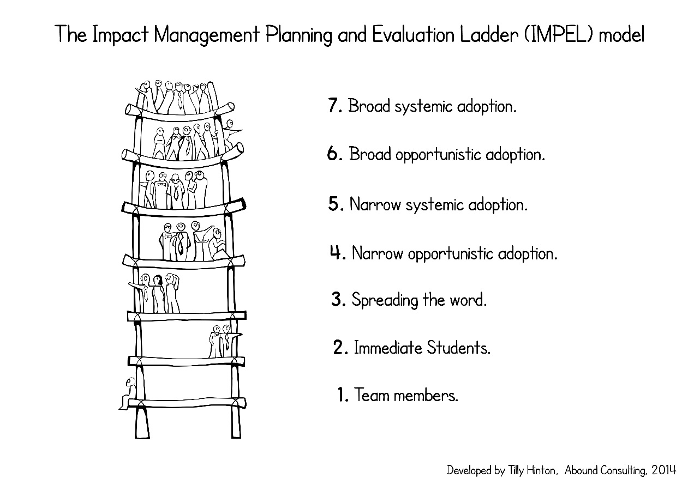
Project Impact Plan
Impact is the difference that a project makes in its sphere of influence, both during and after the funding period. Maximising impact requires forecasting and planning. The questions and matrix below provide a structure to prompt active and ongoing consideration and re-evaluation of impact and how it may be maximised given the evolution of the project. Maintaining updated responses to the template is not intended to be a reporting requirement, rather a strategic steering tool for the project. The responses to the questions below, including input to the matrix, are expected to change over the life of the project, as the work and results progress. The ATN will be interested in discussing evolving projections of impact at key points during the project, including at progress and final reporting points.

Anticipated changes at:
NB: these are approximations & text is not expected in every cell
 | Project completion | Six months post-completion | Twelve months post-completion | Twenty-four months post-completion
(1) Team members
(2) Immediate students
(3) Spreading the word
(4) Narrow opportunistic adoption
(5) Narrow systemic adoption
(6) Broad opportunistic adoption
(7) Broad systemic adoption

  - What indicators exist that there is a climate of readiness for change in relation to your intended project?
  - In brief and indicatively, what impacts (changes and benefits) do you expect your project to bring about, at the following levels and stages of the Impact Management Planning and Evaluation Ladder (IMPEL)?
  - What are your strategies for engaging with stakeholders throughout the project?
  - How will you enable transfer that is ensuring that your project remains impactful after the funding period?
  - What barriers may exist to achieving change in your project?
  - How will you keep track of the project’s impact? What analytics may be useful?
  - How will you maintain relevant project materials for others to access after the project is completed?

Information about project budget, funding and payment

Budget items
The grant is provided for the purpose of achieving the aim, deliverables, outcomes and impact of the project for which it is approved.
Funding for the Strategic Initiative Grant is up to $235,000 per grant. The size of the grant sought must align with the scale, scope and significance of the proposed project.
All projects must be designed around stages that have particular outcomes and deliverables. Please keep in mind that the maximum project duration is one year.
The budget can contain provision for:
  - Salaries or teaching relief and on-costs. If more than 20% of the overall funding amount requested from the ATN will go towards salaries or teaching relief, the reason for this needs to be explicitly justified in the budget justification.
  - research activities
  - project impact activities, including dissemination activities
  - travel and conference attendance costs should not be included in the budget and covered by the ATN University as an in-kind contribution to the project
  - technical and expert support, evaluation and resources essential to the conduct of the project
  - remuneration of advisory or reference group members
  - maximum of 10% for administrative costs and overheads (institutional levy).
The budget for Strategic Initiative proposals must include an allocation of $3,000 for collaboration and/or dissemination activities.
The budget for Strategic Initiative proposals must include an allocation for the Project Evaluation (up to $10,000 as a guide for large projects).
The budget for Strategic Initiative proposals must also include an allocation ($3,000) for editing and desktop publishing of the final report. The editing must be at a professional standard and ensure that the final report is fit for publication as a web-based product.
Please check that your budget adds up. The line items must add up to the sub-totals, and the sub-totals must add to the grand total.

Budget format and template
Budgets must comply with the recommended format and be included in your proposal document.
All costs should be quoted exclusive of GST. All costs must be in whole dollars. The total funding amount requested from the ATN should be rounded to the nearest $1,000, with subtotals and line items adjusted accordingly.

Budget template
 |  | Budget 2019
A | Personnel | ATN | Other  $ | Total  $
 | Subtotal for section A
B | Project Support
 |  |  | Travel
 |  |  | Conference
 | Subtotal for section B
C | Project Activities
 | Subtotal for section C
D | Compulsory Activities
 | Dissemination activities*
 | Editing Costs**
 | Evaluation***
 | Subtotal for section D
E | Miscellaneous
 | Subtotal for section E
F | Institutional levy
TOTAL PROJECT BUDGET#

‘Other’ funding sources
The budget includes a column for 'other' sources of funding and this should show contributions from the lead institution and partners. This support may be in cash or in-kind. Other sources of funding are included here in order to show the total cost of the project.
Provide an explanation of how non-ATN contributions will support the project (use the same sub-headings as set out below). If there are no other sources of funding being provided by the lead institution or partners, explain why.
Budget sub-headings
The budget and justification should be grouped under specific sub-headings. The required budget sub-headings include:
Personnel:
This should include the salaries (e.g. project manager, research assistant/fellow), wages and on-costs of personnel who have overall responsibility for managing and implementing the project. The level of each appointment and the hours per week (or percentage of time committed) should be specified.
A maximum of 20% of the overall funding amount requested from the ATN can be for personnel costs.
Some institutions may have higher on-costs than others. Applicants need to check with their Institution Contact Officers.
Project Support:
This section must be completed where the purpose of expenditure is logistical. Project Support includes all non-staff expenditure for the administration and day-to-day management of the project. For example, project management meetings, stationery, travel, consumables. Please note the purchase of assets cannot to be included in the ATN budget.
Project Activities:
This section must be completed where the purpose of expenditure is directly linked to a project activity.
All costs which directly contribute to a specified activity, should be included here. For example: undertaking research, the hosting of conferences and workshops, communicating with stakeholders, website development and hosting, advocacy, publications (including production).
Note that websites developed as part of any ATN grant need to be kept live and updated for at least five years after completion of the grant project.
This also includes travel relating to specific activities, and personnel expenses if personnel are recruited for a specific project activity. For example a facilitator for a workshop, or an independent evaluator should be budgeted under Project Activities, as should travel to attend the workshop or to undertake the evaluation.
Compulsory activities:
* Dissemination: The budget for Strategic Initiative proposals must include an allocation of $3,000 for collaboration and/or dissemination activities (see Budget items).
** Editing: Proposals must also include an allocation ($3,000) for editing and desktop publishing of the final report (see Budget items).
*** Project Evaluation: All grants must be evaluated by an external evaluator. A maximum of $5,000 can be allocated for this purpose for large grants up to $235,000. For grants less than this, the figure should be adjusted accordingly
Institutional levy
If an institutional level is required, the maximum allocation is 10%.

Non-approved use of the grant
The grant cannot be used for:
  - building works (including the purchase, construction, lease, renovation or fit out of premises)
  - purchase of motor vehicles
  - purchase of assets travel which is not directly related to achieving the outcomes of the project for which the grant was approved
  - general recurrent funding.

Project funding
The initial grant payment will occur in January in the year after the grant was approved.

Payment of Grant
The ATN Grant Conditions document will contain the information on payment instalments linked to agreed project milestones.
For projects involving a consortium of institutions/organisations, the grant will be paid to the lead institution (recipient institution) which will be responsible for the management and acquittal of the funding and the deliverables from the project. When seeking funding for a consortium, care should be taken to ensure the costs associated with the type of collaboration proposed are adequately addressed. The lead institution will be responsible for payments to partner institutions.

Proforma for letters of support
Proforma for lead institution
Endorsement letters must not exceed two pages.

The use of this proforma is mandatory.
Letter of support from the DVC Academic or equivalent must be on the institution’s DVC Academic’s letterhead.
Letter from the lead institution must include the following:
- Title, name and position of the project leader(s) and team members from that institution (if any)
- Title of the application
- The aims of the project and how this aligns with institutional priorities
- The intended impacts of the project, and their institutional relevance
- That the institution will support the time commitment of the project leader and team members from that institution (if any) as indicated in the budget

Certification by the DVC Academic or equivalent
I certify that the application:
- Meets the eligibility criteria as specified in the relevant 2019 programme and operational information, and application instructions
- Complies with the relevant 2019 programme and operational information, and application instructions and if the application is successful [name of lead institution] agrees to abide by the terms in the ATN Grant Conditions
- [Name of lead institution] will notify the ATN if there are any changes in the project leader’s circumstances which may impact on his/her eligibility to participate in, or ability to perform, the project subsequent to the submission of this proposal

Signature(s) of DVC Academic or equivalent

Proforma for partner institution(s)
Endorsement letters must not exceed two pages.

The use of this proforma is mandatory.
Letter(s) of support from the DVC Academic or equivalent must be on the institution’s DVC Academic’s letterhead.
Letter(s) from the partner institution(s) must include the following:
- Title, name and position of the project leader
- Title, name and position of team member(s) from that partner institution
- Title of the application
- The aims of the project and how this aligns with institutional priorities
- The intended impacts of the project, and their institutional relevance
- The institution will support the time commitment of the team member(s) as indicated in the budget

Certification by the DVC Academic or equivalent
I certify that:
- If the application is successful [name of partner institution] agrees to abide by the terms of the Conditions of grant between the ATN and the lead institution
- [Name of partner institution] will notify the ATN if there are any changes in the team member(s)’ from the [Name of partner institution] circumstances which may impact on his/her eligibility to participate in, or ability to perform, the project subsequent to the submission of this proposal

Signature(s) of DVC Academic or equivalent

The full version of the IMPEL model, developed by Tilly Hinton whilst on secondment to the Office for Learning and Teaching, is online at www.olt.gov.au/impact. Further information on this model and resources to assist in considering project impact are also available on the website.
Refer definition of ‘transfer’ above when used in this context

