Assessing the benefits of environmental improvements works along the Campaspe River

Project background
Coliban Water has partnered with the North Central Catchment Management Authority to fund a further 10-kilometre section of their successful Caring for the Campaspe stream frontage management program (SFMP). Designed to improve the ecological condition of the Campaspe River by improving riverside vegetation, the program removes exotic willows and revegetates with indigenous/ native plants and provides fencing to keep stock out of the river corridor, reducing faecal contamination and nutrient inputs/ pollution. Restoration works were completed in December 2019 and are now being maintained.
The Aquatic Environmental Stress Research Group (AQUEST) from RMIT University was engaged by Coliban Water to assess the environmental benefits of this program.
River health background
For most water catchments, including the Campaspe River catchment, there can be diverse sources of pollution, with numerous land uses and factors contributing to its condition. Pollution and pollutants can originate from indirect sources (such as agriculture and urban runoff) and from direct sources like water reclamation plants.
Regardless of the source of input, riverside vegetation can act as a filter, using excess nutrients for plant growth and removing or locking up some other pollutants.
Native trees provide the right amount of shade, and a constant small supply of leaf litter and instream habitat in the form of woody debris, while exotic species, such as willows, can choke a stream, drop large amounts of leaf litter in a single season, which either shades out the stream or leaves the stream exposed.
In areas where the river frontage is not fenced, cattle can be a major source of faecal and nutrient pollution. Did you know, that cows defecate more when standing in water than they do on land!
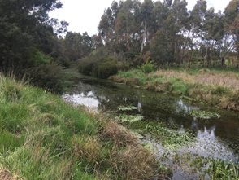 | 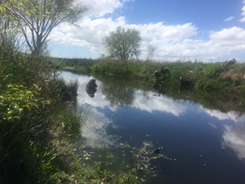 | 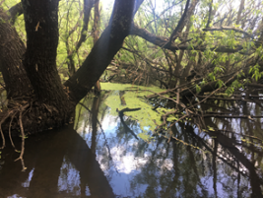 | 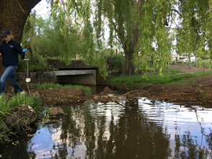
A selection of sites being monitored along the Campaspe River system. From L to R: Site 2, Cobb & Co Rd., Carlsruhe; Site 6 Burton Ave., Kyneton; Site 7 Old Station Rd. and Site 8, Snipes Creek, Barbower Rd.
Approach to the study
AQUEST is undertaking river health monitoring each year over a five-year period (2018 -2023), targeting periods when the Campaspe River is flowing (it usually ceases to flow over summer). A variety of indicators will be used to understand river health and how the environmental improvement works are creating a better aquatic environment, including:
- Water quality;
- Aquatic ecology;
- Nutrient availability; and
- Ecotoxicology.
Our sampling design lets us track condition change over time, showing the benefits of these river health improvement works. Ten sites are being monitored, eight along the Campaspe River, from Carlsruhe to Redesdale, one on Post Office Creek within Kyneton, and one on Snipes Creek.

Findings to date  The first two years of river health results are in and show that there’s a lot going on in the Campaspe River System within the study area.  Overall, the condition of the Campaspe catchment in the study area varies considerably.  Some parts of the system are in physically very poor condition, including Old Station Rd; Post Office Creek and Snipes Creek, being choked by willows, with poor water quality; while other sites are in good condition, dominated by native vegetation and lower levels of pollution.  However, some pollutants were present throughout the study area; particularly, elevated nutrients and several herbicides and insecticides.  Heavy metal pollution was present in some areas. Nickel is naturally elevated in local soils, but other metals, particularly zinc and copper, are likely to be coming from urban and road runoff. | 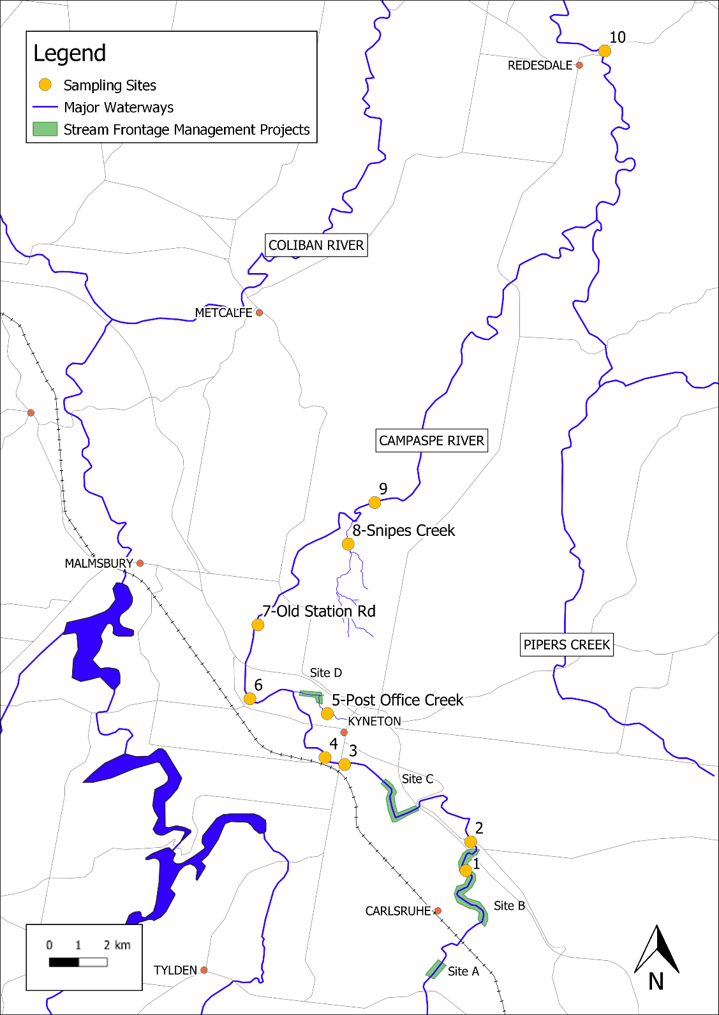
Location of monitoring sites within the Campaspe River system and Stream Frontage Management Plan (SFMP) sites.

The macroinvertebrates (aquatic animals/ bugs) showed good diversity, considering it’s a river system that only flows for part of the year. When poorer diversity was present, it corresponded to high pollution levels and poor habitat. The ecotoxicology results showed that, at the time of sampling, the Campaspe River had generally low toxicity, except for the site at Old Station Road and on Post Office Creek.
The major pollution contributors to sites in poor condition, with poor water quality, were the lack of quality habitat, urban and industrial runoff from Kyneton, runoff from agricultural areas, and treated (e.g.: Kyneton Water Reclamation Plant) and untreated (e.g.: septic system seepage) wastewater inputs. Without further revegetation work at these degraded sites and multiple inputs being addressed, these sites are unlikely to improve.
However, overall, it’s expected that there will be substantial improvements in the physical and ecological condition of the Campaspe River with the environmental improvement works that have been completed, and there are also opportunities for further improvement by reducing major pollution sources, such as heavy metals, pesticides and hydrocarbons, dependent on funding.
Next steps
The third year of results are due mid- year 2021, with fourth year sampling underway.

For more detailed results, please read our second year report: Myers, JH., Odell EH., Kellar, C. Ahmed, W. and Pettigrove, V. (2020), Coliban Water Monitoring Program: Monitoring Program for Assessing the Benefits of Environmental Offsets on the Condition of the Campaspe River: Year 2 (2019), Technical Report 40. Aquatic Environmental Stress Research Group, RMIT University, Victoria, Australia.

and/ or our first year report: Myers, JH., Manassa, R.P., Kellar, C. and Pettigrove, V. (2019), Coliban Water Monitoring Program: Monitoring Program for Assessing the Benefits of Environmental Offsets on the Condition of the Campaspe River: Year 1 (2018-2019), Technical Report #22. Aquatic Environmental Stress Research Group, RMIT University, Victoria, Australia.

Project Team
RMIT AQUEST: Jackie Myers, Vincent Pettigrove, Dan McMahon, Claudette Kellar, Monica Tewman

Contact
Jackie.Myers@rmit.edu.au or Vincent.Pettigrove@rmit.edu.au

