Risk Assessment No: Click here to enter text. |  | Date: Click here to enter text. |  |  | Version No: Click here to enter text.
Activity Description: Click here to enter text.
SECTION 1: General Information
Campus:  Click here to enter text. | Building / Level / Room No.:  Click here to enter text. |  | Date:  Click here to enter a date. | College / Portfolio:  Click here to enter text. |  | School / Area:  Click here to enter text.
Supervisor:  - Click here to enter text. |  | Person undertaking the activity:  - Click here to enter text. |  |  | Independent Assessor:  - Click here to enter text.
Description of who can access the work area and when (e.g. days of the week; hours of the day) if applicable: Click here to enter text.
Description of how the area is accessed (e.g. swipe card, key lock etc.) if applicable: Click here to enter text.
Below is a checklist of some example hazards. Use the checklist to assist with completion of this form and use the ‘Other’ space available for any hazards identified which are not included in the checklist.
All identified hazards must then be assigned to the relevant activity step in Section 4 and included in Section 5 of this document.
☐ Allergic reaction | ☐ Animals |  | ☐ Biological material (e.g. bacteria, viruses) | ☐ Confined spaces |  | ☐ Contamination of product
☐ Damage to RMIT property | ☐ Damage to RMIT reputation |  | ☐ Fumes/vapours | ☐ Ergonomic hazards |  | ☐ Excavation
☐ Extremes of heat/cold | ☐ Disruption to RMIT Operations |  | ☐ Ground uneven / unstable / slippery | ☐ Inclement weather |  | ☐ Struck by vehicle or moving object
☐ Interaction with public | ☐ Noise |  | ☐ Overhead power lines | ☐ Pollution to air / waterways |  | ☐ Insect bites
☐ Radiation (including UV) | ☐ Lasers |  | ☐ Manual handling | ☐ Plant / equipment |  | ☐ Hazardous Chemicals
☐ Trip hazards | ☐ UV light |  | ☐ Vibration | ☐ Work at heights |  | ☐ Work in isolation
NOTE: If the activity involves the use of plant-machinery / hazardous manual handling / confined spaces / radiation / biohazards / lasers – you must complete the risk assessment template specific designed to address those hazard types.
Other (describe):

SECTION 2: Risk Score Matrix
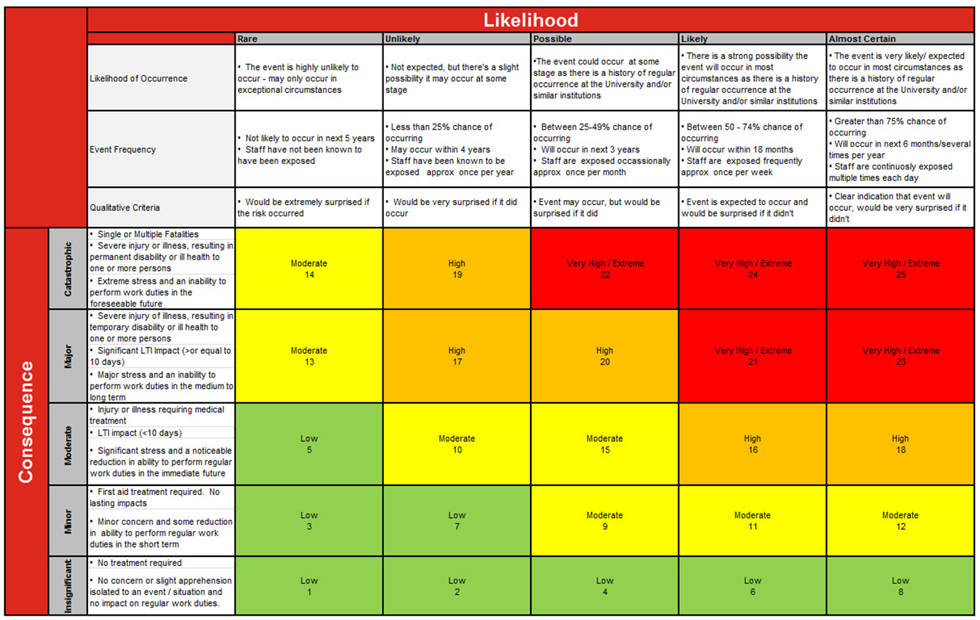

Please Note: 1. ALL risks must be reduced to as low as reasonably practicable. 2. If the residual risk is High or Very High / Extreme, the activity is NOT to proceed until higher level controls are in place 3. Residual Risks that are Moderate must be signed off by the responsible/accountable Manager

SECTION 3: Controlling the Hazards
What you should do for each stage of the risk assessment: | Hierarchy of Control
- Provide hazard description for every activity or process you plan to undertake.
- Determine the initial risk rating (i.e. the risk without any controls in place) by referencing the Risk Score Matrix in Section 2.
- Specify the risk control type and control description for each hazard in Section 4.
- Determine the residual risk rating by again referencing the Risk Score Matrix in Section 2.
- Apply the Hierarchy of Controls to decrease the level of hazard/risk.
- Select the most effective controls in preference to least effective ones as much as practicable.
- Combination of control measures may be used to reduce risk.
- PPE is only to be used in addition to controls 1 - 4.

SECTION 4: Activity Assessment
Activity / Process description  (step-by-step description) | Hazard identification  (please specify for each step) | Associated Risk  (resulting in damage, injury or illness) | Initial Risk Rating
 |  |  | Consequence | Likelihood | Score

SECTION 5: Risk Control Plan
Hazard / Risk  (from Section 4) | Risk control measures required to reduce the risk as far as practicable |  | Residual Risk Rating |  |  | Responsible Person  (for implementation and monitoring) | Date Completed
 | Select risk control(s) | Details of risk controls | Consequence | Likelihood | Score
Click here to enter text. | ☐Elimination  ☐Substitution  ☐Isolation  ☐Engineering  ☐Administration  ☐PPE | Click here to enter text. | Click here to enter text. | Click here to enter text. | Click here to enter text. | Click here to enter text. | Click here to enter a date.
Click here to enter text. | ☐Elimination  ☐Substitution  ☐Isolation  ☐Engineering  ☐Administration  ☐PPE | Click here to enter text. | Click here to enter text. | Click here to enter text. | Click here to enter text. | Click here to enter text. | Click here to enter a date.
Click here to enter text. | ☐Elimination  ☐Substitution  ☐Isolation  ☐Engineering  ☐Administration  ☐PPE | Click here to enter text. | Click here to enter text. | Click here to enter text. | Click here to enter text. | Click here to enter text. | Click here to enter a date.
Click here to enter text. | ☐Elimination  ☐Substitution  ☐Isolation  ☐Engineering  ☐Administration  ☐PPE | Click here to enter text. | Click here to enter text. | Click here to enter text. | Click here to enter text. | Click here to enter text. | Click here to enter a date.
Click here to enter text. | ☐Elimination  ☐Substitution  ☐Isolation  ☐Engineering  ☐Administration  ☐PPE | Click here to enter text. | Click here to enter text. | Click here to enter text. | Click here to enter text. | Click here to enter text. | Click here to enter a date.
Note: Add more rows if required.

SECTION 6: Consultation
Consult with technical staff or equivalent (e.g. Research Officer) in the local area to ensure all RISKS AND HAZARDS have been identified and appropriate controls are in place (signature not required).
Position | Name | Comment (optional)
Technical Officer (or equivalent): | Click here to enter text. | Click here to enter text.
SECTION 7: Approval
Position | Name | Signature (If soft copy, please type name) | Date
Supervisor: | Click here to enter text. | Click here to enter text. | Click here to enter text.
Person undertaking activity: | Click here to enter text. | Click here to enter text. | Click here to enter text.
Independent Assessor: | Click here to enter text. | Click here to enter text. | Click here to enter text.
Manager: (is required to sign off, where the residual risk score is assessed as Moderate for any risk / hazard) | Click here to enter text. | Click here to enter text. | Click here to enter text.
SECTION 8: Review
Risk assessment should be reviewed if any changes to the activity are made or otherwise every 12 months from date of approval (new version number required).
Position | Name | Signature (If soft copy, please type name) | Date
Click here to enter text. | Click here to enter text. | Click here to enter text. | Click here to enter text.
Click here to enter text. | Click here to enter text. | Click here to enter text. | Click here to enter text.
Click here to enter text. | Click here to enter text. | Click here to enter text. | Click here to enter text.
Comments:

